At the Frontier of Mobile Renewable Energy
from Dynamic Catalyst Surface Resonance

Paul J. Dauenhauer, Professor
University of Minnesota

Abstract:
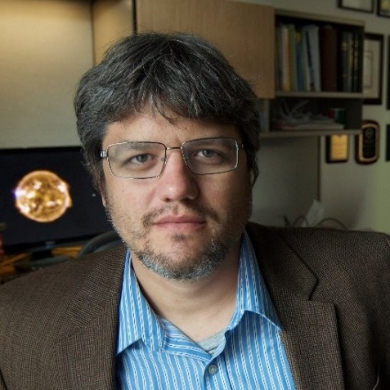
The emergence of competitive renewable energy from solar and wind heightens the importance of moving energy from the place of origin to the places where people live and work. Chemically capturing energy as compressed hydrogen or energy liquids including hydrocarbons and ammonia remains the leading method of energy storage based on density and fungibility, but the catalytic technology necessary for transformation of electricity into chemicals in small, distributed energy systems is the key challenge for implementation. In this work^{[1]}, the general approach of dynamic catalyst operation is described as oscillatory binding energy of sorbates on active sites as a method to dramatically accelerate the rate of catalytic reaction. Surface oscillations in sinusoidal and square waveforms of transient binding energy are imposed on catalyst surfaces with varying amplitude and frequency to identify the resonance conditions leading to 10,000x enhancement in overall reaction rate. The results are presented in the context of catalyst-reaction behavior and with regard to implementation in industrial reactor technologies necessary for moving and storing renewable energy.

References
[1] M.A. Ardagh, O. Abdelrahman, P.J. Dauenhauer, “Principles of Dynamic Heterogeneous Catalysis: Surface Resonance and Turnover Frequency Response” ACS Catalysis, 2019, 9(8), 6929-6937. doi.org/10.26434/chemrxiv.7790009.v1
[2] M.A. Ardagh, T. Birol, Q. Zhang, O. Abdelrahman, P.J. Dauenhauer, “Catalytic Resonance Theory: SuperVolcanoes, Catalytic Molecular Pumps, and Oscillatory Steady State,” ChemRxiv, 2019. http://doi.org/10.26434/chemrxiv.8862677.v1

Biosketch:
Paul Dauenhauer received a bachelor of science in chemical engineering and chemistry from the University of Wisconsin - Madison in 2004, and a Ph.D. in chemical engineering from the University of Minnesota in 2008 supervised by Professor Lanny D. Schmidt. From 2008 to 2009, Paul worked as a senior research engineer for the Dow Chemical Company within Core R&D Reaction Engineering in Midland, MI and the Hydrocarbons & Energy Department in Freeport, TX. In 2009, he joined the University of Massachusetts, Amherst, Department of Chemical Engineering as an assistant professor. As of 2014, he is the Lanny Schmidt Honorary Professor at the University of Minnesota in the Department of Chemical Engineering and Materials Science. His published patent applications serve as the scientific foundation of three startup companies: Sironix Renewables, Activated Research Company, and enVerde, LLC.

When: Tuesday, Sept. 17, 2019, 4-4:50 pm
Where: EP 252

