Accelerating the computational discovery of catalyst design rules and exceptions with machine learning

Dr. Heather J. Kulik

Associate Professor in the Department of Chemical Engineering at MIT

Abstract: Over the past decade, first-principles computation has emerged as a powerful complement to experiment in the discovery of new catalysts and materials. In many cases, computation has excelled most in distilling rules for catalyst structure-property relationships in well defined spaces such as bulk metals into descriptors or linear free energy relationships. More development is needed of computational tools for them to show the same promise in emerging catalytic materials such as single-site metal-organic framework catalysts or single atom catalysts that have increased promise of atom economy and selectivity. In this talk, I will outline our efforts to accelerate first-principles (i.e., with density functional theory, or DFT) screening of open-shell transition metal catalysts with a focus on challenging reactions (e.g., selective partial hydrocarbon oxidation). We have developed tools that not only automate simulation but can be autonomously driven by decision engines that predict which simulations are most promising to be carried out. We also develop neural network machine learning models to accelerate prediction of catalyst reaction energetics and properties at a fraction of the cost of DFT. Paired with new estimates of when such models are reliable, I will show how we rapidly evaluate properties of 10k-100k catalysts in a fraction of the time that conventional first-principles simulation would require. We use such tools to accelerate the identification of design rules and exceptions to expectations when applied to the wider space of emerging single-atom and single-site catalysts.

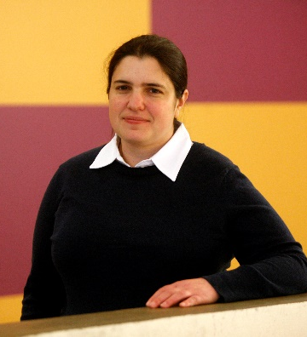
Professor Heather J. Kulik is an Associate Professor in the Department of Chemical Engineering at MIT. She received her B.E. in Chemical Engineering from the Cooper Union in 2004 and her Ph.D. from the Department of Materials Science and Engineering at MIT in 2009. She completed postdoctoral training at Lawrence Livermore and Stanford, prior to joining MIT as a faculty member in November 2013. Her research has been recognized by a Burroughs Welcome Fund Career Award at the Scientific Interface, Office of Naval Research Young Investigator Award, DARPA Young Faculty Award, NSF CAREER Award, the AAAS Marion Milligan Mason Award, and the Journal of Physical Chemistry Lectureship, among others.

When: Tuesday, March 31, 2020 at 4 pm
Where: EEP#252

