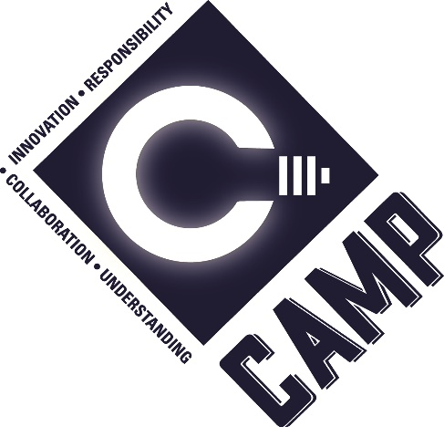
THE BOOK OF CAMP
Center of Excellence for Advanced Manufacturing and Production

INDEX
www.sdsmt/edu/camp
CAMP Flyer
CAMP Personnel
What is CAMP?
- CAMP Vision CAMP Mission and Objectives
CAMP Advisors
Teams
CAMP Expectations
Executive Council
Safety
Manufacturing Process
Advanced Manufacturing Late Policy
Chemical Process
CAMP Team Project Purchasing Procedures
Bank Accounts & Budgeting
Team Travel Information
Fundraising

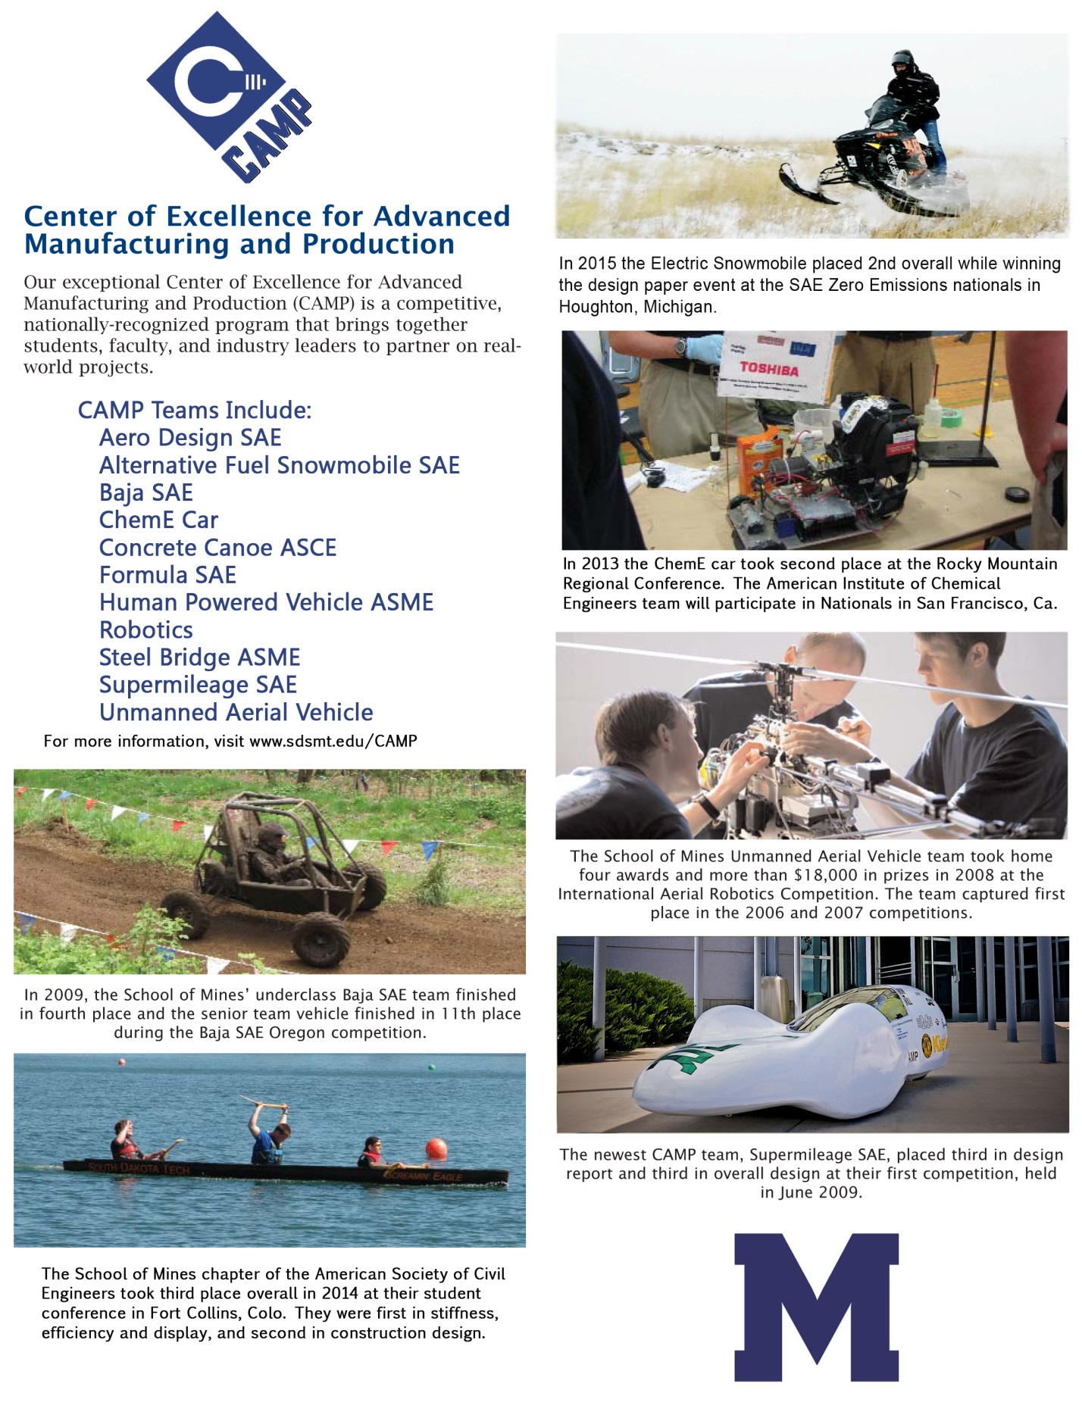

CAMP FACULTY & STAFF
Director: Manufacturing Specialist:
Dan Dolan Ryan Koontz
CM 246B CM 208
Phone: (605)394-1273 Phone: (605)394-6885 Daniel.Dolan@sdsmt.edu Ryan.Koontz@sdsmt.edu
Associate Director:
Kimberly Osberg
CM 246A
Phone: (605)394-2500
Kimberly.Osberg@sdsmt.edu

WHAT IS CAMP?
As part of the educational experience, the South Dakota School of Mines and Technology offers students a unique opportunity to participate in a student-centered, hands-on, engineering program called CAMP, the Center of Excellence for Advanced Manufacturing and Production. A key part of this experience involves designing, building, testing, and competing in a variety of engineering challenges.
What makes CAMP distinctive is an approach based on voluntary, individual contributions with students organizing themselves into teams that actively encourage participation, organization, and leadership starting in the freshman year. CAMP actively combines the classroom experience where students apply their developing technical skills in real world situations that involve fundraising, project management, deadlines, and international competitions where the teams test their mettle against engineering universities from around the world.
The success of CAMP is based on combining both the contributions of each student with the demands of working with others. To accomplish this CAMP recognizes the importance of critical values such as trust, respect, well-being, and responsibility as essential in resolving conflicts, establishing goals, and completing a project. The unique element of CAMP is a focus on the process of understanding and managing ourselves, building relationships and coping and dealing with challenge. Each team constructs a distinctive structure based on the dynamics of each member. By actively encouraging each student to fully contribute, CAMP teams have been able to develop a high level of intrinsic motivation where each student feels that he or she can make a constructive contribution while at the same time contributes to the success of others. The development of a winning engineering project could not be accomplished without developing the personal as well as the technical skills of each participating student.
Currently there are eleven teams and over three hundred students involved in CAMP. Students from any year or discipline may join. Contact the team leaders through Mines Link or the CAMP staff and faculty for more information.
CAMP MISSION
The mission of CAMP is to be a Center of Excellence in engineering education with a focus on teaming and leadership.

CAMP VISION
Every CAMP student will demonstrate self-authorship through social and emotional intelligence and the ethical use of technical knowledge by graduation.

CAMP PROGRAM OBJECIVE
Professional Development of the Students
- Provide a significant engineering experience
- Going from the abstract to the real (apply engineering science)
- Project Management
- Product Design, Development, Manufacture, Test
- Provide a significant development experience
- Identity
- Improve Social & Emotional Intelligence
- Teaming & Leadership
- Promote Self-authorship in the students by graduation

CAMP CORE VALUES

CAMP STUDENT OBJECTIVES:
In line with CAMP values, students who actively participate in CAMP during their time at the South Dakota School of Mines and Technology will:
- Increase personal and ethical responsibility by developing deeper self-awareness, self-management, social awareness, and relationship management skills.
- Obtain deeper understanding of both technical and broader social competencies needed to be successful by enhancing critical thinking, creative thinking, and reflective judgment skills.
- Demonstrate understanding and the ability to apply knowledge learned in the classroom and develop the technical skills necessary to successfully design, manufacture, analyze, and compete with team projects.
- Display the ability to identify, communicate and solve complex problems using innovative strategies and creative thinking.
- Demonstrate positive collaboration within a multi-disciplinary teaming environment by increasing social awareness, relationship management and communication skills.

CAMP STUDENT OUTCOMES:

Students who have actively participated in CAMP will be able to demonstrate the following upon graduation:
- Increased understanding and greater abilities in self-awareness, self-management, social awareness, and relationship management, specifically the self-awareness, self-expression, interpersonal relationships, decision-making, and stress management competencies.

- Proficient or higher levels of critical thinking, creative thinking, and reflective judgment, two of the most prominent components in higher level thinking and understanding.

- Proficient or higher levels of design thinking, and integrative learning.

- Proficient or higher levels of teamwork as well as higher levels of social competencies, specifically interpersonal relationships.

Model of the CAMP Professional

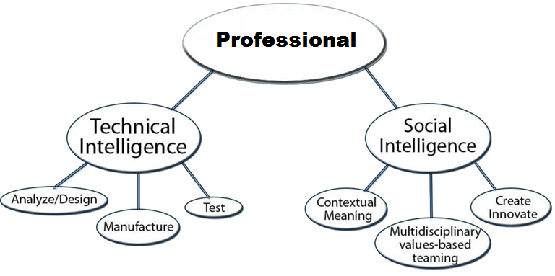

The Two Sides of ABET a-k
Accreditation Board for Engineering and Technology, Inc. (ABET). This body accredits college degree programs in engineering. CAMP tries to meet all requirements.

Technical Social
(a) math, science, and engineering (d) multi-disciplinary teams
(b) design and conduct experiments (f) professional and ethical responsibility
(c) ability to design (g) an ability to communicate effectively
(e) solve engineering problems (h) broad education
(k) engineering practice (i) life-long learning
(j) a knowledge of contemporary issues
(k) engineering practice

Teams and their Advisors:
Students can access Mines Link https://sdsmt.campuslabs.com/engage/ for team rosters and team contact information.
- AIChE ChemE Car – Dr. Brenza
- ASCE Concrete Canoe – Dr. Shearer
- ASCE Steel Bridge – Dr. Surovek
- ASME Human - Powered Vehicle- Kimberly Osberg, Dr. Dolan
- AUVSI UAV – Dr. Dolan, Dr. Weiss, Elaine Linde, Dr. Tolle, Dr. Hoover
- IEEE Robotics – Dr. McGough
- SAE Aero Design – Dr. Dolan, Kimberly Osberg
- SAE Clean Snowmobile – Dr. Dolan
- SAE Formula SAE – Dr. Dolan,
- SAE Mini Baja – Dr. Muci, Dr. Dolan
- SAE Supermileage – Dr. Dolan, Dr. Abata

AERO DESIGN
The Aero Design® competition challenges engineering students to: conceive, design, fabricate, test, a radio controlled aircraft that can take off and land while carrying the maximum cargo. This gives students the opportunity to apply the knowledge learned in the classroom on a practical problem. The students have to design an airplane capable of carrying the most weight given certain constraints on wing size, wing area and motor size. The team competes in the SAE Aero Design competition yearly.
Goals: Building a plane with a net weight of less than 6 pounds. Creating a flyable plane with a ten foot plus wing span that is capable of carrying a 30 pound payload. We aim to build character, responsibility, and reliability within a team. http://students.sae.org/cds/aerodesign/

ALTERNATIVE FUEL VEHICLE/Zero-Emissions Clean Snowmobile
The Alternative Fuel Vehicle Team designs, engineers, builds and races an alternative fuel vehicle. The team currently competes in the SAE Zero Emission Snowmobile Challenge. The top vehicles are then sent to Antarctica to be used by scientists in air quality studies.
We believe that the Zero Emission category of the SAE Clean Snowmobile Challenge meets the goals set forth by the previous teams that are now gone (Solar Car and Hydrogen Fuel Cell Car) in making an environmentally friendly vehicle that is a model for future designs. This is both a challenging and exciting project.
History
The SDSM&T Alternative Fuel Vehicle Team (AFV) has been a valued part of the university since its beginning in 1994. In the beginning the team was called the Solar Motion Team (SMT) and produced five high-quality, solar-powered vehicles. The SMT designed, engineered, built and raced solar-powered vehicles in annual competitions against other engineering institutions such as CalTech, Purdue, Kansas State and other nationally renowned schools. The SMT team decided to change its focus from a hydrogen fuel cell vehicle to competing in the SAE Clean Snowmobile Challenge. This shift in focus was caused by the cancellation of the American Solar Challenge that was expected to run in the summer of 2007. The AFV team met to decide what to do with the car and where the group was headed. Transferring to Zero Emissions, the AFV team continues to work for the betterment of modern day vehicles. http://students.sae.org/cds/snowmobile/

CHEM E CAR
The Chemical Engineering Car (ChemE Car) Team designs and runs a car completely powered and controlled by chemical reactions. The team competes in regional and national conferences.
For competition, there are many requirements that must be met. First and most important, the car must be started and stopped by a chemical reaction. Secondly, it must be able to carry a container ranging from 0 to 500mL of water. Last but not least, the car must be able to travel a specified distance between 50 to 100 feet. The distance and amount of water are not given to the teams until one hour before the competition. Teams use a variety of methods to accomplish their vehicle, from acid-base reactions and hydrogen fuel cells to air-die grinders. The possibilities of approaches to run a car are endless. The Grubby Mobile uses a combination of an organic clock timer and a hydrogen fuel cell to run and stop itself. The fuel cell converts hydrogen to electricity that can operate the motor. The organic clock timer is a reaction called the “Blue Bottle” reaction. We use a photocell to detect the blue solution color change to clear, and this breaks the circuit.
The SDSM&T American Institute of Chemical Engineers Chemical Engineering Car Team is an opportunity for engineers to work with exciting technology to overcome challenges given by both faculty and society.
For competition, there are many requirements that must be met. First and most important, the car must be started and stopped by a chemical reaction. Secondly, it must be able to carry a container ranging from 0 to 500mL of water. Last but not least, the car must be able to travel a specified distance between 50 to 100 feet. The distance and amount of water are not given to the teams until one hour before the competition. Teams use a variety of methods to accomplish their vehicle, from acid-base reactions and hydrogen fuel cells to air-die grinders. The possibilities of approaches to run a car are endless. The Grubby Mobile (ChemE Car) uses a combination of an organic clock timer and a hydrogen fuel cell to run and stop itself. The fuel cell converts hydrogen to electricity that can operate the motor. The organic clock timer is a reaction called the “Blue Bottle” reaction. We currently use a photocell to detect the blue solution color change to clear, and this breaks the circuit.
The SDSM&T American Institute of Chemical Engineers Chemical Engineering Car Team is an opportunity for engineers to work with exciting technology to overcome challenges given by both faculty and society. In the coming years, we will continue to advance our knowledge with innovative technology and the fierce desire to learn more!
The ChE car team began nine years ago. In that time, we have competed at every annual competition.
Team Objectives
1. To provide students an opportunity to design and build a chemical-powered car
2. To promote professionalism among the membership
3. To develop engineering skills and practices outside of the classroom
4. To compete in the annual regional and national AIChE competitions
5. To develop relationships between faculty, staff and students
6. To promote engineering and SDSM&T by taking part in community and campus activities
https://www.aiche.org/community/students/chem-e-car

CONCRETE CANOE

The concrete canoe team designs and manufactures a new canoe from scratch every year for competition in the Rocky Mountain Regional Conference and possibly the National Competition at the various locations that are selected by the Committee on National Concrete Canoe Competitions.

Our concrete canoe is constructed from scratch every year for competition in the Rocky Mountain Regional Conference and possibly the National Competition at the various locations that are selected by the Committee on National Concrete Canoe Competitions.

The concrete canoe at South Dakota Tech is known for its domination at the Rocky Mountain Regional Conference each year. We have made it to the National Concrete Canoe Competition 13 of the last 16 years. The concrete canoe is also very competitive at the national level, with a national championship in 1995 and many top ten finishes at the national competition.

For the canoe to be competitive at the national level many hours are spent preparing a mold to the perfection of the design that was created. While the mold is being constructed, various mix designs are tested for maximum strength and minimum density with the purpose of floatation in water given a maximum cargo of four paddlers. Many hours are put into sanding the mold as well as the concrete after it is applied to the mold. The project must also be described in a presentation accompanied by a design paper, both of which are scored at each competition. A tremendous amount of heart and soul goes into each year's concrete canoe. This year was no different, and we look forward to future competitions!

Our chapter competes in a regional competition each year with two major projects: the concrete canoe and the steel bridge. We have done very well in the past and many times have advanced to nationals. We have many community service projects such as highway clean-up, volunteering at schools and helping elementary kids build popsicle-stick bridges, and helping with the annual E-Week activities. http://www.asce.org/student_conferences/

HUMAN POWER VEHICLE

The Human Powered Vehicle Team designs and manufactures an aesthetically unique vehicle that focuses on ergonomics, the team members' safety, and the ability to succeed in all aspects of competition. They compete yearly in the ASME Human Powered Vehicle competition.

Mission

Our purpose, as the Human Powered Vehicle Team of South Dakota School of Mines and Technology, is to design and create an aesthetically unique vehicle that focuses on ergonomics, the team members' safety, and the ability to succeed in all aspects of competition. The team provides students an opportunity to learn, design, manufacture, and ride a human powered vehicle. Students will also learn teaming and leadership skills needed in industry. We work closely with other teams on campus to share valuable information in the learning process. As a team we promote SDSM&T and engineering by taking part in campus and community activities.

Our main focus is in getting to the national competition held every year. The team has performed well in the past and strives to continue this tradition of performance. We also focus on our members as we build on our strengths and work to minimize weaknesses to develop a quality product and great team.

History

Through the years, transportation has been a significant engineering and technological challenge. Methods of transportation have greatly relied upon the petroleum industry as a main source of energy. As natural resources diminish, other forms of energy for transportation will need to be found. Human power is just one of the alternative forms of energy that is being experimented with today.

Our focus is to attack the old saying of “getting from point A to point B” by using human power. From rowboats to the common bicycle, human powered vehicles (HPV's) have been around for hundreds of years. However, due to a variety of factors, human power as energy is often limited to recreation rather than a primary source of transportation.

Today, muscle power is not limited to traditional bicycles and rowboats. Human power is being applied to all types of transportation including airplanes and submarines, as well as high-speed land vehicles. Because of the extremely low power available when using the human body as an engine, it becomes a very challenging problem to successfully design and build efficient machines. https://www.asme.org/events/competitions/human-powered-vehicle-challenge-(hpvc)

ROBOTICS

The Robotics team designs and manufactures robots for the IEEE Robotics Competition. The team consists of several teams that work to build varying solutions to complete the competition. The team is dedicated to the educational benefits to involve students in the field of robotics.

The Robotics team is an affiliation dedicated to the educational benefits of the students involved in the field of robotics. The breadth of which includes the application of theoretical knowledge in mechatronics, electrical circuits, and programming; thusly being beneficial to the majors of Electrical Engineering, Computer Engineering, Computer Science, Mechanical Engineering, Industrial Engineering, Mathematics, and Physical Science. These majors consist of well over half of SDSMT's students and alumni.

We are highly involved with the community in many different ways. First, we participate in city parades, like the Red Ribbon Parade, and M-Week Parade. We also help stage a yearly Mall demonstration to get the CAMP name out in the community as well as offer information to people interested in robotics. We compete in Annual competitions, namely the IEEE robotics competition. Fundraising is also a large part of our community involvement by selling food and raff tickets for various items.

The Robotics team is dedicated to the use of hands-on learning. The skills that our team members gain through this process, the products that our teams output, the unique and innovative ideas that our team brings to the table, the opportunity we provide our students to apply their knowledge in prestigious ways, the rapid prototyping methods that we are now capable of because of generous support, and our trophies which stand as a testament to the first rate experience and education that has been and is now taking place through the SDSMT Robotics team.

Robotics team is heavily involved in the application of theoretical knowledge- mechatronics being one of the most integral parts of our processes. The applications of mechatronics include work with sensor guided systems, typically infrared, which may both guide a robots path and implement certain key functions. Also included is the use of mechanical dynamics which include: framework design (building a frame useful for certain hardware integrations), motor design (effectively setting gear ratios, torque, power, angular velocity, etc.), and hardware integration (effectively placing doors, wheels, catapults, flippers, legs, etc.).

Another key field of knowledge that we work with heavily is Electrical Circuits. We design the circuits to integrate with and control the mechanical components of the robots. All participants are given the opportunity to acquire knowledge of circuit-board creation and the design software used to make the process plausible at the level of our competition.

And finally we work with Programming. Working with the programming of the PIC chips in its own language PIC-C, we are able to effectively control a robot either by automaton or remote control.

The SDSMT Robotics team is a vital part of campus education and entirely consistent with what CAMP and SDSMT stand for. Its regional accomplishments speak for itself- the result of the combined efforts of its sponsor’s funds and its student’s minds. But the most invaluable thing of all is the unmistakable experience and education that its members walk away with- stepping into the world as an active and constructive participant to its good; there is no greater idea than this for an institution of higher learning. http://www.ieee.org/membership_services/membership/students/competitions/index.html

BAJA SAE

The SAE Baja team designs and manufactures a four-wheeled off-road vehicle to compete in the SAE Mini Baja Competition. The team typically creates two vehicles, one designed by the seniors and the other by the underclassmen on the team.

Team Objectives

The goal for this two-semester project is to design and manufacture a four-wheel off-road vehicle, to compete in the S.A.E. Mini-Baja West Competition and MIT's Winter Mini Baja Competition. Rather than wipe the slate clean, our focus will be to build on the strengths and improve on the weaknesses of last year’s car.

As is done in industry, evolutionary design will be used to create a stronger performing car, as opposed to designing something entirely new and seeing how it performs. The main objective of the team is to design and build a car capable of winning while developing good teaming skills.

Community Involvement

We will gain community exposure by displaying the vehicles as often as possible and volunteering our time to helping CAMP, the campus, and the community. This includes participating in SDSM&T expositions. http://students.sae.org/cds/bajasae/

FORMULA

The Formula SAE team designs and manufactures a formula style race car for competing in the Formula SAE Competition.

The South Dakota School of Mines & Technology Formula SAE Hardrocker Racing Team is committed to excellence through teamwork, professionalism, respect, and dedication. Our team designs and manufactures a new race car from the ground up every year. We then compete against other engineering schools on a national level. The quality of our performance in engineering design is nationally recognized.

The vehicle for is a 4 wheeled, motorcycle engine powered, open wheeled, and open cockpit formula style racecar. Overall it must be light, fast, well designed, and must be able to navigate a parking lot style autocross course. The competition itself includes 7 events.

"The Formula SAE® competition is for SAE student members to conceive, design, fabricate, and compete with small formula-style racing cars. The restrictions on the car frame and engine are limited so that the knowledge, creativity, and imagination of the students are challenged. The cars are built with a team effort over a period of about one year and are taken to the annual competition for judging and comparison with approximately 120 other vehicles from colleges and universities throughout the world. The end result is a great experience for young engineers in a meaningful engineering project as well as the opportunity of working in a dedicated team effort. For the purpose of this competition, the students are to assume that a manufacturing firm has engaged them to produce a prototype car for evaluation as a production item. The intended sales market is the nonprofessional weekend autocross racer. Therefore, the car must have very high performance in terms of its acceleration, braking, and handling qualities. The car must be low in cost, easy to maintain, and reliable. In addition, the car's marketability is enhanced by other factors such as aesthetics, comfort and use of common parts. The manufacturing firm is planning to produce four (4) cars per day for a limited production run and the prototype vehicle should actually cost below $25,000. The challenge to the design team is to design and fabricate a prototype car that best meets these goals and intents. Each design will be compared and judged with other competing designs to determine the best overall car. http://students.sae.org/cds/formulaseries/

STEEL BRIDGE

Each year, the Steel Bridge Team designs, fabricates, and tests a steel bridge to compete in the American Society of Civil Engineers (ASCE) Rocky Mountain Regional Conference.

ASCE is a professional organization that focuses on upholding the professional practice of civil engineering. Student chapters of ASCE throughout the United States provide students with both learning and networking opportunities with professional civil engineers and other civil engineering students. This allows students to collaborate with each other and find potential careers upon graduation.

What is the Steel Bridge? The Steel Bridge competition is intended to give students a practical problem-solving scenario involving teamwork and application of classroom theory in addition to a real-world design situation. This competition requires students to design, fabricate, and construct a steel bridge that is a minimum of 25 feet in length, 3.5 feet in width, and able to withstand a load of 2500 pounds. Scoring is based on the time it takes to assemble the bridge at competition, the overall efficiency of the bridge, how much it moves after the 2500 lb. load has been applied, and the total weight of the bridge. The competition simulates a bridge being constructed over a river. The water boundaries on the river are taped out, resulting in time penalties for team members crossing into the river. This competition helps students gain valuable hands-on experience by adhering to strict rules and specifications. It also allows them to compete regionally, and the regional winners move on to the national competition, which offers students an even greater chance to grow in their professional careers.

The Rocky Mountain Region is composed of 13 universities from 5 states: Colorado, New Mexico, South Dakota, Utah, and Wyoming. A few of these schools include:

* Colorado School of Mines
* United States Air Force Academy
* University of Colorado – Boulder
* University of Utah
* University of Wyoming

These competitions provide excellent exposure for the team’s sponsors. While at competition, the team wears a team T-shirt sporting the sponsor’s logos. After the competitions, an advertisement is sent to the Rapid City Journal thanking sponsors for their support and letting the community know the results of the competition against some very tough schools. http://www.asce.org/student_conferences/

SUPERMILEAGE

The Supermileage® competition provides engineering and technology students with a challenging design project that involves the development and construction of a single-person, fuel-efficient vehicle. Vehicles are powered by a small four-cycle engine donated by Briggs & Stratton. The vehicles will run a specified course with the vehicle obtaining the highest combined kilometers per liter (miles per gallon) rating plus design segment points winning the event. Students have the opportunity to set a world fuel economy record and increase public awareness of fuel economy. Students involved in Supermileage work towards finding a new and improved way for decreasing the pollution that current vehicles cause.

In 2009, They placed third in the design report (thanks again Tech Comm folks!) and they tied with the University of Massachusetts at Amherst for third place overall on design behind Michigan Tech and Ecole de Technologie Superieure (ETS) from Canada. They placed 17th overall out of the 45 registered teams. They achieved 313 mpg as a rookie team. The winning team, Laval, made 1804 mpg. In 2010, they averaged 669 miles on a gallon of gas. http://students.sae.org/cds/supermileage/

UNMANNED AERIAL VEHICLE (UAV)

The Unmanned Aerial Vehicle team designs and manufactures aerial robots. The team participates in robotic research with several industry and government agencies. The team also competes in the IARC Aerial Robotic Competition yearly.

The South Dakota School of Mines and Technology’s Unmanned Aerial Vehicle team consists of several students from a variety of majors. We also have several professors and faculty working with us to make our project a success.

Our Goal is to design and build an Aerial Vehicle and sub-vehicle to compete in the International Arial Robotics Competition in July. The Vehicle will be capable of flying 3 Kilometers via waypoints, after which, it will search for and find a specific building. Finally it will launch the sub-vehicle. The sub-vehicle will then enter the building and relay video information back to the base station. The real challenge comes from the fact the entire system will be autonomous, meaning the entire process will be controlled by computers on-board the vehicle.

The unmanned aerial vehicle team was formed for several reasons. The primary reason, for at least the first few years, was to compete in and win the International Aerial Robotics Competition. We would also like to gain some real world experience that we can take to our jobs after graduation. Another important reason for the SDSM&T UAV team is to explore the frontier of aerial robotics. The team is working towards developing new technologies which will be used in both commercial and military UAV’s. http://www.auvsi.org/

CAMP Expectations:
- Goals, Objective and the CAMP Philosophy
  - Growth in technical engineering
  - Personal and professional development
  - Values – Communication, collaboration, respect, positive attitude, “check” your ego.
  - Partnership with students and the university. It is a privilege to represent your university.
  - Commitment to excellence
- Code of Cooperation
  - Teams should clearly state how they will interact with each other and setting team roles.
  - Teams should clearly state how they will interact with CAMP - emails and correspondence.
- Expectations from CAMP staff
  - We will do our very best to ensure a safe environment. Not only is your physical safety number one, we care about our students mental and emotional needs as well.
  - Labs will be stocked with proper equipment and supplies.
  - We will be available to you. Setting a meeting time is encouraged but please feel free to stop in, we have an open door policy.
- Process for communication
  - Teams need to be in contact with CAMP staff. As a team leader we need to know if your team will be unable to make an event, Exec Council, All Teams Meetings or other important items. Staff will meet periodically to discuss the level of communication and participation from individual teams. If the CAMP philosophy and expectations are not met you will be put on a probationary period. If communication does not improve you may be asked leave CAMP.
Please know that situations arise, together we are smarter and able to learn and grow from experiences that may arise.
  - Share your events with us. University Relations asks us every month for news items. We have a lot to share and promote ourselves. We also work closely with the Alumni office, Foundation and President’s Office. Help us spread the good word.
  - Identify who will do what on your team (team roles) – treasurer, activities leads, travel, purchasing and working with university relations, who will attend Exec Council, etc. Let CAMP staff know who fill these roles. Mines Link rosters need to remain up to date.
  - Team Leader and at least one other officer should be present at Exec Council. This is where communication about teams, and voting on events takes place. This is also where we discuss many teaming and leadership topics. We highly encourage student input as we operate with shared ideas and partnerships. We value student feedback. It is important you take this information back to your respective teams.
  - Be familiar with dates and deadlines and discuss these with your teams during team operations meetings.
  - Travel deadlines – if the team cannot make the deadline they will work directly with the Business Office. The handbook discusses dates further in the Travel section.
  - If there is conflict or disagreement within your team or with anyone at the university we ask to resolve as soon as possible, preferably in person. Emails back and forth are tough when resolving issues. Set up meeting times in advance so we can be sure to plan.
  - Should we need to implement new ways of operating we will discuss at the Exec Council. Decisions require 70% approval. For your safety and the welfare of CAMP some policies need to remain in place to operate smoothly.
- Team Project Management
  - Team Schedules need to remain up to date. We will keep track of these in Exec Council meetings. Teams will be asked to show these periodically.
  - Team Budgets need to be set and adhered to as much as possible. Teams will present these at Exec Council.
- You will be ineligible to be in CAMP if:
  - You are found in the Cat Lab without another person
  - You are in the Cat Lab after hours
- You will be suspended from CAMP if:
  - Your grades are below the required university academic standards.
  - You disrespect faculty, staff or other students or have other disciplinary issues.

Acknowledgement of Receipt of CAMP Standards
I have read the CAMP Expectations handout and fully understand its meaning and consequences. I support its enforcement.

Please sign and return to Kim Osberg in the CAMP office.

_____________________________Signature of student

_____________________________Signature of CAMP staff

_____________________________Date

CAMP Student Executive Council:

CAMP expects student leads and officers to be part of the Executive Council of CAMP. The Executive Council is partially responsible for running weekly CAMP meetings and seminars as well as monthly all teams meetings. There, orders of business dealing with events and service work are discussed, as well as checking and helping out the teams that could use extra support.
Workshops, seminars, and teaming activities are also instituted by the CAMP staff and faculty. Special activities are offered for students to understand the importance of teaming and individual growth. The activities cover issues such as respect, industry expectations, communication, and design thinking. Team members who attend are expected to relay the information to their whole team through their team operations meetings.

SAFETY
INTRODUCTION
The safety, health, and wellbeing are of primary importance to the CAMP faculty, staff, and students. Health and wellbeing, both mentally and physically, are values that CAMP members work for. Attached are the expectations and procedures expected of each and every member of CAMP for when he or she is in the lab.
General Laboratory Safety Expectations
Safety rules and standards are developed and instituted for two purposes. First and paramount, they protect occupants of the laboratory and others nearby. Second, they protect laboratory equipment and facilities. Standards from the Occupational Safety and Health Administration (OSHA) and other regulations state the minimum requirements for safety and health. General safety rules are presented later in this chapter. However, they may not be sufficient for certain facilities and experiments conducted in engineering departments.
Importance and Benefits of Safety Rules
All safety programs must have the unwavering support of the faculty and staff. These persons must display their convictions that safety and health are important aspects of education by consistently adhering to the established safety rules. Disregard for these rules by the faculty, teaching assistants and staff conveys a very harmful message about the importance of safety to the students. These rules are meant to help students realize that they are responsible for their own safety, that of other members in the group, neighboring groups, the teaching assistant, the professor, and visitors. Each of those persons has a reciprocal responsibility for the safety of every other person in the laboratory.
Authority
The authority for establishing and enforcing all campus safety rules is vested in the Departmental and Campus Safety Committees. Authority for these actions ultimately rests in federal and state law. However, even if these regulations were not in place, faculty members would be responsible for providing a safe and healthy educational environment under the Code of Ethics of their professional engineering society. Likewise, all students should be taught that the principles of safety, health, and loss prevention must become integral parts of every experiment, every design, and laboratory operation.
Laboratory Safety
The easiest way to help students understand the hazards associated with laboratory work, equipment, and chemicals is to provide them with a set of safety rules. It must be made clear that these rules are designed to enhance laboratory safety by identifying and prohibiting unsafe actions. The penalty for infractions should be severe, ranging from no credit for an experiment to dismissal from the laboratory with a failing grade in the case of repeated infractions of any type. Teaching assistants, faculty directly involved in the laboratories, and the Laboratory Director should all assess safety penalties when they are warranted.
Student Rights
The students' acceptance of safety and health as part of every project will be enhanced if an atmosphere is created in which they feel free to correct each other and to point out deficiencies on the part of the faculty and staff directly to them. It must be absolutely clear that students have the right and the responsibility to identify unsafe actions, procedures or conditions without jeopardizing their grade in the laboratory or any other course.
Recommended General Safety Rules
The following safety rules are recommended for general use. The Laboratory Director should modify this list to meet specific requirements.
CAT Lab Hours are 7:00am until 12:00am at night.
1 . "Horseplay" is hazardous and will not be tolerated.
2. No student may work alone in the laboratory at any time except to prepare flow diagrams and operating procedures for equipment.
3. Required personal protective equipment (PPE) must be provided by the Department used whenever specified by the Laboratory Director.
4. Contact lenses will not be worn in the laboratory when vapors or fumes are present.
5. Safety glasses with side shields and plastic lenses must meet ANSI Standard Z87.1-1976 and will be worn at all times in the laboratory. Splash goggles or face shields will also be worn as prescribed by the Laboratory Director.
6. Sandals, open-toed shoes, high-heeled shoes, and shoes (or boots) with holes in the soles or having canvas uppers will not be worn in the laboratory. Shirts or blouses are required in the laboratories. Shorts and skirts are not permitted while working.
7. Long hair and loose items of jewelry or clothing must be secured during work with rotating machinery.
8. Each student must know the use and location of all first aid and emergency equipment in the laboratories, shops, and storage areas.
9. Each student must know the emergency telephone numbers to summon the fire fighters, police, emergency medical service or other emergency response services. These numbers must be posted at many places throughout the building.
10. Each student must be familiar with all elements of fire safety: alarm, evacuation and assembly, fire containment and suppression, rescue, and facilities evaluation.
11. Ungrounded wiring and two-wire extension cords are prohibited. Worn or frayed extension cords or those with broken connections or exposed wiring must not be used. All electrical devices must be grounded before they are turned on.
12. Each student must be familiar with an approved emergency shutdown procedure before initiating any experiment.
13. No deviation from approved equipment operating procedures is permitted.
14. All laboratory aisles and exits must remain clear and unblocked.
15. No student may sniff, breathe, or inhale any gas or vapor used or produced in any experiment unless directed to do so by the Laboratory Director.
16. All containers must be labeled as to content, composition, and appropriate hazard warning: flammable, explosive, corrosive, toxic, etc. The student's name and the date the container was filled must be on the label.
17. The instructions on all warning signs must be read and obeyed.
18. All liquid and solid wastes must be segregated for disposal according to the Laboratory Director's instructions. All acidic and alkaline wastes should be neutralized prior to disposal. No organic waste material is to be poured down any sink or floor drain. These wastes should be properly placed in designated waste disposal containers, labeled, and stored in a well ventilated, secure area.
19. Good housekeeping must be practiced in the laboratories, shops, and storage areas.
20. Eating, drinking, use of all tobacco products, gum chewing, and application of makeup are prohibited in the laboratories, shops, and storage areas.
21. Only chemicals may be placed in the "Chemicals Only" refrigerator, which should be explosion-proof. Only food items may be placed in the "Food Only" refrigerator. Ice from the ice machine may not be used for human consumption or to cool any food or drink.
22. Glassware breakage and malfunctioning instruments or equipment should be reported to the Laboratory Director.
23. All injuries, accidents, and "near misses" must be reported to the Laboratory Director. The Accident Report must be completed as soon as possible after the event by the Laboratory Director.
24. All chemical spills are to be reported, whose directions must be followed for containment and cleanup. All mercury spills must be reported to the Laboratory Director. Students should follow the prescribed instructions for cleanup and decontamination of all spill areas.
25. All students and supervising faculty and staff must wash their hands before leaving the laboratories or shops.
26. No tools, supplies, or any other items may be tossed from one person to another.
27. No material, even water, should be pipetted or siphoned by mouth.
28. Compressed gas cylinders must be secured at all times. Proper safety procedures must be followed when moving compressed gas cylinders. Cylinders not in use must be capped.
29. Only gauges that are marked "Use no oil" are used for oxygen cylinders. Do not use an oiled gauge for any oxidizing or reactive gas.
30. Students are never to play with compressed gas hoses or lines or point their discharges at any person.
31. Do not use adapters or try to modify any gas regulator or connection.
32. There will be no open flames or heating elements used when volatile chemicals are exposed to air.
33. Toxic chemicals will be exposed to the air only in a property ventilated (see the ACGIH Ventilation Manual) hood. Flammable chemicals will be exposed to the air only under a property ventilated hood or in an area which is adequately ventilated (airborne concentration will be less than the PEL specified by the appropriate OSHA standard).
34. Personal items brought into the laboratory must be limited to those things necessary for the experiment.
35. Casual visitors to the laboratory are to be discouraged and must have permission from the Laboratory Director to enter. All visitors and invited guests must adhere to all laboratory safety rules. Adherence is the responsibility of the person visited.

36. All gasoline and storage cans are to be stored in the yellow flammable gas lockers.

First aid and an eye wash station are located in the CAT Lab.

SD Mines Safety Procedures: https://www.sdsmt.edu/Campus-Life/Student-Health-and-Safety/Safety/

Access to labs
Every CAMP student is required to take a safety class before they can get access to use the Cat Lab, the machine shop or other labs. Upon sign-off of the class you can give the CAMP office your name and student ID so that we can get you access to the doors.
If you want to work in the machine shop you are expected to take an online quiz. Once you have passed that quiz you need to speak to the machine shop personnel and follow their strict guidelines.
There are many other labs that a student might wish to use. Many are run by other departments or faculty. Please understand the rules of every lab and proper permissions before use.
Manufacturing Process

All proposed components to manufacture must have:
- Analysis Document
- ASME Y14.5-2009 compliant drawing

Analysis document is no more than two-page document showing what analysis has been completed for the proposed part.

Drawings completed after August 19th, 2017 must use the CAMP supplied Solidworks template (Figure 1). http://webpages.sdsmt.edu/~rkoontz/ Teams are allowed to modify this template to add team specific flare, but all information fields must remain on the document.

Parts to be completed in the ME machine shop must complete the ME work order form, analysis document, and attach an ASME Y14.5-2009 compliant drawing.

In either case drawing must be “signed off” by Ryan Koontz before manufacturing or scheduling manufacturing time. Manufacturing time is scheduled on a first come, first served basic, get you drawing done early to ensure prompt manufacturing.
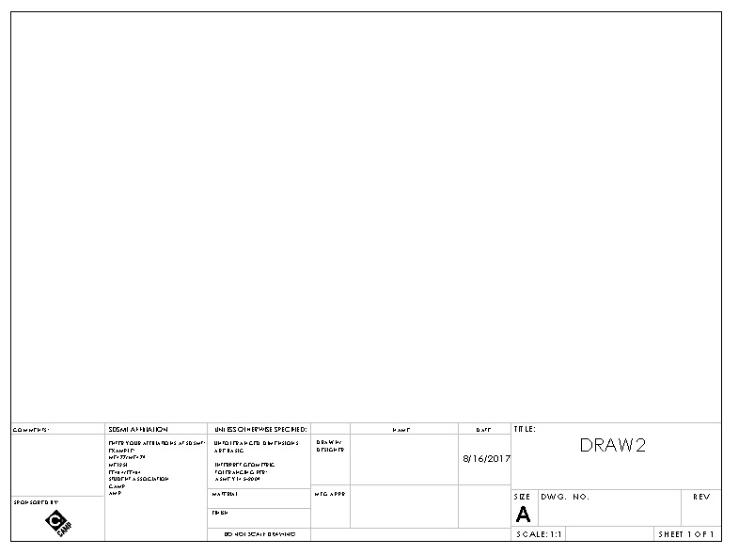
Figure 1 CAMP Drawing Template
Figure 2: CAMP Drawing Template
Unless otherwise agreed upon, a manufacturing time will not be scheduled until the aforementioned steps are complete and any tools or materials are in the position of the student.

Advanced Manufacturing Lab Late Policy

Time scheduled in the advanced manufacturing lab is subject to the following policy:
If you are 10 minutes late to your appointment to manufacture, be prepared to reschedule your project no earlier than 2 school days from the current date.

If you are 15 minutes late or more, be prepared to reschedule your project no earlier than 6 school days from the current date.

If you are going to be late or need extra time please contact ryan.koontz@sdsmt.edu at least 24 hours before your manufacturing time and let me know.

Chemical Processes
(chemical forms are online on the CAMP website)
- Please make sure chemicals that are stored in your area have been approved and are indeed stored correctly. That means you need to take inventory and send this information to Ryan.koontz@sdsmt.edu Please use the CHEMICAL APPROVER FORM. Attach MSDS information with your form.
- Please keep everything that has been approved on an inventory sheet called APPROVED CHEMICALS LIST in your work area so that if Environmental Health and Safety people come through and request to see the chemicals we have on hand we can easily produce that. My suggestion would be to keep this on your F drive and a printed copy in your work area.
- Once the chemicals are approved by Dr. Koontz forward approved chemicals to the campus chemical storeroom – Kandice.green@sdsmt.edu – to get it listed on the online MSDS. You can find that here: http://www.sdsmt.edu/Campus-Services/Environmental-Health-and-Safety/University-Chemical-Storeroom/
- Look under Campus MSDS, then enter Mechanical Engineering as location, etc.
- If you want to order a chemical – whether it be *shop or *lab, please first check the Campus Storeroom Inventory, also found at http://www.sdsmt.edu/Campus-Services/Environmental-Health-and-Safety/University-Chemical-Storeroom/ We are trying to keep items on hand – especially if you request to keep x amount in the storeroom for quick ordering occasions. All lab chemicals must be ordered through the storeroom, some shop chemicals may be purchased through CAMP with prior approval from Dr. Koontz. If you need to get a shop chemical, something that is more free for teams to purchase on your own, you will need the CHEMICAL ORDER FORM. Also attach MSDS.
- If you need to dispose of old chemicals or things you no longer need please place them on a table near the garage door – or a safe spot in your respective lab and record it on the WASTE TURN IN INVENTORY. Please use a sharpie to write a number on the chemical itself that corresponds with the same number on the turn in sheet. Alert Kim that items need to be discarded.
- Barcodes will then be provided to put on your chemicals. The barcode system only applies to chemstore chemicals; this does not apply to shop chemicals. But all chemicals do need to be clearly labeled.
- Safety and Chemical Processes are also located in the Safety binder in the CAT Lab.

University Chemical Storeroom http://www.sdsmt.edu/Campus-Services/Environmental-Health-and-Safety/University-Chemical-Storeroom/
School of Mines Policy Manual (section VII – explains lab and shop chemicals as well as chemical storage and disposal) https://www.sdsmt.edu/About/Office-of-the-President/SD-Mines-Policy-Manual/
Chemical Hygiene and Lab Safety Manual https://www.sdsmt.edu/Campus-Services/Environmental-Health-and-Safety/ (only take them right to the pdf manual that I took a snapshot of and circled below).

CAMP TEAM PROJECT PURCHASING PROCEDURES
(all purchasing forms can be found on the website)

introduction
Every year the teams are awarded a certain amount of money to help with expenses. Part of receiving the money is the responsibility of budgeting it to pay for the essentials of the project. Since there is a team bank account, there are a variety of ways a student can pay for essentials of the project. This handbook will cover the different options available for purchasing these necessary items.
Each team has two accounts given to them. The first is the Business Office Account, and the second is the Foundation account. Each has specific guidelines for appropriate and responsible usage, which is needed especially in team settings.

In the spring, the business office requires that all requisitions for the current fiscal year be processed early, usually by the end of March. For this reason, we suggest that you use your funds in the following order:
- Business Office accounts (SOAP account): This will be the major portion of your SOAP funds plus any monies your team may have been awarded from CAMP. These monies will not carry over from year to year. In the spring, the business office requires that all requisitions for the current fiscal year be processed early, usually by the end of March. (The fiscal year actually starts over in July of every year.) Use your SOAP award first before you use funds from Foundation accounts since you will “lose” that money if you don’t use it. How you spend your SOAP money each year depends on how much SOAP money you will be awarded the following year so use it wisely.
- Foundation funds: Foundation accounts generally contain money that was either earned through fundraising, donations, or team sponsorships. This money does carry over from year to year. It is strongly suggested that each team budgets to have money left over in their Foundation account for the team the following year.
- Agency funds: Some teams have a state account that money was put into called Agency. If a team raises money on campus through it is put into this account. This does carry over from year to year, but under the same rules as your SOAP account.

BUSINESS OFFICE ACCOUNT
The Business Office Account is the six digit account code. This account is the one that the school puts money into every fiscal year (July 1st).
How your business office account works:
- The money allotted in a business account is determined by the student senate. The money that the senate awards are from a campus account called SOAP.
- Student organization must prepare a SOAP proposal presentation each year in order to receive state funding. Student organizations must submit a request with detailed budget forms to the student senate every fall semester. The senate awards this money based on need and smart money budgeting presented in the request and budget forms. The Student Activities and Leadership Center hosts various student organization and SOAP presentation workshops. For further information on SOAP presentations and student org workshops please go to http://www.hpcnet.org/studorghandbook/fininfo.
- It is very important to have all of the money awarded from SOAP used up by the upcoming year because it does NOT carry over to the next fiscal year. It is assumed that if there is money left in the SOAP funds, that the teams do not need that much money the upcoming year. It is important that the teams take into account what they need and can use for the upcoming year and act responsibly with what they do have. Remember, the SOAP account is a campus wide account that many teams depend on, in and out of CAMP.
There are three ways to use the SOAP account. The first technique is called a purchase order (PO), the second is called a personal purchase, and last a CAMP credit card or purchasing card.

PURCHASE ORDER
For the first order of business, the purchase order (PO) (binding contract w/ the company) requires the team to be in good standing with a specific supplier, online or offline. The supplier must also have a W-9 form completed before they can do a PO with the team. PO’s enables the supplier to charge that student’s team whatever the amount being spent without the student having to use their own money. Paper work will need to be filled out on the purchase, then the student will need to turn the paper work as soon as possible to CAMP staff. We will help fill out requisition forms if the student provides sufficient information. No cash, credit cards, or checks are involved on the student’s part. Here is the process:
- Make sure that the company that the team is ordering from accepts purchase orders.
- If your team has not used the company before, check with the CAMP office to make sure that that company is in the state purchasing system.
- If that company is not in the state purchasing system, they must fill out a W-9 form and return it to the CAMP office so that they can be entered into the purchasing system. A blank W-9 form can be found on the CAMP website http://camp-sdmines.com/index.php/forms and can be emailed or faxed to that company.
- A Purchase Order Request form will need to be filled out on the purchase, then the student will need to submit the Purchase Order Request form as soon as possible to the CAMP office. This form can be found on CAMP’s website Forms page.
- After the Purchase order request has been submitted to the CAMP office it will then get entered into the purchasing system.
- Once items have been received, the team must notify the CAMP office that all or part of their order has been received and turn in any invoices that have been received. This allows the CAMP office to “receive in” that order so that the state will send a payment to the company.
- The company that receives the PO is also required to send an invoice to the state office in Brookings (this information is on the purchase order). So if a company tells you that they have not received payment after you have received your order and the CAMP office has “received in” the order - ask them if they have sent an invoice to the Brookings office address that is listed on the purchase order. If they are confused let the CAMP office know and we will work with them on getting their invoice to the right place.
If your order is more than $1000, you will need three formal quotes or a Sole Source Memo included with a PO Request Form. All of these forms can be found on CAMP’s website Forms page.

Under no circumstances will the school be billed for merchandise without a written pre-approved purchase order. Even if the vendor says he doesn’t need a PO, the school does. And remember, the PO cannot be dated later than the invoice. It is a guarantee that the school WILL catch it every time!

CAMP CREDIT CARD (P card)

The CAMP credit card should be used as a last resort or for online companies that do not accept POs.
Before using the card each time:
- Always ask to use the card, do not share freely.
- Purchases cannot be over $1000 unless we work through the business office and set it up beforehand. Competition registration are an example.
- Items must always be sent to 501 Easy Saint Joseph Street, RC, SD 57701
- Items purchased cannot be travel related or food items.
- Items purchased can only come from your SOAP or agency account, not foundation. Make sure you have money in your account before you use the card. If you have overdrawn your account, you will be responsible for finding funds to cover that amount when the credit card bill comes out.
- Do not charge tax. Give the company our tax exempt information. You can find this form on the CAMP website under forms.
- You must send the receipt to CAMP staff as soon as you order your item so that we do not have to track this down. You will be asked to forfeit credit card privileges if this occurs.
- You must show product description and proof of payment on your receipt, not just a confirmation of order.
- Remember this is your responsibility. If you are charged tax, have insufficient funds or information on the receipt it is up to you to call the company back or make arrangements to remedy the situation.

FORMAL QUOTE
A formal quote is a summary done on a specific vendor and their product. They must include the following:
- unit price
- extended price
- delivery time
- terms (including how long the pricing is valid)
- date
- company name
- why this product from this company
- name and phone number of the person providing the quote.
*The Formal Quote form can be found on the CAMP website Forms page.
It is important to evaluate three different vendors for the same product. This is necessary for price and quality check among a group of vendors. Fortunately, it also helps if one vendor does not follow through, and then there are immediate backups. Web pages printed as a quotation from a vendor will not be accepted unless the vendor has established a mechanism to provide formal quotations through a website, and all the required information is included. Catalog pages are not acceptable as quotations.

SOLE SOURCE MEMO

If a student cannot find more than one vendor who sells a specific product needed for competition, the student can fill out a PO with a formal quote on the company. There must be sufficient enough information to prove that the one company is the only company that carries the needed product. The CAMP office will then fill out a Sole Source Memo form, which is the official document for a large-order PO Request Form. The student is not responsible for submitting the Sole Source Memo to the business office; however, it is very helpful to have someone from the team fill out most of the form in order to provide the necessary information.

PERSONAL PURCHASE
For the second order of business, a personal purchase is when the student charges the product on their private bank account, using cash, credit card, or checks. If you chose to pay for an item with your personal credit card or cash, a Check Request form needs to be filled out with a receipt attached. More information about the Check Request Form is listed below.
In order for a check to be issued to the student, the student must have a completed W-9 form on file with the business office. W-9 forms can be picked up in the CAMP office or the Business Office. Separate Check Request forms are used by the business office and the Foundation. Both forms can be found at CAMP’s website. http://camp-sdmines.com/index.php/forms.
Again, students should not pay for items over $100 out of pocket. If a purchase is going to be greater than $100 students should be using a Purchase Order.
The business office requests receipts and invoices be submitted in a specific way along with the Check Request forms.
Items that must be included on the receipt or invoice include:
- Total amount of purchase.
- Proof of payment (i.e. cash, credit card, check).
- Proof that item was paid in full.
- Name and signature of person requesting reimbursement.
- Items that were purchased.
- Authorizing signature (will be provided by Kim or Alycia when receipt is submitted).

Petty Cash
If the student chooses to pay in cash, the student can be immediately reimbursed for approved cash purchases up to $50 per day per vendor per account. This method is called Petty Cash. Bring a receipt, signed by an advisor, along with the proper account information, to the CAMP office. This will come out of your agency or soap account so there can be no tax.

FOUNDATION
The Foundation is a five digit number. Much like the Business Office Account (BOA), students can do a purchase order or a requisition through the foundation office. The main difference between the BOA and the Foundation is that the money in Foundation transfers to the next fiscal year and the money is earned by the individual teams through fundraising or from alumni donations. It is highly recommended to use the Foundation account once the BOA/SOAP money runs out since the BOA/SOUP money cannot be transferred to the next fiscal year.

If there is a Foundation expense, we need an invoice (bill) or Reimbursement Form. It is important to note that food and clothing typically has to come out of Foundation account. On rare occasions it can be charged to SOAP account.

ENDING NOTES:

If the team decides to have more than the two accounts given to them, then they are responsible for understanding the requirements and responsibilities of using that account.

Any shirts including their printing must be approved by University Relations. Be sure to check with them before you make an order. Look at
http://www.sdsmt.edu/Campus-Services/University-Relations/ for branding guidelines and a job request work order.

CAMP TEAM TRAVEL PROCEDURES
(all purchasing forms can be found on the CAMP website)

INTRODUCTION

At least once a year, each team goes on a trip somewhere around the world. While the trip may be the highlight of the year, it is very important to have the necessary details taken care of before the team leaves for competition. The next few pages covers the essentials of student trip insurance, transportation, lodging, meals, and miscellaneous. A checklist of what the student needs to do is located below. Attached at the end are work sheets to help with travel itineraries, travel budgets, and team/individual checklists before competition starts.

Pre-Trip Preparation

Semester Before
- Planning meeting with agenda below (Attendees: Team leaders and all team members traveling, Advisors, CAMP Personnel).
-- Establish the cost/budget and possible sponsors
-- Determine what paperwork is needed and when the deadline is for submitting all paperwork
-- Begin travel checklist and keep copies of all travel-related paperwork in the teams’ travel folder.
- Submit budget paperwork to CAMP office and keep a copy for the team.
- Determine payment method for competition registration (you must fill out a Pre-Payment of Registration form if using State SOAP funds).
- Make reservations with hotels, State Fleet vehicles, car rental companies, vendors, etc.
- Submit travel paper work, such as CAMP Request for Out of State Travel form, Student Insurance form, and Cash Advance Request form (if necessary).

At Least 2 Months Before (preferably immediately after registration is confirmed)
- Review trip itinerary with all team members and advisors at a pre-trip meeting.
- Fill out and submit Waiver and Medical Release Forms to the CAMP office. Please note that these forms say that they should be submitted to Student Activities and Leadership office - please submit them to the CAMP office instead. Ensure that all required travel paperwork has been submitted to the CAMP and/or business office. Have copies of all paperwork for your team’s travel folder AND the CAMP office.

Two Weeks Before
- Confirm all reservations (lodging, State fleet vehicle, car rentals, etc.)
- Last chance to submit Cash Travel Advance Request if necessary
- Check in with CAMP office to make sure that all paperwork has been submitted and all signatures have been obtained.
- Finish itinerary (various examples on-line), send to all traveling with the team and give the CAMP office a copy.

One Week Before
- Obtain Cash Travel Advance 7 to 10 days before departure (if necessary)

Day Before or Day of Prior to Departure
- Pick up vehicle (if necessary)
- Load vehicle and/or trailer
- Make sure you have travel documents (team travel folder) as well as the registration paperwork for the CAMP trailer.
- Look over all vehicles and trailers for safety including brakes and lights.

Post Trip
- Record mileage of vehicle before and after trip.
- Fill vehicles up with gas.
- Unload and clean out van/trailer.
- Return vehicle/keys to the facilities building (they have a drop off window if after hours).
- Submit all receipts to the CAMP office for travel details and reimbursements no later than 14 days after your team has returned from the trip.

Registering for Competition
Registration is a necessary requirement for most competitions and the method of registration differs depending on the group sponsoring the competition. There are certain methods of payment for registration fees that are required by the business office. These options are outlined below. Work with the CAMP office to determine which method will works best for the type of registration your team will be engaging in.

Prepayment of Registration Fees
- This form must be filled out by any team that is using state SOAP funds to pay for their registration fee.
- This form should be filled out no later than 2 weeks prior to registration if possible. The Request for Prepayment of Registration Fee form can be found at on the CAMP website http://camp-sdmines.com/index.php/forms.
- Please submit this to the CAMP office and retain a copy for your team’s travel folder as well.

Purchase Order
- Not all of the organizations sponsoring a competition will allow for a purchase order to be used as payment of registration fees. However, if this is an option, please let the CAMP office know and they will work with you to submit a purchase order for your registration fees.
- If the vendor is not in the SDSMT system a SDSMT W-9 is required to be submitted by that vendor before they will be paid.

School Credit Card
- SDSMT Purchasing Office has a credit card for use by the school, however, there is a rather low credit limit on this card so please make sure that your team notifies the CAMP office to set up arrangements no later than 14 days prior to using the card for registration. You will need to obtain a receipt if you sign up online and give to CAMP office.

Personal payment/reimbursement
- Personal payment for registration by a member of the team is acceptable, however, you are still required to submit a Request for Pre-Payment of Registration Fees form if you are going to be reimbursed using state funds (SOAP). You MUST provide a receipt with proof of payment, an agenda of the event, and a signature of approval from Dr. Dolan, Kim, or Alycia in order to be reimbursed.

Travel Paperwork and Documents
There are several documents that need to be submitted to the business office before students are allowed to travel. These documents are listed below. Please note the required time frames for submitting these documents. All of these documents can be found at http://camp-sdmines.com/index.php/forms.

Request for Out of State Travel
- If your team is traveling out of state you are required to submit this form to the business office at least 30 days prior to travel. Since this form is required before the school will provide payment to vendors (for registration, hotel, airfare, etc.) or cash advances, submitting this form earlier than 30 days prior to travel is highly recommended.
- Please fill out the CAMP Request for Out of State Travel form and submit it to the CAMP office no later than 45 days prior to travel so that CAMP personnel are able to complete the official Request for Out of State Travel and submit it to the business office in the requisite amount of time.
- The official form (filled out by the CAMP office) will require the signature of the requester (team leader) before it can be submitted.
- Although it does not say so on the form, you must also submit the names, signatures, and student ID numbers of all students that will be traveling with the team.
- This form can be found at CAMP's website Forms page.

Student Trip Insurance:
- A list with the names of all students traveling is required to submit this form. The CAMP Request for Out of State Travel form also requires a list of the students traveling so that form may be used to complete the Student Trip Insurance form. The CAMP office will fill out this form when the Request for Out of State Travel is received.

Cash Travel Advance:
- If your team requires a cash travel advance you must submit a Cash Travel Advance Request to the business office. Cash advances are calculated at 80% of expenses and are subject to a $200 minimum and a $2,000 maximum.
- This form must be submitted no later than 14 days before travel and the advance will be paid 7 to 10 days prior to departure.
- This form also requires the signature of the requester (team leader) and Department Head/Director (Dan Dolan or Kim Osberg).
- This form can be found at http://camp-sdmines.com/index.php/forms.

Transportation
It is the responsibility of the team to determine what modes of transportation will be used when traveling, however, there are pros and cons to all methods of transportation. This section will describe the types of transportation that may be used and what paperwork is required for each method.

State Vehicles (fleet)
- State vehicles are available for rental through the Facilities office. If your team wishes to rent a fleet vehicle you will need to fill out the State Fleet Vehicle Request form and submit it to the CAMP office no later than 30 days prior to departure. CAMP will submit the request to Facilities and send the team a confirmation of the fleet reservation.
- Any students who may be driving state vehicles will need to provide a copy of their drivers license and proof of auto insurance coverage.
- State vehicle rates can be found at: https://boa.sd.gov/divisions/travel/ftm_rates.aspx
- If you need to make more than three fuel ups in any given day please contact the CAMP office so that they may ask for extra fill ups from state fleet in Pierre (Amy at 605-773-3162).

Airlines
Airline tickets may be purchased through the Purchasing Office using a purchase order or may be purchased personally and reimbursed on the travel detail after the trip. If your team will be using a purchase order, you must submit your Request for Out of State Travel form to the CAMP office as it contains all of the information necessary to order tickets for your team. Note that the Request for Out of State Travel form is required to be submitted before the purchase order for airline tickets will be submitted to the business office.

Personal Vehicles
- The business office prefers that personal vehicles are NOT used unless there are no fleet vehicles available during the times that they are needed. If the team chooses to use a personal vehicle they will be reimbursed at a lower rate (20 cents per mile) than the normal rate (37 cents per mile). Note that the only time personal vehicles will be reimbursed at the normal rate of 37 cents per mile is if there are no fleet vehicles available.
- Make sure to notify the CAMP office if and why a personal vehicle is being used.

Rental vehicle
- If a rental vehicle (a non-state fleet vehicle) is needed the team will need to provide a rental car justification memo attached to the reimbursement request. The justification memo must include why a rental car was necessary and why a taxi or other public transportation could not be used.
- All rental car insurance is a personal expense unless it is for a student driver under a specific age.

Lodging and Per Diem Expenses
It is important to make your lodging reservations as soon as you know the dates that you will be traveling and your request to travel has been approved (if traveling out of the state or country). The following information includes the daily allowances for lodging and per diem rates as well as methods of payment for lodging.

Paying for lodging
There are several methods that can be used when paying for lodging. Each option has its pros and cons. They include:
- Cash Advance: As stated previously, cash advances are calculated at 80% of the total estimated cost so some money will still be coming out of pocket and you will have to request to be reimbursed for that amount. If you go over the amount of the cash advance you will be responsible for paying SDSMT back. If your team wishes to pay with a cash advance please fill out the cash advance form and submit to the CAMP office (Alycia) no later than 14 days prior to departure.
- Check: This method is only possible through the Foundation. Some hotels will not accept checks as payment but you never know until you ask. They may require you to hold the room with a credit card but will allow you to pay them with a check upon checkout. Make sure to make these arrangements with the hotel when making your reservations. If you are using a check to pay for lodging, you must submit a Foundation Check Request no later than 14 business days before departure to ensure that the Foundation can cut the check for your team to take on the trip.
- Personal payment/credit card: Please note that this method is not encouraged by the business office. However, if your team is paying for lodging with personal credit cards it works best if each team member pays for their own portion of the hotel bill as that is how they will be reimbursed. Each person is reimbursed for their portion of the hotel bill so even if one member of the team pays for everyone’s rooms they will NOT be reimbursed for the entire amount. It will be up to the rest of the individuals that traveled to make sure that their portion of the reimbursement makes it back to the person that actually paid for the hotel room. Also, you MUST provide an itemized hotel bill to receive reimbursement - not just a receipt.

Lodging and Per Diem Rates

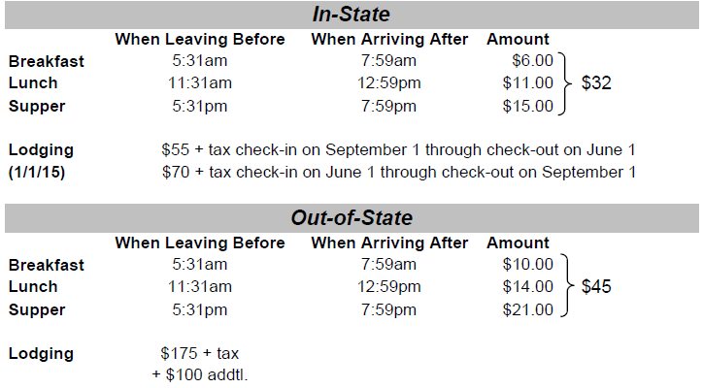

Out-of-Country
Lodging rate $150.00 plus tax, per day, with additional $100.00 with approval.
Per Diem rates:
Breakfast $ 7.00
Lunch $18.00
Dinner $25.00
Total $50.00 (No receipts required for foreign per diem)

Notes:
- Per diem for meals is not payable at home stations (i.e. if the event is in Rapid City and you are not traveling) except through the Foundation.
- If meals are covered by registration fees you may not receive per diem reimbursement for those meals.

Fundraising & Sponsorships

Every year teams should meet with a representative from the Foundation office. That office will give you the correct procedure to reach out to companies you wish to contact. They can help create materials that will be most presentable and give information regarding previous members of your team. Many forms and guidelines can be found on their website - https://foundation.sdsmt.edu/resources/foundation-forms You advisor may have to sign off on these forms.

