Single Atom Catalysts on Amorphous Supports:
A Wild Frontier for ab initio Calculations

Dr. Baron Peters
Chemical & Biomolecular Engineering
University of Illinois

Abstract:
Several industrially important catalysts for olefin polymerization, metathesis, and epoxidation are atomically dispersed metal centers on amorphous supports. These heterogeneous catalysts elude the usual experimental and theoretical analyses because every site on an amorphous catalyst is different. Moreover, the disorder is “quenched” unlike the predictable dynamical disorder of a liquid environment. We discuss the mysterious initiation process in the Phillips ethylene polymerization catalyst (Cr/SiO₂) catalyst at molecular and catalyst pellet scales. At the molecular scale, prevalent bis(ethylene)Cr(II) complexes can generate active Cr(III)-alkyl sites via a new tethered homolysis mechanism. The computationally predicted initiation times and fractions of active sites compare well to experimental estimates. At the pellet scale, the porous support pulverizes itself upon initiation and the Cr/SiO₂ catalyst becomes diluted in an expanding sphere of polyethylene. Contrary to intuition, catalyst dilution leads to an effectiveness factor that increases with size of the expanding polyethylene/catalyst spheres. Thus, the observed activity increases with polymerization time may, in part, be due to early transport limitations. Finally, we introduce a new “Importance Learning” algorithm that combines machine learning and importance sampling methods for site-averaged rate calculations in ab initio studies of these catalysts. The new algorithm requires rate calculations at approximately 1000-fold fewer sites than existing strategies, based on results with the same confidence interval.
Bio sketch:
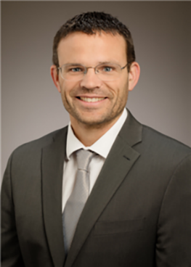
Baron Peters (born 1976, from Moberly, Missouri) is W. H. and J. G. Lycan Professor of Chemical and Biomolecular Engineering at the University of Illinois at Urbana-Champaign. He completed B.S. degrees in Chemical Engineering and Mathematics at the University of Missouri - Columbia. He studied catalysis and reaction rate theory for a PhD with Alex Bell and Arup Chakraborty at the University of California - Berkeley in 2004. He did post-doctoral research with Bernhardt Trout at the Massachusetts Institute of Technology and with Berend Smit at the Centre Européen de Calcul Atomique et Moleculaire (CECAM). He then held ranks of Assistant, Associate, and Full Professor at the University of California – Santa Barbara from 2007 to 2018 before moving to Illinois in 2019. Baron has contributed several leading computational methods and theories in the areas of reaction rate theory, heterogeneous catalysis, and nucleation kinetics. Baron also authored “Reaction Rate Theory and Rare Events” (Elsevier 2017), the first comprehensive textbook on reaction rate theories and rare events methods.
When: Tuesday, Oct. 15, 2019 at 4 pm
Where: EEP #252

