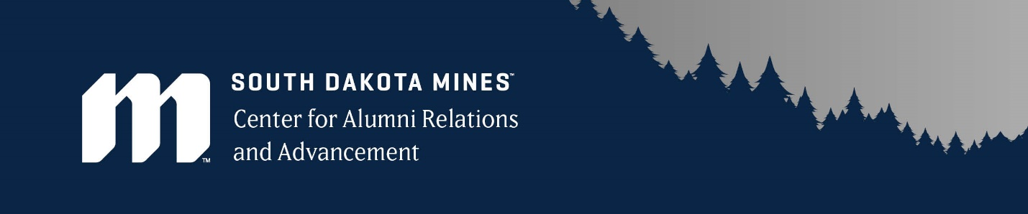

Congratulations on receiving a scholarship from South Dakota Mines!
Our donors appreciate hearing from you. You may not know this, but 100% of scholarship funding at South Dakota Mines comes from private donors. A short, professional note from you affirms the value and significance of their contributions and encourages their continued support. They are excited to support students like you and appreciate knowing their gift is making a difference in someone’s life.
Before you write your thank you letter, please take a minute to reflect on the fact that this scholarship is available because one of our alumni or friends of the university is willing to invest in your future.

There are a few guidelines that we ask you follow when writing your thank you letter to ensure you are representing your best self:
- Be prompt in submitting your letter. Aim for within 2 weeks of accepting your scholarship. Every scholarship awarded needs a thank you letter written.
- Letters must be typed as handwritten letters are too difficult to read.
- Use the spelling and grammar check and proofread for errors.
- Use the formatting guide on the following page (visit the Resources>Forms section of the Foundation’s website, cara.sdsmt.edu, for an extra copy). Letters without a professional header and physical signature will not be accepted.
- Send your signed thank you letter to SDSMT-FoundationScholarships@sdsmt.edu.
- Alternatively, you can also mail/drop off a signed copy to the SD Mines Center for Alumni Relations & Advancement @ 330 East Kansas City Street, Rapid City, SD 57701 for their delivery to the donor. Emailed copies are preferred.

If you have any questions about the process or if a photo is appropriate, please contact Kathleen Fitzgerald-Ellis at Kathleen Fitzgerald-Ellis@sdsmt.edu.
Please note that while submitting a thank you letter is a requirement to receiving your award, it has far more meaning. You play a crucial role in our stewardship process with our scholarship donors. Stewardship involves showing appreciation and being accountable to our alumni and friends. We appreciate you and hope you will partner with us in thanking them promptly, personally, and professionally.
Unless your donor is listed as the President of CARA, you are encouraged to maintain contact with the scholarship donor(s). Donor(s) are interested in you and want to know their commitment to Mines truly makes a difference. For example, sending a Christmas card and/or updates throughout the year would be great ways to accomplish this. If you wish to send a card or note, please bring it by the CARA office to forward to your scholarship donor. If you have established personal contact with your scholarship donor you may send directly.
[Type your name]
[Your Street Address]
[City, State, Zip]

[Name of Benefactor]
[Name of Scholarship]

Dear [Name of Benefactor],

[Body of Letter: 3-4 Paragraphs. Include the following information:
● Express your appreciation for the donor’s commitment to supporting
scholarships for South Dakota Mines students. Be sure to include the name of
the scholarship award in your letter.
● Share how this award enables you to further your college education.
● Tell the donors about:
- Yourself
- Your family
- Where you are from
- Why you chose to attend South Dakota Mines
- Include what year you are in school (Freshman, Sophomore, Junior or Senior) and your expected graduation year
- What you have been learning (or hope to learn if this is the initial award year) in the classroom and how you have been able to put that learning into practice outside the classroom.
- Your goals for the future
● Reiterate your appreciation for being the recipient of this particular
scholarship.]

Sincerely,
[Sign your name—physical signature via digitally signing on a tablet or print and sign]
[Type your name]
[Email and/or phone number: optional but encouraged]

