**Accommodate Faculty User Instructions**

South Dakota Mines

SD Mines has implemented a new accommodation management platform called Accommodate. Your Accommodate portal will house important information about your students’ accommodations. Please follow the step-by-step instructions below to access and navigate your Accommodate portal.

**Log-in to Accommodate here: https://sdsmt-accommodate.symplicity.com/ and select “Faculty”**

**After you log-in you will arrive in the “Home” section.**

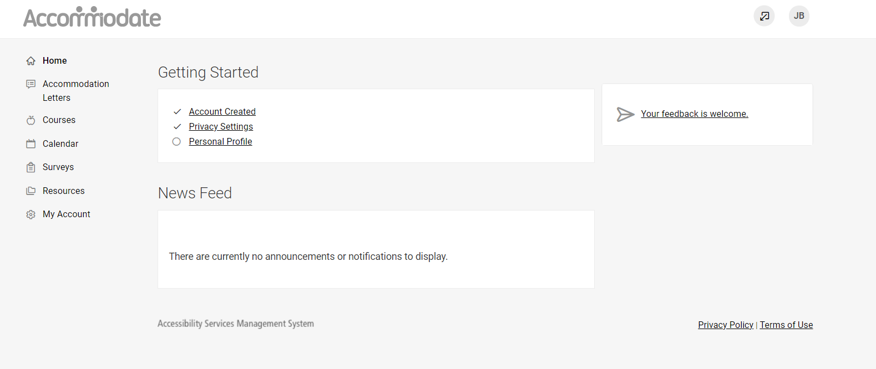

**To view a student’s accommodation letter, select “Accommodation Letters.” Select the letter that you wish to view. If your signature is requested, “Requested” will appear in a black rectangle next to the letter. Once a letter is signed, the text will indicate “signed.”**

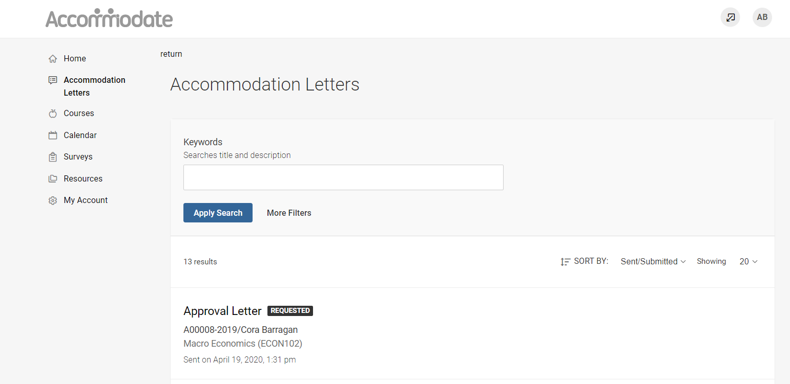

**Once the letter is open, you have the option to print or generate a PDF of the accommodation letter. If your signature is requested, please complete the form as indicated. To return to the full list, select “Return to List (Accommodation Letter)”**

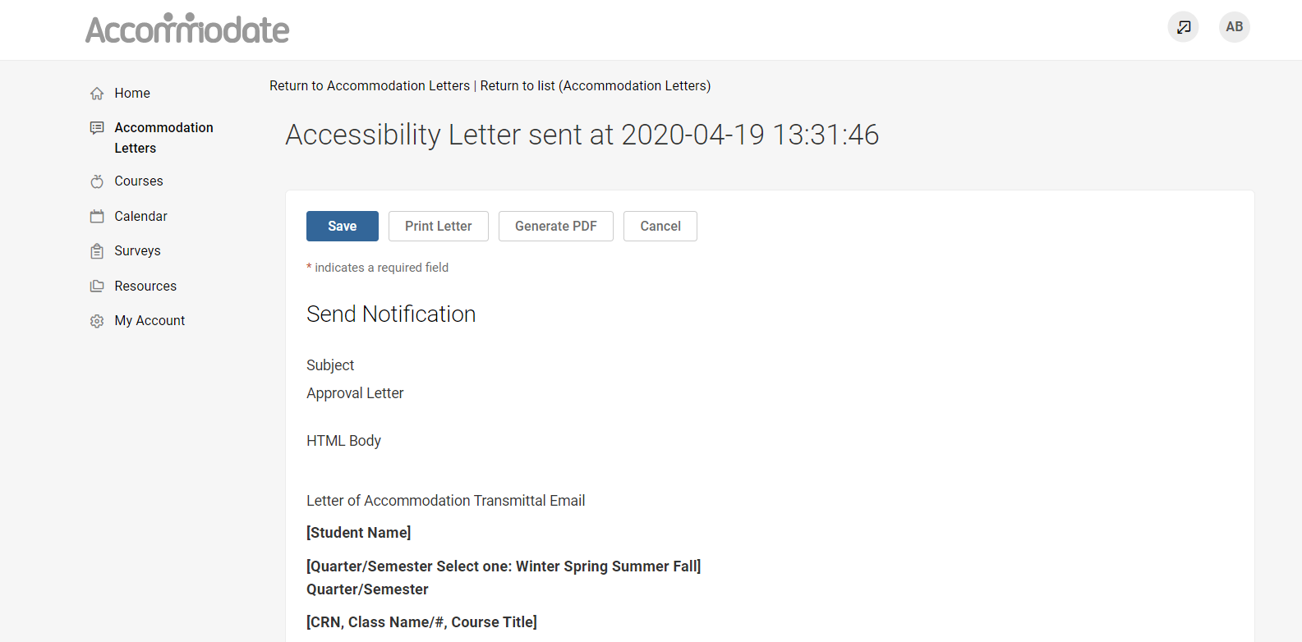

**To view a list of students enrolled in your course with accommodations, select “Courses.” Select the course you wish to view. Here you can view course details, enrolled students, room bookings, exams, or course notes.**

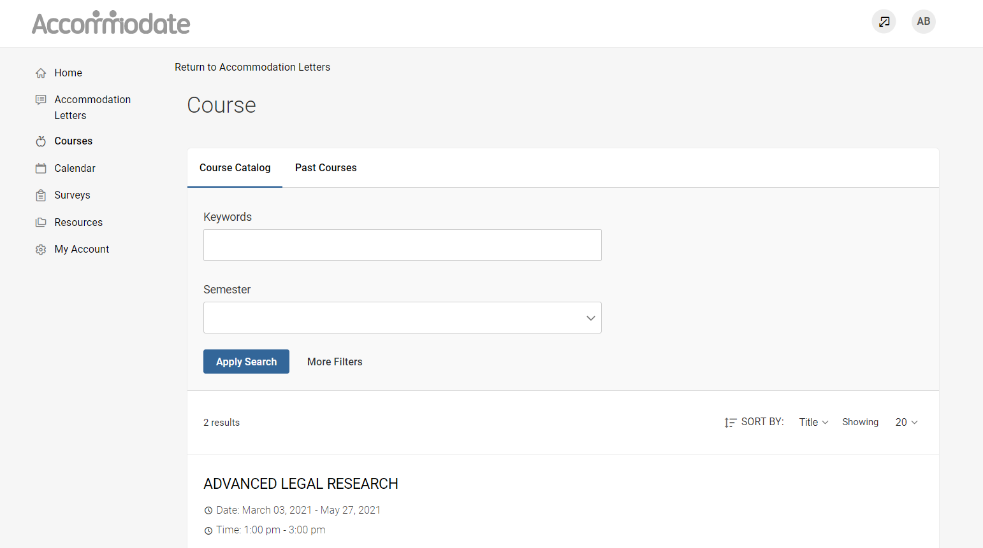

**To view enrolled students with accommodations, select “Enrolled Students” and then select “More Filters.” Select “Yes” Under Approved Accommodations for this Course to view only students who are approved for accommodations in this course.**

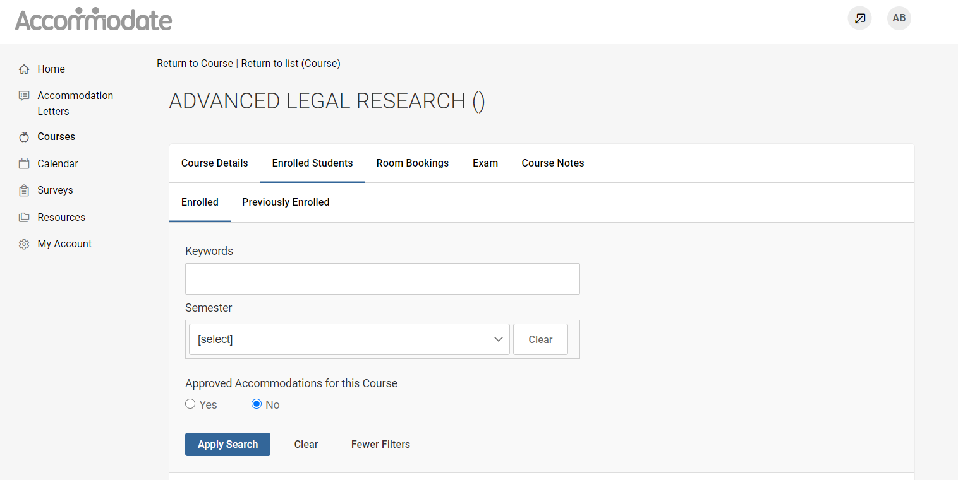

**To view Test Room Booking Requests, select “Room Bookings.” Select the Pending tab to approve requests (if Office is allowing faculty to approve requests) or select the Approved tab to view exams.**

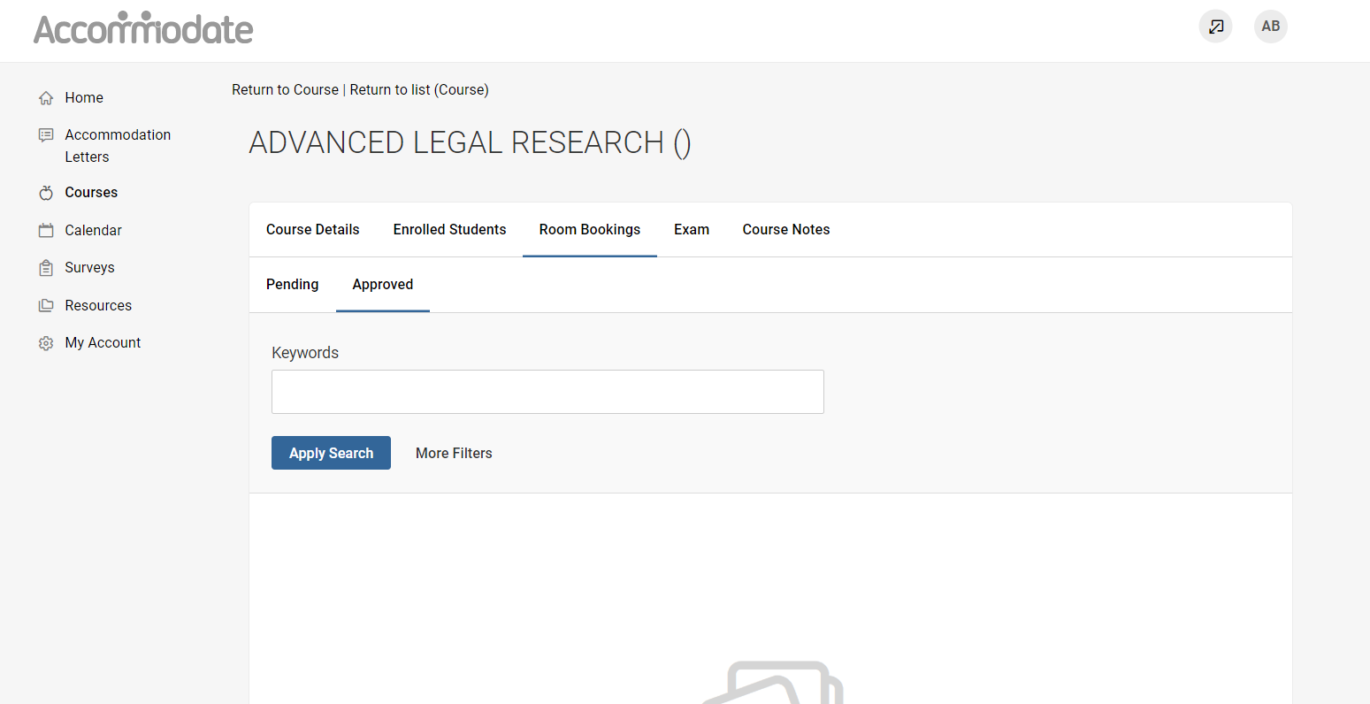

**To upload an exam for a test room booking request, select “Exam” > “Add New Exam”**

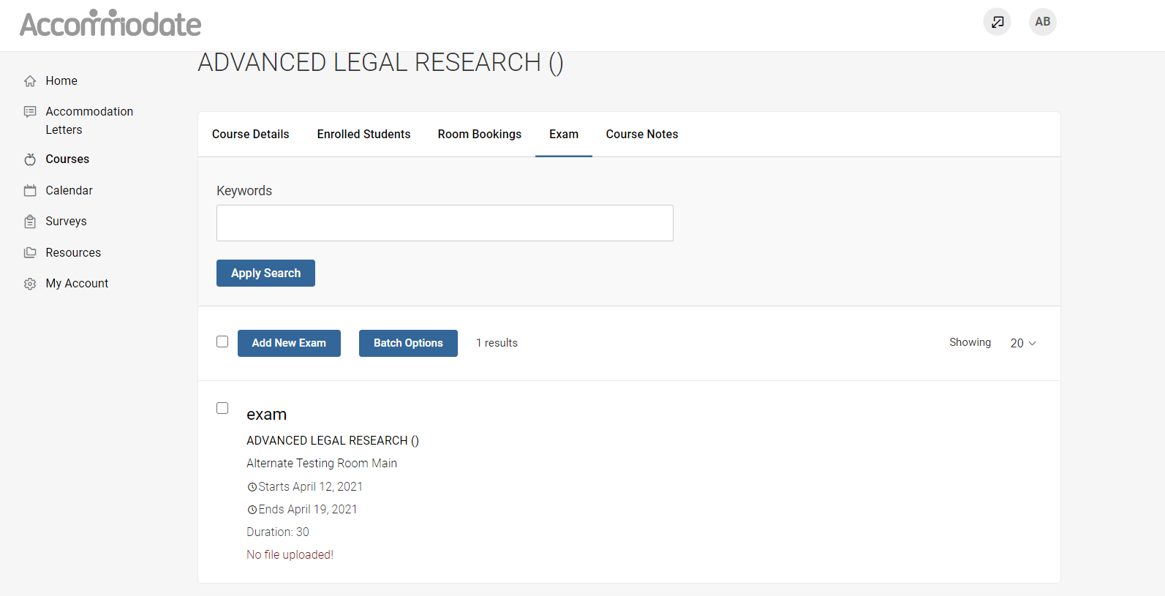

**To view notes that have been uploaded for your course or to add notes for your course, select “Notes” > “Add New”**

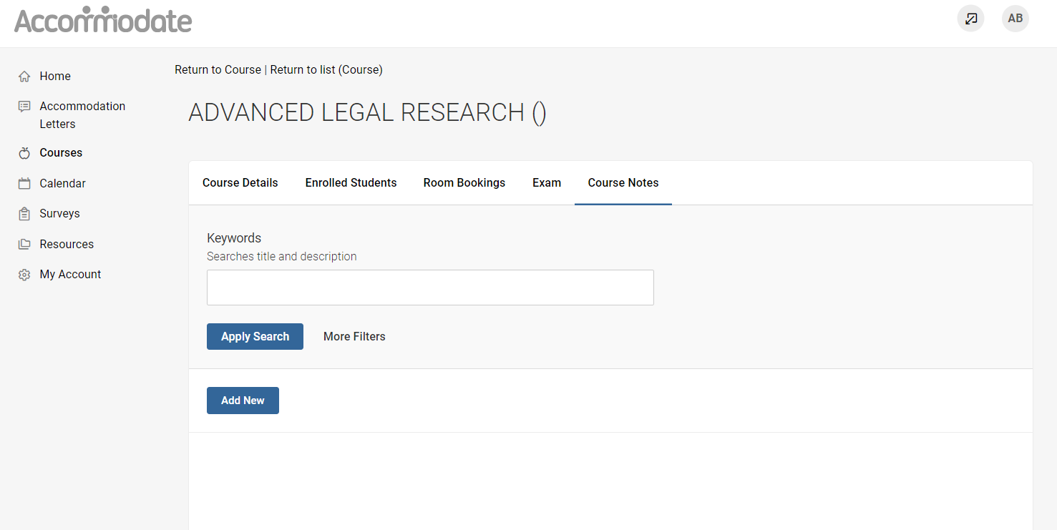

**To view resources uploaded by the Accessibility Service Office, select “Resources” > “Resource Library”**

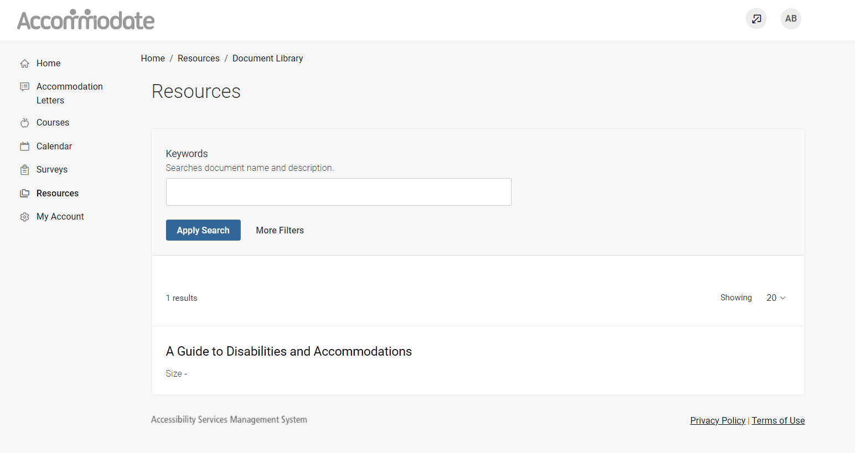

**By selecting “Personal Profile” on the homepage you can view and edit your account details**

