Accommodate Student User Instructions
South Dakota Mines

SD Mines has implemented a new accommodation management platform called Accommodate. Your Accommodate portal will house important information about your accommodations. Please follow the step-by-step instructions below to access and navigate your Accommodate portal.

To submit an initial request for accommodations, use this URL: https://sdsmt-accommodate.symplicity.com/public_accommodation/
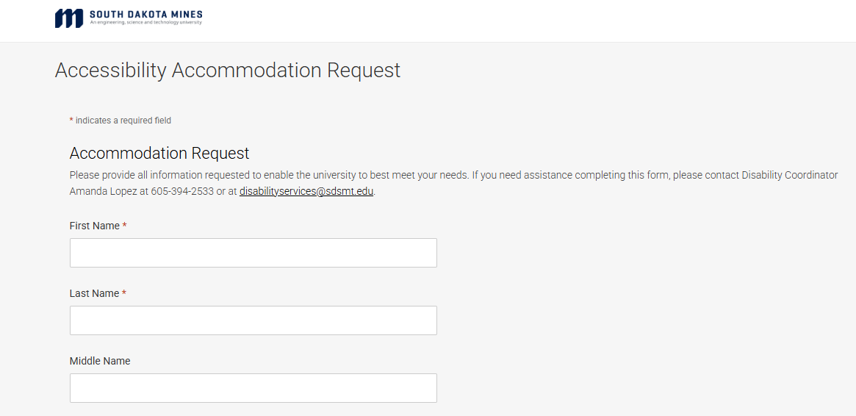

Log-in to Accommodate here: https://sdsmt-accommodate.symplicity.com/ and select “Student”

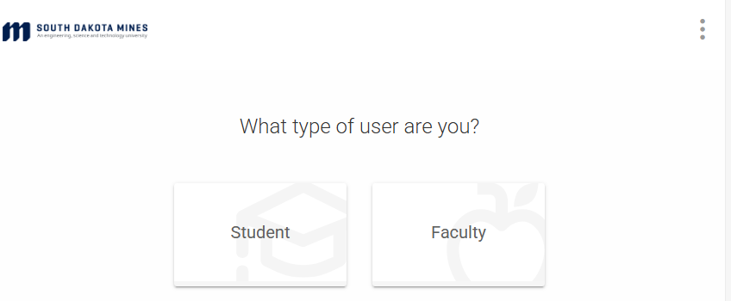

After you log-in you will arrive in the “Home” section.
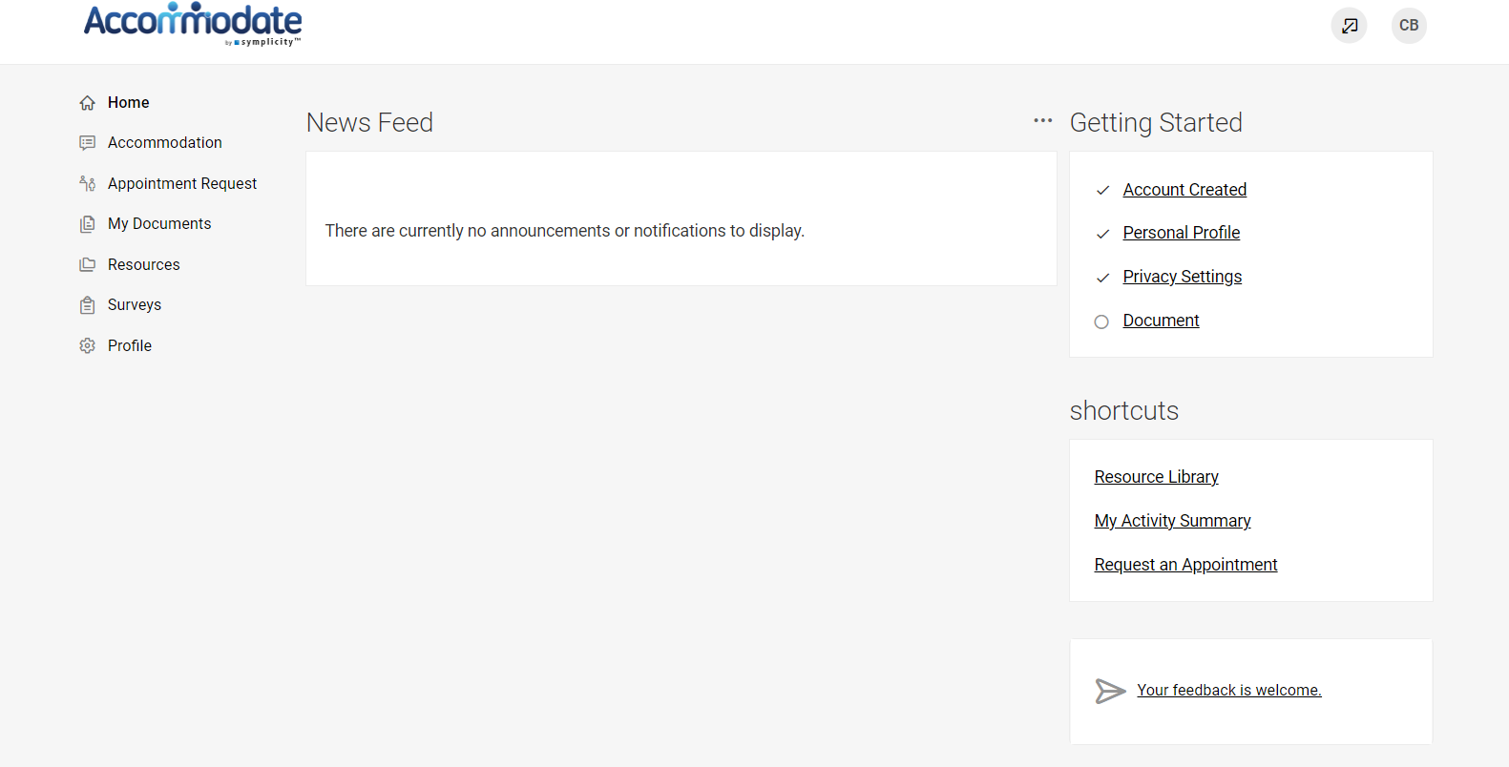

To view your original accessibility request, select “Accommodation” > “Accessibility Request”
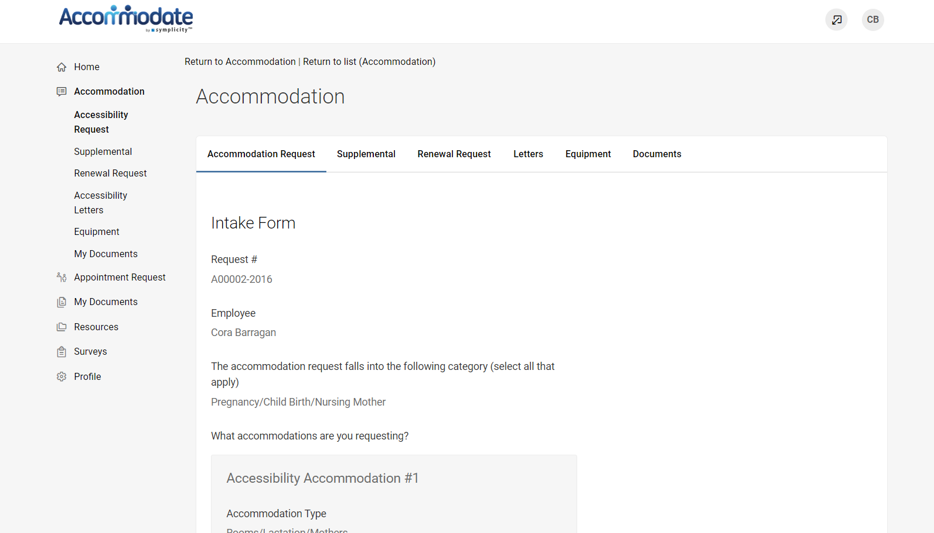

To view your accommodation letters, select “Accommodation” > “Accessibility Letters”
Once the letter is open, you have the option to print or generate a PDF of the accommodation letter. To return to the full list, select “Return to List (Accommodation Letter)”

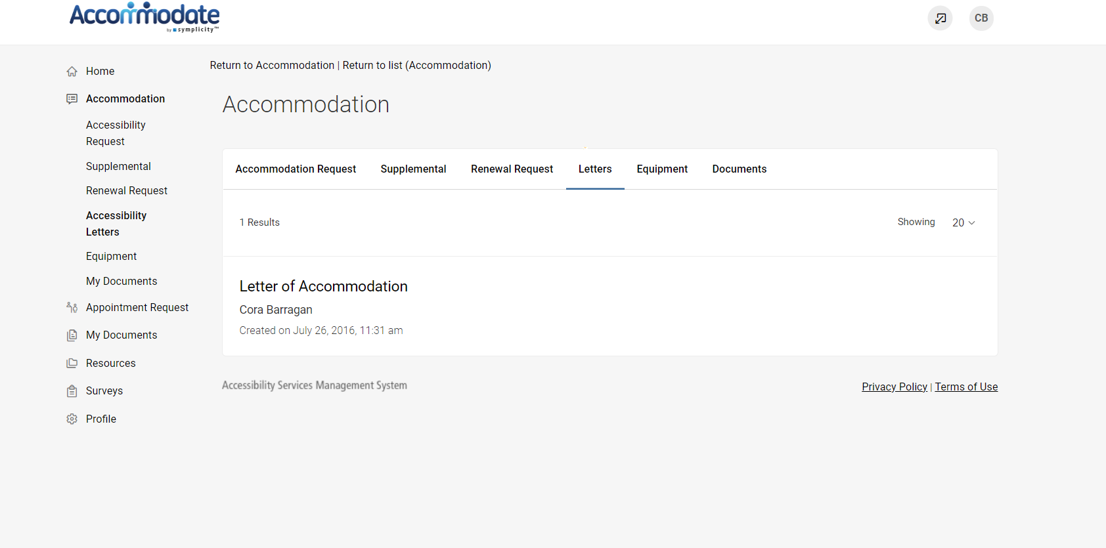

To submit a request for supplemental accommodations, select “Accommodation” > “Supplemental Request” > “Add New”

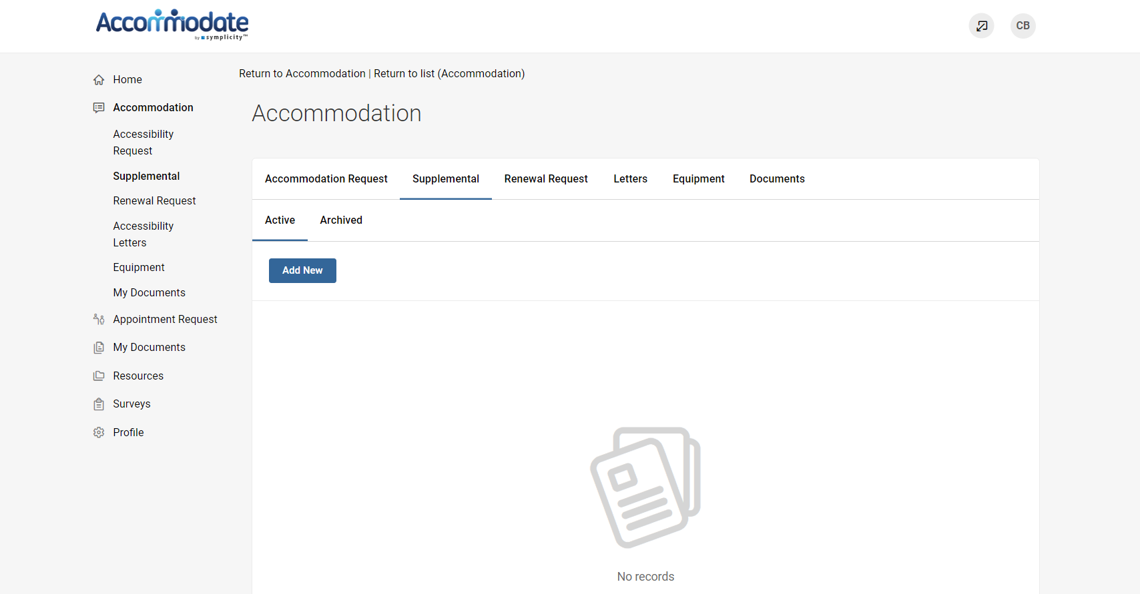

To renew your accommodations, select “Accommodation” > “Renewal Request” > “Add New”

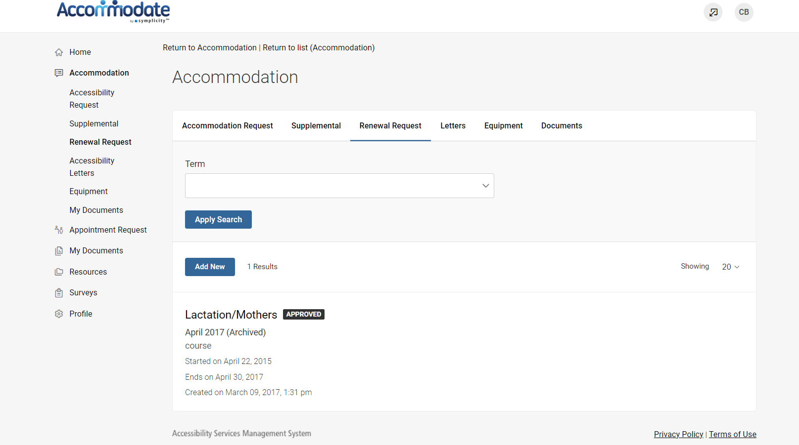

To request an appointment with an Accessibility Services staff member, select “Appointment Request” > “Request New Appointment”
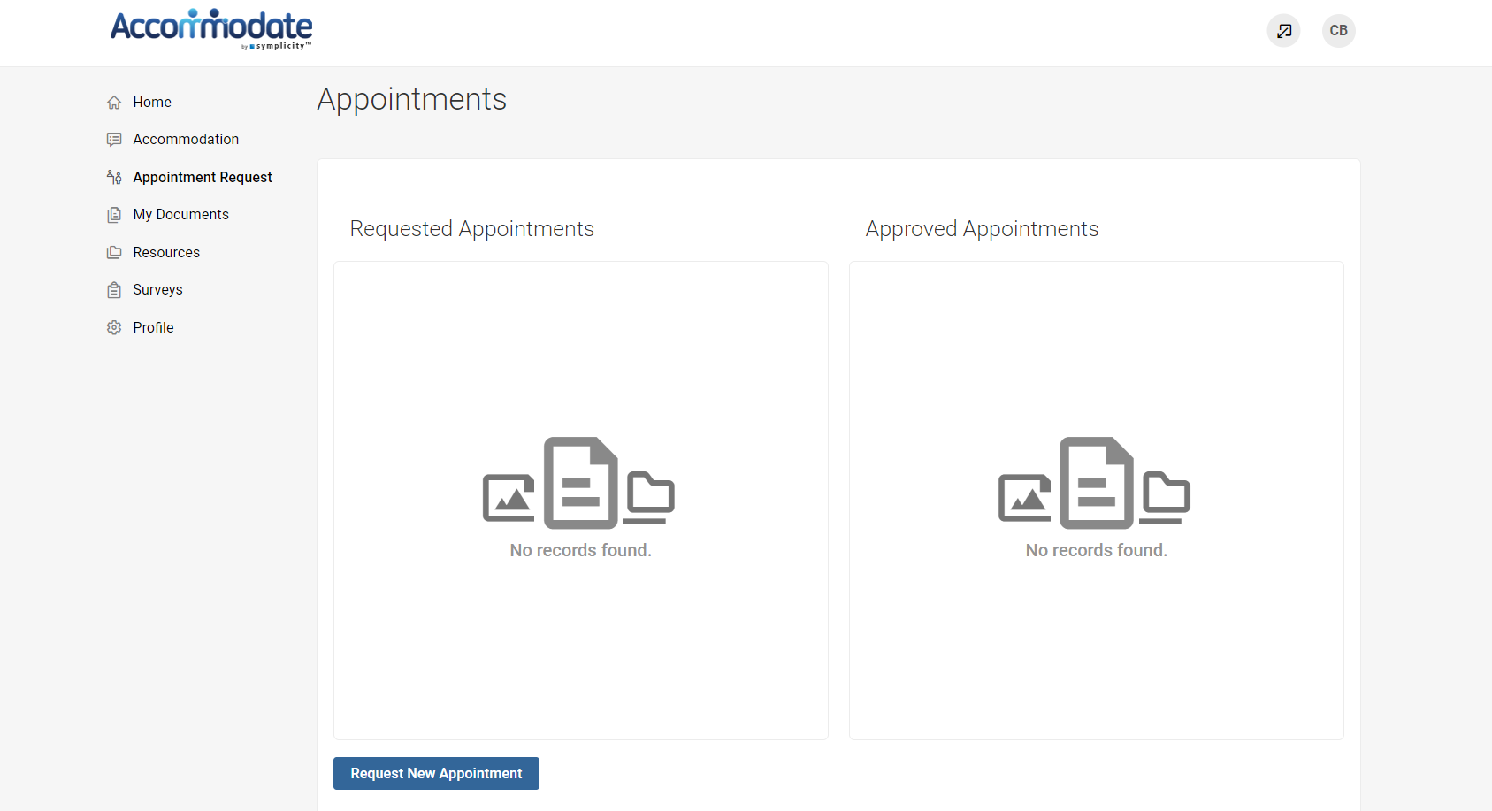

To upload a new document, select “My Documents” > “Add New”

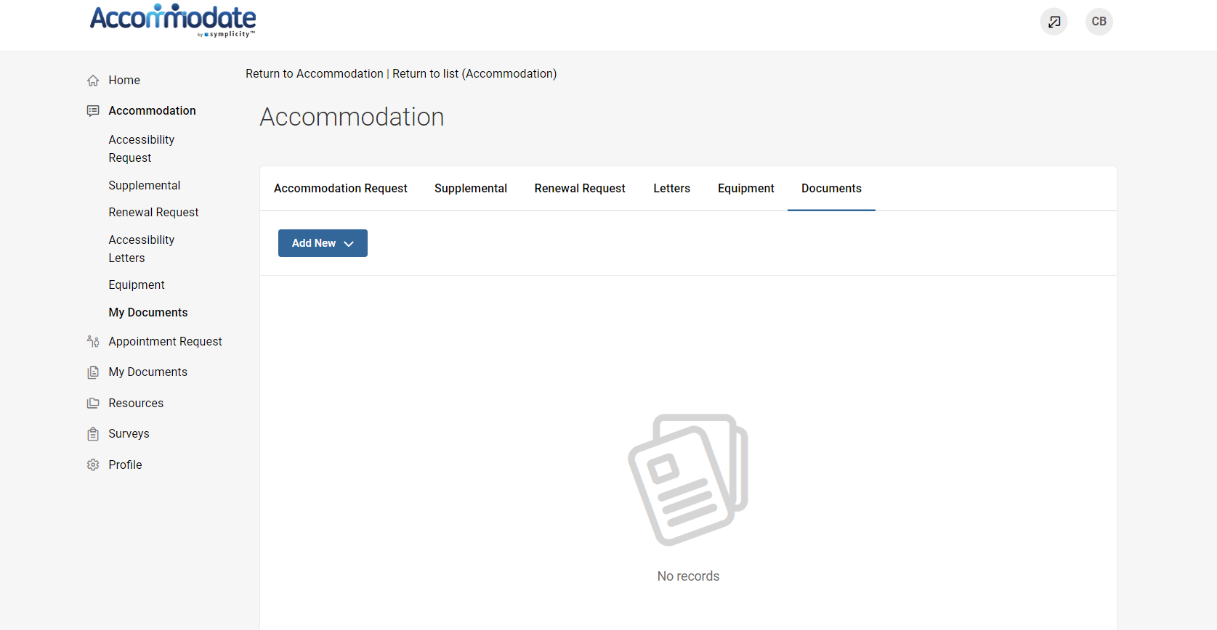

To view resources uploaded by Accessibility Services, select “Resources” > “Resource Library”

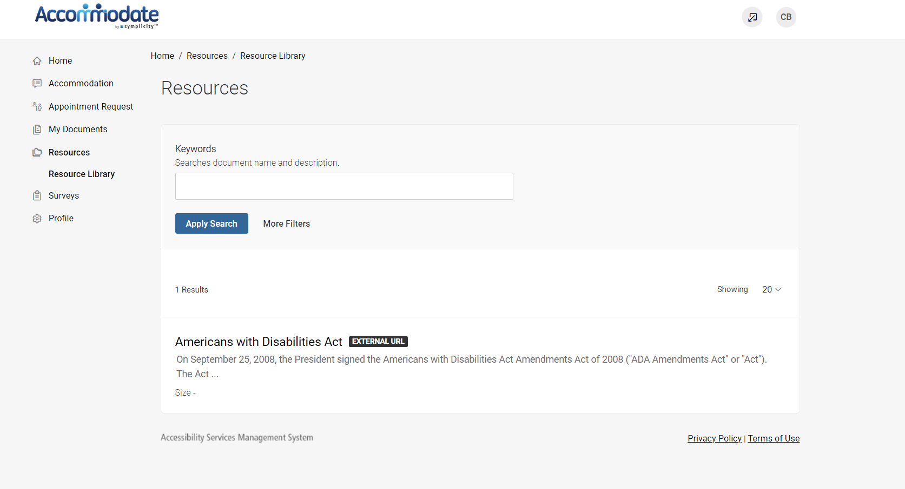

By selecting “Profile” on the homepage you can view and edit your account details

