

Docusign Envelope ID: E92000FD-2DDE-45EA-BA8C-DEEA0B0C03EC

# Northeast Community College logoAssociate to Bachelors (A2B) Articulation Agreement

**Prescribed Curriculum:** Northeast Community College

## Associate of Science – Chemistry

|  |  |  |  |  |
| --- | --- | --- | --- | --- |
| General Education Courses | | | | **33** CREDIT HOURS |
|  | **Credit Hours** | **Course No.** | **Course Title or Category** | |
| **Written Comm** | 3 | ENGL 1010, or  ENGL 2070 | English Composition I, or  Technical Communications I | |
| **Oral Communication** | 3 | SPCH 1010 or 1110 | Fundamentals of Communication or Public Speaking | |
| **Behavioral & Social Sciences** | 3 | Select 1 course from | AS General Education list *(except AGRI 1530)* | |
| **English/Literature** | 3 | Select 1 course from | AS General Education list *(except ENGL 1020)* | |
| **Fine Arts and**  **Language** | 3 | Select 1 course from | AS General Education list | |
| **Mathematics** | 10 | MATH 1600  MATH 2010 | Analytic Geometry and Calculus I Analytic Geometry and Calculus II | |
| **Natural Science** | 8 | CHEM 1090  CHEM 1100 | General Chemistry I  General Chemistry II | |

|  |  |  |  |
| --- | --- | --- | --- |
| Required Courses | |  | **21** CREDIT HOURS |
|  | **Credit Hours** | **Course No.** | **Course Title** |
| **Mathematics & Science** | 3 | MATH 2100 | Differential Equations |
| 5 | PHYS 2110 | General Physics I w/Calculus |
| 5 | PHYS 2120 | General Physics II w/Calculus |
| 4 | CHEM 2510 | Organic Chemistry I |
| 4 | CHEM 2520 | Organic Chemistry II |

|  |  |  |  |
| --- | --- | --- | --- |
| Program Elective Courses | |  | **6** CREDIT HOURS |
|  | **Credit Hours** | **Course No.** | **Course Title** |
| **Electives** | 3 | MATH 2170 | Applied Statistics, or any 3-credit course on the AA or AS General Education lists (except MATH) |
| 3 | ENGL 2080 | Technical Communications II |

|  |  |
| --- | --- |
| **Associate of Science – Chemistry Total:** | **60 CREDIT HOURS** |

**Post-Associate Degree Prescribed Curriculum:** South Dakota Mines

## Bachelor of Science – Chemistry

|  |  |  |  |  |
| --- | --- | --- | --- | --- |
| General Education Courses | | | | **3** CREDIT HOURS |
|  | **Credit Hours** | **Course No.** | **Course Title or Category** | |
| **Social Sciences** | 3 | Select 1 course from | CIV 100, HIST 151, HIS 152, POLS 100, or POLS 210 | |

|  |  |  |  |
| --- | --- | --- | --- |
| Major Required Courses | |  | **34** CREDIT HOURS |
|  | **Credit Hours** | **Course No.** | **Course Title** |
| **Chemistry** | 4 | CHEM 332/332L | Analytical Chemistry w/Lab |
| 2 | CHEM 328L | Organic Chemistry II Lab |
| 3 | CHEM 342 | Physical Chemistry I |
| 3 | CHEM 352 | Systematic Inorganic Chemistry |
| 3 | CHEM 482 | Environmental Chemistry |
| 5 | CHEM 344/344L | Physical Chemistry II w/Lab |
| 4 | CHEM 452/452L | Inorganic Chemistry w/Lab |
| 3 | CHEM 464 | Biochemistry I |
| 1 | CHEM 490 | Seminar |
| 1 | CHEM 370 | Chemical Literature |
| 5 | CHEM 434/434L | Instrumental Analysis w/Lab |

|  |  |  |  |
| --- | --- | --- | --- |
| Elective Courses | |  | **23** CREDIT HOURS |
|  | **Credit Hours** | **Course No.** | **Course Title** |
| **Program Electives** | 3 | Select with Advisor | From list of approved electives |
| **Free Electives** | 20 | Select with Advisor |  |

|  |  |
| --- | --- |
| **Post-Associate Degree Total:** | **60 CREDIT HOURS** |

|  |  |
| --- | --- |
| **Bachelor of Science – Chemistry Total:** | **120 CREDIT HOURS** |

**A2B Articulation Agreement Guarantees & Limitations**

### GUARANTEES

Students who:

1. complete the Associate of Science – Chemistry degree prescribed curriculum at Northeast Community College exactly as it is identified in this articulation agreement, **and**
2. have the degree conferred on their education record at Northeast Community College (post high school graduation)**, and**
3. earn a minimum cumulative grade point average (GPA) of 2.75 at the Northeast Community College, **and**
4. pass all 60 credits for the associate degree, earning a grade C- or higher in each course

are **guaranteed** the following at the South Dakota School of Mines and Technology (South Dakota Mines):

1. junior standing at South Dakota Mines with no more than 60 remaining credits to meet the graduation requirements for the Bachelor of Science degree in Chemistry.
2. admission to South Dakota Mines
3. admission to the Bachelor of Science degree in Chemistry.

### LIMITATIONS

1. This agreement is between the Associate of Science – Chemistry degree at Northeast Community College and the Bachelor of Science degree in Chemistry at South Dakota Mines only.
2. Students must meet all admission and application requirements at South Dakota Mines, including the submission of all required documentation by stated deadlines. Students are advised to contact the Office of Admissions at the South Dakota Mines early in their transfer planning.
3. Student must have a cumulative grade point average (GPA) at the Northeast Community College of 2.75 or higher

**and** only courses with grades of C- or higher are guaranteed to be accepted in transfer by South Dakota Mines.

1. The credit and course transfer guarantees described in this agreement apply to the Associate of Science – Chemistry degree at Northeast Community College and the Bachelor of Science degree in Chemistry at South Dakota Mines. If the student changes majors at Northeast Community College or at South Dakota Mines, the student is no longer covered by this Articulation Agreement and none of the Guarantees of the Agreement apply.
2. Students utilizing any form of transfer credit, including but not limited to credit awarded from other higher education institutions, standardized exam (CLEP, AP, DSST, etc.), prior learning assessment (military, certifications, ACE recommended credit, portfolio, challenge exam, work experience equivalent credit, etc.) to satisfy any Associate degree requirements will have those credits evaluated by South Dakota Mines. Should South Dakota Mines not accept the transfer credits accepted by Northeast Community College, the student will be required to make up the credit deficiency at South Dakota Mines.
3. No course substitutions are allowed for the courses listed in the Prescribed Curriculum for the associate degree at Northeast Community College.

### A2B CONTACT INFORMATION

South Dakota Mines Northeast Community College

Office of the Provost Registration Office

605.394.2256 402.844.7265

[Provost@sdsmt.edu](mailto:Provost@sdsmt.edu)

### RENEWAL, REVISION, and TERMINATION

1. This Associate to Bachelor Articulation Agreement (A2B) shall be in effect July 1 – June 30 each year and will automatically renew annually unless action is taken by South Dakota Mines or Northeast Community College to terminate or modify it.
2. The South Dakota Mines Office of the Provost and the Northeast Community College Academic Affairs division will collaborate to coordinate a review of the content of the associate and bachelor degrees on a three-year cycle to ensure this A2B is still appropriate.
3. South Dakota Mines and the Northeast Community College each reserve the right to seek revision of this agreement at any time.
4. Revision of any content of the agreement (except Appendices content) will be approved by each institution and result in a new agreement being signed, with copies retained by each institution.
   1. Revision to any Appendices will be communicated to each institution, but do not need to be approved by each institution and will not result in a new agreement being signed by each institution.
5. South Dakota Mines and the Northeast Community College each reserve the right to seek termination of this agreement at any time.
6. Should the agreement be terminated, each institution agrees to collaborate and engage in appropriate plans to notify and work with impacted students, providing a minimum one-year advance notice of termination.

### Leah Barrett signatureBrian Tande signatureAPPROVALS

|  |  |  |  |
| --- | --- | --- | --- |
|  | 8/4/2025 |  | 7/28/2025 |
| Brian Tande, Ph.D. President | Date | Leah Barrett, Ed.D. President | Date |
| South Dakota Mines |  | Northeast Community College |  |
| [Brian.Tande@sdsmt.edu](mailto:Brian.Tande@sdsmt.edu) |  | [lbarrett@northeast.edu](mailto:lbarrett@northeast.edu) |  |
|  | 8/4/2025 |  | 7/25/2025 |
| Lance Roberts, Ph.D. | Date | Charlene Widener, Ph.D. | Date |

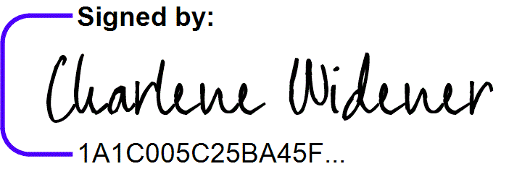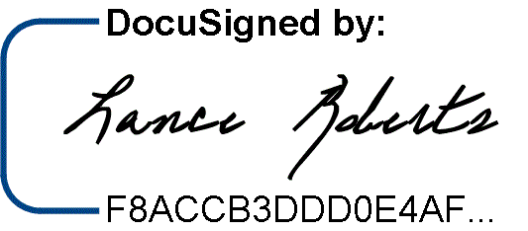Provost and Vice President for Academic Affairs Vice President of Educational Services South Dakota Mines Northeast Community College

[Lance.Roberts@sdsmt.edu](mailto:Lance.Roberts@sdsmt.edu) [cwidener@northeast.edu](mailto:cwidener@northeast.edu)

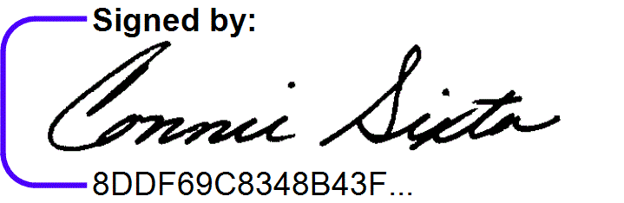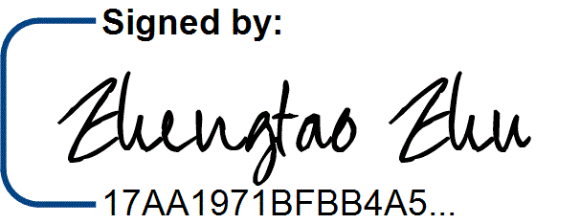8/4/2025 7/25/2025

Zhengtao Zhu, Ph.D. Date Connie Sixta Date Department Head Dean of Science, Technology, Agriculture & Math

South Dakota Mines Northeast Community College

[Zhengtao.Zhu@sdsmt.edu](mailto:Zhengtao.Zhu@sdsmt.edu) [connie@northeast.edu](mailto:connie@northeast.edu)

## Appendix A: Course Sequence

**Course Sequence:** Northeast Community College

## Chemistry (A.S.)

|  |  |  |  |  |
| --- | --- | --- | --- | --- |
| **Semester** | **Course No.** | **Course Title** | **Credit Hours** | **Completed** |
| Freshman | ENGL 1010 | English Composition I, or ENGL 2070 Tech Comm I | 3 |  |
| Year |
| MATH 1600 | Analytic Geometry and Calculus I | 5 |  |
| First |
| CHEM 1090 | General Chemistry I | 4 |  |
| Semester |
| Select 1 course from | General Education: Behavioral/Social Sci (Except AGRI 1530) | 3 |  |
|  |  |  |  |  |
|  |  | ***Total Credits*** | ***15*** |  |

|  |  |  |  |  |
| --- | --- | --- | --- | --- |
| **Semester** | **Course No.** | **Course Title** | **Credit Hours** | **Completed** |
| Freshman | Select 1 course from | General Education: English/Literature (Except ENGL 1020) | 3 |  |
| Year |
| CHEM 1100 | General Chemistry II | 4 |  |
| Second |
| MATH 2010 | Analytic Geometry and Calculus II | 5 |  |
| Semester |
| PHYS 2110 | General Physics I with Calculus | 5 |  |
|  |  |  |  |  |
|  |  |  |  |  |
|  |  | ***Total Credits*** | ***17*** |  |

|  |  |  |  |  |
| --- | --- | --- | --- | --- |
| **Semester** | **Course No.** | **Course Title** | **Credit Hours** | **Completed** |
| Sophomore | Select 1 course from | SPCH 1010 Fund of Comm or SPCH 1110 Public Speaking | 3 |  |
| Year |
| PHYS 2120 | General Physics II with Calculus | 5 |  |
| First |
| MATH 2100 | Ordinary Differential Equations | 3 |  |
| Semester |
| CHEM 2510 | Organic Chemistry I | 4 |  |
|  |  |  |  |  |
|  |  |  |  |  |
|  |  |  |  |  |
|  |  | ***Total Credits*** | ***15*** |  |

|  |  |  |  |  |
| --- | --- | --- | --- | --- |
| **Semester** | **Course No.** | **Course Title** | **Credit Hours** | **Completed** |
| Sophomore | Select 1 course from | General Education: Fine Arts and Language | 3 |  |
| Year |
| CHEM 2520 | Organic Chemistry II | 4 |  |
| Second  Semester |
| MATH 2170 | Applied Statistics, or any 3-credit course on the AA or AS  General Education lists (except MATH) | 3 |  |
|  | ENGL 2080 | Technical Communication II | 3 |  |
|  |  |  |  |  |
|  |  |  |  |  |
|  |  | ***Total Credits*** | ***13*** |  |

|  |  |
| --- | --- |
| **General Education Coursework Total:**  **Major and Elective Coursework Total:**  **Northeast Community College Coursework Total:** | **33 credit hours**  **27 credit hours**  **60 CREDIT HOURS** |



Docusign Envelope ID: E92000FD-2DDE-45EA-BA8C-DEEA0B0C03EC

**Course Sequence:** South Dakota Mines – Fall Semester Start

**Chemistry (B.S.) – Even year start**

|  |  |  |  |  |
| --- | --- | --- | --- | --- |
| **Semester** | **Course No.** | **Course Title** | **Credit Hours** | **Completed** |
| Junior Year First Semester  - FALL | CHEM 332/332L | Analytical Chemistry w/Lab | 4 |  |
| CHEM 342 | Physical Chemistry I | 3 |  |
| CHEM 352 | Systematic Inorganic Chemistry | 3 |  |
| CHEM 482 | Environmental Chemistry | 3 |  |
|  | Free Electives | 3 |  |
|  |  |  |  |
| ***Total Credits 16*** | | | |  |

|  |  |  |  |  |
| --- | --- | --- | --- | --- |
| **Semester** | **Course No.** | **Course Title** | **Credit Hours** | **Completed** |
| Junior Year | CHEM 344/344L | Physical Chemistry II w/Lab | 5 |  |
| Second |
| CHEM 452/452L | Inorganic Chemistry w/ Lab | 4 |  |
| Semester - |
| CHEM 328L | Organic Chemistry II Lab | 2 |  |
| SPRING |
| Select 1 course from | Social Science (Goal 3) - Civics CIV 100, HIST 151, HIS 152, | 3* |  |
|  | POLS 100, or POLS 210 |
|  |  |  |  |  |
|  |  | ***Total Credits*** | ***14*** |  |

|  |  |  |  |  |
| --- | --- | --- | --- | --- |
| **Semester** | **Course No.** | **Course Title** | **Credit Hours** | **Completed** |
| Senior Year First Semester  - FALL | CHEM 464 | Biochemistry | 3 |  |
| Select 1 course from | Program Electives: CHEM 420, 421, 426, 462, or 465 | 3 |  |
|  | Free Electives | 9 |  |
|  |  |  |  |
|  |  |  |  |
| ***Total Credits 15*** | | | |  |

|  |  |  |  |  |
| --- | --- | --- | --- | --- |
| **Semester** | **Course No.** | **Course Title** | **Credit Hours** | **Completed** |
| Senior Year | CHEM 370 | Chemical Literature | 1 |  |
| Second |
| CHEM 434/434L | Instrumental Analysis w/Lab | 5 |  |
| Semester - |
| CHEM 490 | Seminar | 1 |  |
| SPRING |
|  | Free Electives | 8 |  |
|  |  |  |  |  |
|  |  |  |  |  |
|  |  | ***Total Credits*** | ***15*** |  |

|  |  |
| --- | --- |
| General Education Coursework Total:  Major and Elective Coursework Total:  **South Dakota Mines Coursework Total:** | 3 credit hours  57 credit hours  **60 CREDIT HOURS** |



Docusign Envelope ID: E92000FD-2DDE-45EA-BA8C-DEEA0B0C03EC

**Course Sequence:** South Dakota Mines – Fall Semester Start

**Chemistry (B.S.) – Odd year start**

|  |  |  |  |  |
| --- | --- | --- | --- | --- |
| **Semester** | **Course No.** | **Course Title** | **Credit Hours** | **Completed** |
| Junior Year First Semester  - FALL | CHEM 464 | Biochemistry | 3 |  |
| CHEM 332/332L | Analytical Chemistry w/Lab | 4 |  |
| CHEM 342 | Physical Chemistry I | 3 |  |
|  | Free Electives | 3 |  |
| Select 1 course from | Social Science (Goal 3) - Civics CIV 100, HIST 151, HIS 152,  POLS 100, or POLS 210 | 3* |  |
|  |  |  |  |
|  |  |  |  |
| ***Total Credits 16*** | | | |  |

|  |  |  |  |  |
| --- | --- | --- | --- | --- |
| **Semester** | **Course No.** | **Course Title** | **Credit Hours** | **Completed** |
| Junior Year | CHEM 434/434L | Instrumental Analysis w/Lab | 5 |  |
| Second |
| CHEM 328L | Organic Chemistry II Lab | 2 |  |
| Semester - |
| CHEM 370 | Chemical Literature | 1 |  |
| SPRING |
| CHEM 344/344L | Physical Chemistry II w/Lab | 5 |  |
|  |  | Free Electives | 3 |  |
|  |  |  |  |  |
|  |  | ***Total Credits*** | ***16*** |  |

|  |  |  |  |  |
| --- | --- | --- | --- | --- |
| **Semester** | **Course No.** | **Course Title** | **Credit Hours** | **Completed** |
| Senior Year First Semester  - FALL | Select 1 course from | Program Electives: CHEM 420, 421, 426, 462, or 465 | 3 |  |
| CHEM 482 | Environmental Chemistry | 3 |  |
| CHEM 352 | Systematic Inorganic Chemistry | 3 |  |
|  | Free Electives | 6 |  |
|  |  |  |  |
| ***Total Credits 15*** | | | |  |

|  |  |  |  |  |
| --- | --- | --- | --- | --- |
| **Semester** | **Course No.** | **Course Title** | **Credit Hours** | **Completed** |
| Senior Year | CHEM 452/452L | Inorganic Chemistry w/ Lab | 4 |  |
| Second |
| CHEM 490 | Seminar | 1 |  |
| Semester - |
|  | Free Electives | 8 |  |
| SPRING |
|  |  |  |  |  |
|  |  |  |  |  |
|  |  | ***Total Credits*** | ***13*** |  |

|  |  |
| --- | --- |
|  |  |
| General Education Coursework Total:  Major and Elective Coursework Total:  **South Dakota Mines Coursework Total:** | 3 credit hours  57 credit hours  **60 CREDIT HOURS** |