

Docusign Envelope ID: 3E4D196C-ADA1-482F-B3A1-8FEC1F163357

# Northeast Community College logoAssociate to Bachelors (A2B) Articulation Agreement

**Prescribed Curriculum:** Northeast Community College

## Associate of Science – Mathematics

|  |  |  |  |  |
| --- | --- | --- | --- | --- |
| General Education Courses | | | | **33** CREDIT HOURS |
|  | **Credit Hours** | **Course No.** | **Course Title or Category** | |
| **Written Comm** | 3 | ENGL 1010 | English Composition I | |
| **Oral Communication** | 3 | SPCH 1010 or 1110 | Fundamentals of Communication or Public Speaking | |
| **Behavioral & Social Sciences** | 3 | Select 1 course from | AS General Education list *(except AGRI 1530)* | |
| **English/Literature** | 3 | Select 1 course from | AS General Education list *(except ENGL 1020)* | |
| **Fine Arts and Language** | 3 | Select 1 course from | AS General Education list | |
| **Mathematics** | 10 | MATH 1600  MATH 2010 | Analytic Geometry and Calculus I  Analytic Geometry and Calculus II | |
| **Natural Science** | 8 | CHEM 1090  CHEM 1100 | General Chemistry I  General Chemistry II | |

|  |  |  |  |
| --- | --- | --- | --- |
| Required Courses | |  | **21** CREDIT HOURS |
|  | **Credit Hours** | **Course No.** | **Course Title** |
| **Mathematics & Science** | 3 | MATH 2100 | Differential Equations |
| 3 | MATH 2170 | Applied Statistics |
| 5 | MATH 2020 | Analytic Geometry and Calculus III |
| 5 | PHYS 2110 | General Physics I w/Calculus |
| 5 | PHYS 2120 | General Physics II w/Calculus |

|  |  |  |  |
| --- | --- | --- | --- |
| Program Elective Courses | |  | **6** CREDIT HOURS |
|  | **Credit Hours** | **Course No.** | **Course Title** |
| **Electives** | 3 | ENGR 1020 | Programming and Problem Solving |
| 3 | ENGL 1020 | English Composition II |

|  |  |
| --- | --- |
| **Associate of Science – Mathematics Total:** | **60 CREDIT HOURS** |

**Post-Associate Degree Prescribed Curriculum:** South Dakota Mines

## Bachelor of Science – Mathematics

|  |  |  |  |  |
| --- | --- | --- | --- | --- |
| General Education Courses | | | | **3** CREDIT HOURS |
|  | **Credit Hours** | **Course No.** | **Course Title or Category** | |
| **Social Sciences** | 3 | Select 1 course from | CIV 100, HIST 151, HIS 152, POLS 100, or POLS 210 | |

|  |  |  |  |
| --- | --- | --- | --- |
| Major Required Courses | |  | **28** CREDIT HOURS |
|  | **Credit Hours** | **Course No.** | **Course Title** |
| **Mathematics and Computer Science** | 3 | CSC 115 | Test-Driven Software Development |
| 4 | CSC 215 | Programming Techniques |
| 3 | MATH 251 | Finite Structures |
| 3 | MATH 315 | Linear Algebra |
| 3 | MATH 373 | Introduction to Numerical Analysis |
| 3 | MATH 381 | Introduction to Probability & Statistics |
| 4 | MATH 423 | Advanced Calculus I |
| 1 | MATH 498 | Research |
| 1 | MATH 402 | Communicating Mathematics |
| 3 | MATH 413 | Abstract Algebra I |

|  |  |  |  |
| --- | --- | --- | --- |
| Elective Courses | |  | **29** CREDIT HOURS |
|  | **Credit Hours** | **Course No.** | **Course Title** |
| **Sequence Electives** | 3 | Select with Advisor | From list of approved MATH sequence electives |
| **Upper-Level Elec** | 3 | Select with Advisor | From list of approved MATH upper-level electives |
| **Department Appr** | 6 | Select with Advisor | From list of department approved electives |
| **Free Electives** | 17 | Select with Advisor |  |

|  |  |
| --- | --- |
| **Post-Associate Degree Total:** | **60 CREDIT HOURS** |

|  |  |
| --- | --- |
| **Bachelor of Science - Mathematics Total:** | **120 CREDIT HOURS** |

**A2B Articulation Agreement Guarantees & Limitations**

### GUARANTEES

Students who:

1. complete the Associate of Science – Mathematics degree prescribed curriculum at Northeast Community College exactly as it is identified in this articulation agreement, **and**
2. have the degree conferred on their education record at Northeast Community College (post high school graduation)**, and**
3. earn a minimum cumulative grade point average (GPA) of 2.75 at the Northeast Community College, **and**
4. pass all 60 credits for the associate degree, earning a grade C- or higher in each course

are **guaranteed** the following at the South Dakota School of Mines and Technology (South Dakota Mines):

1. junior standing at South Dakota Mines with no more than 60 remaining credits to meet the graduation requirements for the Bachelor of Science degree in Mathematics.
2. admission to South Dakota Mines
3. admission to the Bachelor of Science degree in Mathematics.

### LIMITATIONS

1. This agreement is between the Associate of Science – Mathematics degree at Northeast Community College and the Bachelor of Science degree in Mathematics at South Dakota Mines only.
2. Students must meet all admission and application requirements at South Dakota Mines, including the submission of all required documentation by stated deadlines. Students are advised to contact the Office of Admissions at the South Dakota Mines early in their transfer planning.
3. Student must have a cumulative grade point average (GPA) at the Northeast Community College of 2.75 or higher

**and** only courses with grades of C- or higher are guaranteed to be accepted in transfer by South Dakota Mines.

1. The credit and course transfer guarantees described in this agreement apply to the Associate of Science – Mathematics degree at Northeast Community College and the Bachelor of Science degree in Mathematics at South Dakota Mines. If the student changes majors at Northeast Community College or at South Dakota Mines, the student is no longer covered by this Articulation Agreement and none of the Guarantees of the Agreement apply.
2. Students utilizing any form of transfer credit, including but not limited to credit awarded from other higher education institutions, standardized exam (CLEP, AP, DSST, etc.), prior learning assessment (military, certifications, ACE recommended credit, portfolio, challenge exam, work experience equivalent credit, etc.) to satisfy any Associate degree requirements will have those credits evaluated by South Dakota Mines. Should South Dakota Mines not accept the transfer credits accepted by Northeast Community College, the student will be required to make up the credit deficiency at South Dakota Mines.
3. No course substitutions are allowed for the courses listed in the Prescribed Curriculum for the associate degree at Northeast Community College.

### A2B CONTACT INFORMATION

South Dakota Mines Northeast Community College

Office of the Provost Registration Office

605.394.2256 402.844.7265

[Provost@sdsmt.edu](mailto:Provost@sdsmt.edu)

### RENEWAL, REVISION, and TERMINATION

1. This Associate to Bachelor Articulation Agreement (A2B) shall be in effect July 1 – June 30 each year and will automatically renew annually unless action is taken by South Dakota Mines or Northeast Community College to terminate or modify it.
2. The South Dakota Mines Office of the Provost and the Northeast Community College Academic Affairs division will collaborate to coordinate a review of the content of the associate and bachelor degrees on a three-year cycle to ensure this A2B is still appropriate.
3. South Dakota Mines and the Northeast Community College each reserve the right to seek revision of this agreement at any time.
4. Revision of any content of the agreement (except Appendices content) will be approved by each institution and result in a new agreement being signed, with copies retained by each institution.
   1. Revision to any Appendices will be communicated to each institution, but do not need to be approved by each institution and will not result in a new agreement being signed by each institution.
5. South Dakota Mines and the Northeast Community College each reserve the right to seek termination of this agreement at any time.
6. Should the agreement be terminated, each institution agrees to collaborate and engage in appropriate plans to notify and work with impacted students, providing a minimum one-year advance notice of termination.

### APPROVALS

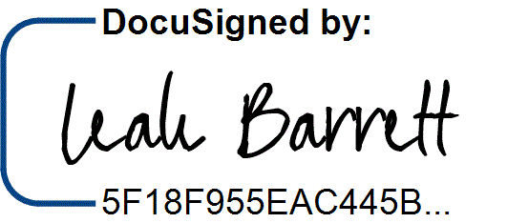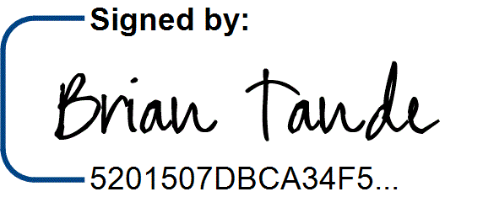7/29/2025 7/28/2025

Brian Tande, Ph.D. Date Leah Barrett, Ed.D. Date President President

South Dakota Mines Northeast Community College

[Brian.Tande@sdsmt.edu](mailto:Brian.Tande@sdsmt.edu) [lbarrett@northeast.edu](mailto:lbarrett@northeast.edu)

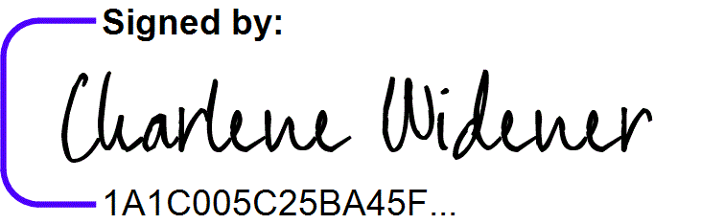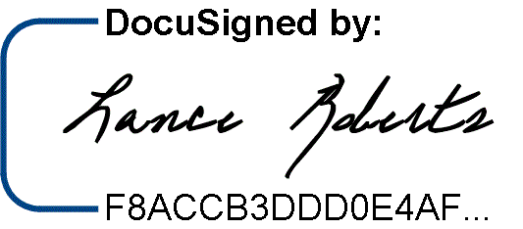7/29/2025 7/25/2025

Lance Roberts, Ph.D. Date Charlene Widener, Ph.D. Date Provost and Vice President for Academic Affairs Vice President of Educational Services

South Dakota Mines Northeast Community College

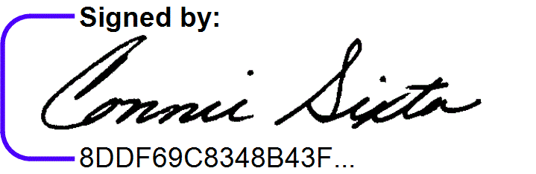[Lance.Roberts@sdsmt.edu](mailto:Lance.Roberts@sdsmt.edu) [cwidener@northeast.edu](mailto:cwidener@northeast.edu)

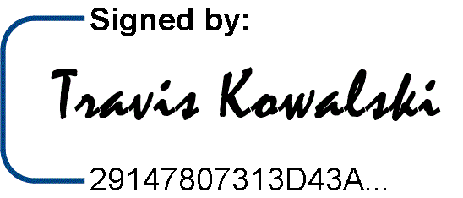7/28/2025

7/25/2025

Travis Kowalski, Ph.D. Date Connie Sixta Date Department Head Dean of Science, Technology, Agriculture & Math

South Dakota Mines Northeast Community College

[Travis.Kowalski@sdsmt.edu](mailto:Travis.Kowalski@sdsmt.edu) [connie@northeast.edu](mailto:connie@northeast.edu)

## Appendix A: Course Sequence

**Course Sequence:** Northeast Community College

## Mathematics (A.S.)

|  |  |  |  |  |
| --- | --- | --- | --- | --- |
| **Semester** | **Course No.** | **Course Title** | **Credit Hours** | **Completed** |
| Freshman | ENGL 1010 | English Composition I (or ENGL 2070 Tech Comm I) | 3 |  |
| Year |
| MATH 1600 | Analytic Geometry and Calculus I | 5 |  |
| First |
| CHEM 1090 | General Chemistry I | 4 |  |
| Semester |
| Select 1 course from | General Education: Fine Arts and Language | 3 |  |
|  |  |  |  |  |
|  |  | ***Total Credits*** | ***15*** |  |

|  |  |  |  |  |
| --- | --- | --- | --- | --- |
| **Semester** | **Course No.** | **Course Title** | **Credit Hours** | **Completed** |
| Freshman | Select 1 course from | General Education: English/Literature (Except ENGL 1020) | 3 |  |
| Year |
| CHEM 1100 | General Chemistry II | 4 |  |
| Second |
| MATH 2010 | Analytic Geometry and Calculus II | 5 |  |
| Semester |
| PHYS 2110 | General Physics I with Calculus | 5 |  |
|  |  |  |  |  |
|  |  |  |  |  |
|  |  | ***Total Credits*** | ***17*** |  |

|  |  |  |  |  |
| --- | --- | --- | --- | --- |
| **Semester** | **Course No.** | **Course Title** | **Credit Hours** | **Completed** |
| Sophomore | MATH 2100 | Ordinary Differential Equations | 3 |  |
| Year |
| Select 1 course from | General Education: Behavioral/Social Sci (Except AGRI 1530) | 3 |  |
| First |
| Select 1 course from | SPCH 1010 Fund of Comm or SPCH 1110 Public Speaking | 3 |  |
| Semester |
| PHYS 2120 | General Physics II with Calculus | 5 |  |
|  |  |  |  |  |
|  |  |  |  |  |
|  |  |  |  |  |
|  |  | ***Total Credits*** | ***14*** |  |

|  |  |  |  |  |
| --- | --- | --- | --- | --- |
| **Semester** | **Course No.** | **Course Title** | **Credit Hours** | **Completed** |
| Sophomore | MATH 2020 | Analytic Geometry and Calculus III | 5 |  |
| Year |
| MATH 2170 | Applied Statistics | 3 |  |
| Second |
| ENGL 1020 | English Composition II | 3 |  |
| Semester |
| ENGR 1020 | Programming & Problem Solving | 3 |  |
|  |  |  |  |  |
|  |  |  |  |  |
|  |  | ***Total Credits*** | ***14*** |  |

|  |  |
| --- | --- |
| General Education Coursework Total:  Major and Elective Coursework Total:  **Northeast Community College Coursework Total:** | 34 credit hours  26 credit hours  **60 CREDIT HOURS** |

**Course Sequence:** South Dakota Mines – Fall Semester Start

## Mathematics (B.S.)

|  |  |  |  |  |
| --- | --- | --- | --- | --- |
| **Semester** | **Course No.** | **Course Title** | **Credit Hours** | **Completed** |
| Junior Year First Semester  - FALL | CSC 115 | Test-Driven Software Development | 3 |  |
| MATH 315 | Linear Algebra | 3 |  |
| MATH 251 | Finite Structures | 3 |  |
| Select 1 course from | Gen Ed Social Science (Goal 3) – Civics CIV 100, HIST 151,  HIS 152, POLS 100, or POLS 210 | 3 |  |
|  | Free Electives | 3 |  |
|  |  |  |  |
|  |  |  |  |
| ***Total Credits 15*** | | | |  |

|  |  |  |  |  |
| --- | --- | --- | --- | --- |
| **Semester** | **Course No.** | **Course Title** | **Credit Hours** | **Completed** |
| Junior Year | CSC 215 | Programming Techniques | 4 |  |
| Second |
| MATH 373 | Introduction to Numerical Analysis | 3 |  |
| Semester - |
| MATH 381 | Introduction to Probability & Statistics | 3 |  |
| SPRING |
| Select 1 course from | MATH Sequence Elective | 3 |  |
|  | Select 1 course from | MATH Upper-level Elective | 3 |  |
|  |  |  |  |  |
|  |  | ***Total Credits*** | ***16*** |  |

|  |  |  |  |  |
| --- | --- | --- | --- | --- |
| **Semester** | **Course No.** | **Course Title** | **Credit Hours** | **Completed** |
| Senior Year First Semester  - FALL | MATH 423 | Advanced Calculus I | 4 |  |
| MATH 498 | Undergraduate Research | 1 |  |
| Select 1 course from | Department Approved Elective | 3 |  |
|  | Free Electives | 6 |  |
|  |  |  |  |
|  |  |  |  |
|  |  |  |  |
| ***Total Credits 14*** | | | |  |

|  |  |  |  |  |
| --- | --- | --- | --- | --- |
| **Semester** | **Course No.** | **Course Title** | **Credit Hours** | **Completed** |
| Senior Year | MATH 413 | Abstract Algebra I | 3 |  |
| Second |
| MATH 402 | Communicating Mathematics | 1 |  |
| Semester - |
| Select 1 course from | Department Approved Elective | 3 |  |
| SPRING |
|  | Free Electives | 8 |  |
|  |  |  |  |  |
|  |  |  |  |  |
|  |  |  |  |  |
|  |  | ***Total Credits*** | ***15*** |  |

|  |  |
| --- | --- |
| General Education Coursework Total:  Major and Elective Coursework Total:  **South Dakota Mines Coursework Total:** | 3 credit hours  57 credit hours  **60 CREDIT HOURS** |