

Docusign Envelope ID: 1291E394-9D22-4D53-8896-3BECAF6BBD92

# Northeast Community College logoAssociate to Bachelors (A2B) Articulation Agreement

**Prescribed Curriculum:** Northeast Community College

## Associate of Science – Pre-Engineering (Civil)

|  |  |  |  |  |
| --- | --- | --- | --- | --- |
| General Education Courses | | | | **34** CREDIT HOURS |
|  | **Credit Hours** | **Community College Course No.** | **Course Title or Category** | |
| **Written Comm** | 3 | ENGL 2070, or  ENGL 1010 | Technical Communications I, or  English Composition I | |
| **Oral Communication** | 3 | SPCH 1010, or  SPCH 1110 | Fundamentals of Communication, or  Public Speaking | |
| **Behavioral & Social Sciences** | 3 | Select 1 course from | AS General Education list, *except AGRI 1530* | |
| **English/Literature** | 3 | Select 1 course from | AS General Education list, *except ENGL 1020* | |
| **Fine Arts and Language** | 3 | Select 1 course from | AS General Education list | |
| **Mathematics** | 10 | MATH 1600  MATH 2010 | Analytic Geometry and Calculus I  Analytic Geometry and Calculus II | |
| **Natural Science** | 9 | CHEM 1090  PHYS 2110 | General Chemistry I  General Physics I w/Calculus | |

|  |  |  |  |
| --- | --- | --- | --- |
| Required Courses | |  | **18** CREDIT HOURS |
|  | **Credit Hours** | **Course No.** | **Course Title** |
| **Mathematics, Science, and Engineering** | 4* | CHEM 1100 | General Chemistry II |
| 3 | ENGR 1010 | Introduction to Engineering Design |
| 3 | ENGR 2020 | Engineering Statics |
| 5 | MATH 2020 | Analytic Geometry and Calculus III |
| 3 | MATH 2100 | Differential Equations |

|  |  |  |  |
| --- | --- | --- | --- |
| Program Elective Courses | |  | **11** CREDIT HOURS |
|  | **Credit Hours** | **Course No.** | **Course Title** |
| **Program Course** | 3 | ENGR 1020 | Programming and Problem Solving |
| **Program Electives** | 2 | ARCH 2150 | Civil Drafting |
| 3 | ARCH 2100 | Surveying and Site Planning |
| 3 | PHYS 2150 | Structural Analysis |

|  |  |
| --- | --- |
| **Associate of Science – Pre-Engineering (Civil) Total:** | **63 CREDIT HOURS**  **\*(62 Credits Apply)** |

**Post-Associate Degree Prescribed Curriculum:** South Dakota Mines

## Bachelor of Science – Civil Engineering

|  |  |  |  |  |
| --- | --- | --- | --- | --- |
| General Education Courses | | | | **6** CREDIT HOURS |
|  | **Credit Hours** | **Community College Course No.** | **Course Title or Category** | |
| **Written Communication** | 3 | ENGL 289 | Explorations in STEM Communications | |
| **Social Sciences** | 3 | Select 1 course from | Civics CIV 100, HIST 151, HIS 152, POLS 100, or POLS 210 | |

|  |  |  |  |
| --- | --- | --- | --- |
| Major Required Courses | |  | **48** CREDIT HOURS |
|  | **Credit Hours** | **Course No.** | **Course Title** |
| **Civil Engineering** | 3 | EM 331 | Fluid Mechanics |
| 3 | CEE 274 | Construction Engineering and Management |
| 3 | CEE 325 | Introduction to Sustainable Design |
| 3 | CEE 326 | Environmental Engineering and Science I |
| 3 | CEE 284 | Applied Numerical Methods |
| 3 | EM 321 | Mechanics of Materials |
| 3 | CEE 316/316L | Engineering and Construction Materials w/Lab |
| 3 | CEE 336/336L | Hydraulic Systems Design w/Lab |
| 3 | CEE 346/346L | Geotechnical Engineering w/Lab |
| 3 | CEE 353 | Structural Theory |
| 3 | CEE 468 | Highway Engineering |
| 9 | Select 3 courses from | CEE 327/327L, CEE 337, CEE 347/347L, or CEE 456 |
| 3 | CEE 463 | Concepts of Professional Practice |
| 3 | CEE 489 | Capstone Design Project |

|  |  |  |  |
| --- | --- | --- | --- |
| Other Required Courses | |  | **5** CREDIT HOURS |
|  | **Credit Hours** | **Course No.** | **Course Title** |
| **Mathematics** | 3 | MATH 381 | Introduction to Probability and Statistics |
| **Economics** | 2 | IENG 301 | Basic Engineering Economics |

|  |  |  |  |
| --- | --- | --- | --- |
| Elective Courses | |  | **9** CREDIT HOURS |
|  | **Credit Hours** | **Course No.** | **Course Title** |
| **Dept Approved** | 9 | Select from list | Department Approved Electives |

|  |  |
| --- | --- |
| **Post-Associate Degree Total:** | **68 CREDIT HOURS** |

|  |  |
| --- | --- |
| **Bachelor of Science – Civil Engineering Total:** | **130 CREDIT HOURS** |

**A2B Articulation Agreement Guarantees & Limitations**

GUARANTEES

Students who:

1. complete the Associate of Science – Pre-Engineering degree prescribed curriculum at Northeast Community College exactly as it is identified in this articulation agreement, **and**
2. have the degree conferred on their education record at Northeast Community College (post high school graduation)**, and**
3. earn a minimum cumulative grade point average (GPA) of 2.75 at the Northeast Community College, **and**
4. pass all 63 credits for the associate degree, earning a grade C- or higher in each course

are **guaranteed** the following at the South Dakota School of Mines and Technology (South Dakota Mines):

1. junior standing at South Dakota Mines with no more than 68 remaining credits to meet the graduation requirements for the Bachelor of Science degree in Civil Engineering.
2. admission to South Dakota Mines
3. admission to the Bachelor of Science degree in Civil Engineering.

### LIMITATIONS

1. This agreement is between the Associate of Science – Pre-Engineering degree at Northeast Community College and the Bachelor of Science degree in Civil Engineering at South Dakota Mines only.
2. Students must meet all admission and application requirements at South Dakota Mines, including the submission of all required documentation by stated deadlines. Students are advised to contact the Office of Admissions at the South Dakota Mines early in their transfer planning.
3. Student must have a cumulative grade point average (GPA) at the Northeast Community College of 2.75 or higher

**and** only courses with grades of C- or higher are guaranteed to be accepted in transfer by South Dakota Mines.

1. The credit and course transfer guarantees described in this agreement apply to the Associate of Science – Pre- Engineering degree at Northeast Community College and the Bachelor of Science degree in Civil Engineering at South Dakota Mines. If the student changes majors at Northeast Community College or at South Dakota Mines, the student is no longer covered by this Articulation Agreement and none of the Guarantees of the Agreement apply.
2. Students utilizing any form of transfer credit, including but not limited to credit awarded from other higher education institutions, standardized exam (CLEP, AP, DSST, etc.), prior learning assessment (military, certifications, ACE recommended credit, portfolio, challenge exam, work experience equivalent credit, etc.) to satisfy any Associate degree requirements will have those credits evaluated by South Dakota Mines. Should South Dakota Mines not accept the transfer credits accepted by Northeast Community College, the student will be required to make up the credit deficiency at South Dakota Mines.
3. No course substitutions are allowed for the courses listed in the Prescribed Curriculum for the associate degree at Northeast Community College.

### A2B CONTACT INFORMATION

South Dakota Mines Northeast Community College

Office of the Provost Registration Office

605.394.2256 402.844.7265

[Provost@sdsmt.edu](mailto:Provost@sdsmt.edu)

### RENEWAL, REVISION, and TERMINATION

1. This Associate to Bachelor Articulation Agreement (A2B) shall be in effect July 1 – June 30 each year and will automatically renew annually unless action is taken by South Dakota Mines or Northeast Community College to terminate or modify it.
2. The South Dakota Mines Office of the Provost and the Northeast Community College Academic Affairs division will collaborate to coordinate a review of the content of the associate and bachelor degrees on a three-year cycle to ensure this A2B is still appropriate.
3. South Dakota Mines and the Northeast Community College each reserve the right to seek revision of this agreement at any time.
4. Revision of any content of the agreement (except Appendices content) will be approved by each institution and result in a new agreement being signed, with copies retained by each institution.
   1. Revision to any Appendices will be communicated to each institution, but do not need to be approved by each institution and will not result in a new agreement being signed by each institution.
5. South Dakota Mines and the Northeast Community College each reserve the right to seek termination of this agreement at any time.
6. Should the agreement be terminated, each institution agrees to collaborate and engage in appropriate plans to notify and work with impacted students, providing a minimum one-year advance notice of termination.

### APPROVALS

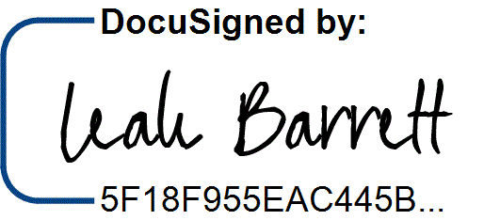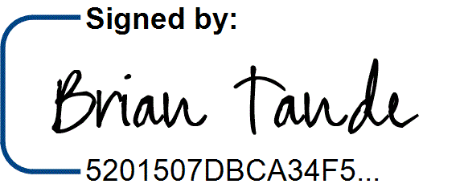7/29/2025 7/28/2025

Brian Tande, Ph.D. Date Leah Barrett, Ed.D. Date President President

South Dakota Mines Northeast Community College

[Brian.Tande@sdsmt.edu](mailto:Brian.Tande@sdsmt.edu) [lbarrett@northeast.edu](mailto:lbarrett@northeast.edu)

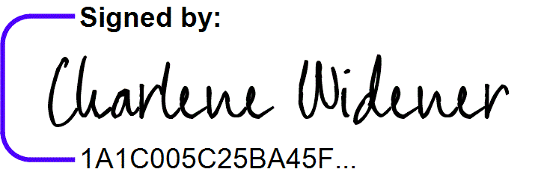7/29/2025 7/25/2025

Lance Roberts, Ph.D. Date Charlene Widener, Ph.D. Date Provost and Vice President for Academic Affairs Vice President of Educational Services

South Dakota Mines Northeast Community College

[Lance.Roberts@sdsmt.edu](mailto:Lance.Roberts@sdsmt.edu) [cwidener@northeast.edu](mailto:cwidener@northeast.edu)

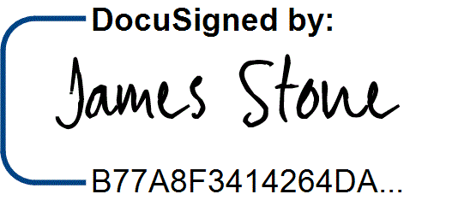7/28/2025 7/25/2025

James Stone, Ph.D. Date Connie Sixta Date Department Head Dean of Science, Technology, Agriculture & Math

South Dakota Mines Northeast Community College

[James.Stone@sdsmt.edu](mailto:James.Stone@sdsmt.edu) [connie@northeast.edu](mailto:connie@northeast.edu)

## Appendix A: Course Sequence

**Course Sequence:** Northeast Community College

## Pre-Engineering - Civil (A.S.)

|  |  |  |  |  |
| --- | --- | --- | --- | --- |
| **Semester** | **Course No.** | **Course Title** | **Credit Hours** | **Completed** |
| Freshman | ENGL 2070 | Technical Communications I (or ENGL 1010 English Comp) | 3 |  |
| Year |
| MATH 1600 | Analytic Geometry and Calculus I | 5 |  |
| First |
| CHEM 1090 | General Chemistry I | 4 |  |
| Semester |
| ENGR 1010 | Introduction to Engineering Design | 3 |  |
|  |  |  |  |  |
|  |  | ***Total Credits*** | ***15*** |  |

|  |  |  |  |  |
| --- | --- | --- | --- | --- |
| **Semester** | **Course No.** | **Course Title** | **Credit Hours** | **Completed** |
| Freshman | Select 1 course from | English/Literature (except ENGL 1020) | 3 |  |
| Year |
| MATH 2010 | Analytic Geometry and Calculus II | 5 |  |
| Second |
| PHYS 2110 | General Physics I with Calculus | 5 |  |
| Semester |
| ENGR 1020 | Programming and Problem Solving | 3 |  |
|  |  |  |  |  |
|  |  |  |  |  |
|  |  | ***Total Credits*** | ***16*** |  |

|  |  |  |  |  |
| --- | --- | --- | --- | --- |
| **Semester** | **Course No.** | **Course Title** | **Credit Hours** | **Completed** |
| Sophomore | ENGR 2020 | Engineering Statics | 3 |  |
| Year |
| MATH 2100 | Differential Equations | 3 |  |
| First |
| Select 1 course from | Behavioral and Social Sciences (except AGRI 1530) | 3 |  |
| Semester |
| ARCH 2150 | Civil Drafting | 2 |  |
|  | ARCH 2100 | Surveying and Site Planning | 3 |  |
|  |  |  |  |  |
|  |  |  |  |  |
|  |  | ***Total Credits*** | ***14*** |  |

|  |  |  |  |  |
| --- | --- | --- | --- | --- |
| **Semester** | **Course No.** | **Course Title** | **Credit Hours** | **Completed** |
| Sophomore | Select 1 course from | Fine Arts and Language | 3 |  |
| Year |
| MATH 2020 | Analytic Geometry and Calculus III | 5 |  |
| Second |
| Select 1 course from | SPCH 1010 (Fund of Comm) or SPCH 1110 (Public Speaking) | 3 |  |
| Semester |
| CHEM 1100 | General Chemistry II | 4 |  |
|  | PHYS 2150 | Structural Analysis | 3 |  |
|  |  |  |  |  |
|  |  |  |  |  |
|  |  | ***Total Credits*** | ***18*** |  |

|  |  |
| --- | --- |
| **General Education Coursework Total:**  **Major and Elective Coursework Total:**  **Northeast Community College Coursework Total:** | **34 credit hours**  **29 credit hours**  **63 CREDIT HOURS** |

**Course Sequence:** South Dakota Mines – Fall Semester Start

## Civil Engineering (B.S.)

|  |  |  |  |  |
| --- | --- | --- | --- | --- |
| **Semester** | **Course No.** | **Course Title** | **Credit Hours** | **Completed** |
| Junior Year First Semester  - FALL | EM 331 | Fluid Mechanics | 3 |  |
| CEE 284 | Applied Numerical Methods | 3 |  |
| EM 321 | Mechanics of Materials | 3 |  |
| MATH 381 | Introduction to Probability and Statistics | 3 |  |
| ENGL 289 | STEM Communication for Technical & Public Audiences | 3 |  |
| Select 1 course from | Social Science (Goal 3) - Civics CIV 100, HIST 151, HIS 152,  POLS 100, or POLS 210 | 3 |  |
| ***Total Credits 18*** | | | |  |

|  |  |  |  |  |
| --- | --- | --- | --- | --- |
| **Semester** | **Course No.** | **Course Title** | **Credit Hours** | **Completed** |
| Junior Year | CEE 274 | Construction Engineering and Management | 3 |  |
| Second |
| CEE 326 | Environmental Engineering and Science I | 3 |  |
| Semester - |
| CEE 325 | Introduction to Sustainable Design | 3 |  |
| SPRING |
| IENG 302 | Engineering Economics | 3 |  |
|  |  | Department Approved Electives | 6 |  |
|  |  | ***Total Credits*** | ***18*** |  |

|  |  |  |  |  |
| --- | --- | --- | --- | --- |
| **Semester** | **Course No.** | **Course Title** | **Credit Hours** | **Completed** |
| Senior Year First Semester  - FALL | CEE 316/316L | Engineering and Construction Materials w/Lab | 3 |  |
| CEE 336/336L | Hydraulic Systems Design w/Lab | 3 |  |
| CEE 346/346L | Geotechnical Engineering w/Lab | 3 |  |
| CEE 353 | Structural Theory | 3 |  |
| CEE 463 | Concepts of Professional Practice | 2 |  |
|  | Department Approved Electives | 3 |  |
| ***Total Credits 17*** | | | |  |

|  |  |  |  |  |
| --- | --- | --- | --- | --- |
| **Semester** | **Course No.** | **Course Title** | **Credit Hours** | **Completed** |
| Senior Year | CEE 468 | Highway Engineering | 3 |  |
| Second |
| Select 3 courses from | CEE 327/327L, CEE 337, CEE 347/347L, or CEE 456 | 9 |  |
| Semester - |
| CEE 489 | Capstone Design | 3 |  |
| SPRING |
|  |  |  |  |
|  |  |  |  |  |
|  |  | ***Total Credits*** | ***15*** |  |

|  |  |
| --- | --- |
| **General Education Coursework Total:**  **Major and Elective Coursework Total:**  **South Dakota Mines Coursework Total:** | **6 credit hours**  **62 credit hours**  **68 CREDIT HOURS** |