

Docusign Envelope ID: C703696B-03EF-48CF-82AE-6DAA995A21FE

# Northeast Community College logoAssociate to Bachelors (A2B) Articulation Agreement

**Prescribed Curriculum:** Northeast Community College

## Associate of Science – Engineering (Industrial)

|  |  |  |  |  |
| --- | --- | --- | --- | --- |
| General Education Courses | | | | **34** CREDIT HOURS |
|  | **Credit Hours** | **Course No.** | **Course Title or Category** | |
| **Written Comm** | 3 | ENGL 2070 | Technical Communications I | |
| **Oral Communication** | 3 | SPCH 1010 or 1110 | Fundamentals of Communication or Public Speaking | |
| **Behavioral & Social Sciences** | 3 | PSYC 1810 | Introduction to Psychology | |
| **English/Literature** | 3 | Select 1 course from | AS General Education list *(except ENGL 1020)* | |
| **Fine Arts and Language** | 3 | Select 1 course from | AS General Education list | |
| **Mathematics** | 10 | MATH 1600  MATH 2010 | Analytic Geometry and Calculus I  Analytic Geometry and Calculus II | |
| **Natural Science** | 9 | CHEM 1090  PHYS 2110 | General Chemistry I  General Physics I w/Calculus | |

|  |  |  |  |
| --- | --- | --- | --- |
| Required Courses | |  | **23** CREDIT HOURS |
|  | **Credit Hours** | **Course No.** | **Course Title** |
| **Mathematics & Science** | 5 | PHYS 2120 | General Physics II w/Calculus |
| 3 | MATH 2100 | Differential Equations |
| 5 | MATH 2020 | Analytic Geometry and Calculus III |
| **Engineering** | 3 | ENGR 1010 | Introduction to Engineering Design |
| 4 | ENGR 2010 | Introduction to Circuits and Electronics |
| 3 | ENGR 2020 | Engineering Statics |

|  |  |  |  |
| --- | --- | --- | --- |
| Program Elective Courses | |  | **3** CREDIT HOURS |
|  | **Credit Hours** | **Course No.** | **Course Title** |
| **Electives** | 3 | ENGR 1020 | Programming and Problem Solving |

|  |  |
| --- | --- |
| **Associate of Science – Engineering (Industrial) Total:** | **60 CREDIT HOURS** |

**Post-Associate Degree Prescribed Curriculum:** South Dakota Mines

## Bachelor of Science – Industrial Engineering and Engineering Management

|  |  |  |  |  |
| --- | --- | --- | --- | --- |
| General Education Courses | | | | **6** CREDIT HOURS |
|  | **Credit Hours** | **Course No.** | **Course Title or Category** | |
| **Written Communication** | 3 | ENGL 289 | Explorations in STEM Communications | |
| **Social Sciences** | 3 | Select 1 course from | Civics CIV 100, HIST 151, HIS 152, POLS 100, or POLS 210 | |

|  |  |  |  |
| --- | --- | --- | --- |
| Major Required Courses | |  | **56** CREDIT HOURS |
|  | **Credit Hours** | **Course No.** | **Course Title** |
|  | 2 | IENG 248/248L | Engineering Graphics and Computer Modeling w/Lab |
|  | 3 | IENG 381 | Introduction to Probability & Statistics |
|  | 3 | IENG 215 | Cost Estimating for Engineers |
|  | 3 | IENG 382 | Probability Theory and Statistics II |
|  | 3 | IENG 302 | Engineering Economics |
|  | 3 | IENG 311/311L | Work Methods and Measurements w/Lab |
|  | 1 | IENG 352 | Creativity and Innovation |
|  | 1 | IENG 354 | Marketing Technology Innovations |
| **Industrial** | 3 | IENG 362 | Stochastic Models |
| 3 | IENG 486 | Statistical Quality and Process Control |
| **Engineering and** |
| 3 | IENG 321/321L | Ergonomics/Human Factors Engineering w/Lab |
| **Engineering** |
| 1 | IENG 355 | Financing Technology Innovations |
| **Management** |
| 3 | ENGM 435 | Optimization Techniques |
|  | 3 | IENG 441 | Simulation |
|  | 3 | IENG 425 | Production and Operation Management |
|  | 3 | IENG 464 | Senior Design Project I |
|  | 3 | IENG 471 | Facilities Planning |
|  | 3 | Select 1 course from | IENG 331 Safety Engineering or IENG 431 Industrial Hygiene |
|  | 3 | IENG 366 | Engineering Management |
|  | 3 | IENG 465 | Senior Design Project II |
|  | 3 | IENG 475 | Computer-Controlled Manufacturing Sys & Robotics w/Lab |

|  |  |  |  |
| --- | --- | --- | --- |
| Elective Courses | |  | **8** CREDIT HOURS |
|  | **Credit Hours** | **Course No.** | **Course Title** |
| **Professional** | 5 | Select with Advisor | From list of approved electives |
| **Department** | 3 | Select with Advisor | From list of approved electives |

|  |  |
| --- | --- |
| **Post-Associate Degree Total:** | **70 CREDIT HOURS** |

|  |  |
| --- | --- |
| **Bachelor of Science – Industrial Engineering & Engineering Management Total:** | **130 CREDIT HOURS** |

**A2B Articulation Agreement Guarantees & Limitations**

### GUARANTEES

Students who:

1. complete the Associate of Science – Pre-Engineering degree prescribed curriculum at Northeast Community College exactly as it is identified in this articulation agreement, **and**
2. have the degree conferred on their education record at Northeast Community College (post high school graduation)**, and**
3. earn a minimum cumulative grade point average (GPA) of 2.75 at the Northeast Community College, **and**
4. pass all 60 credits for the associate degree, earning a grade C- or higher in each course

are **guaranteed** the following at the South Dakota School of Mines and Technology (South Dakota Mines):

1. junior standing at South Dakota Mines with no more than 70 remaining credits to meet the graduation requirements for the Bachelor of Science degree in Industrial Engineering and Engineering Management.
2. admission to South Dakota Mines
3. admission to the Bachelor of Science degree in Industrial Engineering and Engineering Management.

### LIMITATIONS

1. This agreement is between the Associate of Science – Pre-Engineering degree at Northeast Community College and the Bachelor of Science degree in Industrial Engineering and Engineering Management at South Dakota Mines only.
2. Students must meet all admission and application requirements at South Dakota Mines, including the submission of all required documentation by stated deadlines. Students are advised to contact the Office of Admissions at the South Dakota Mines early in their transfer planning.
3. Student must have a cumulative grade point average (GPA) at the Northeast Community College of 2.75 or higher

**and** only courses with grades of C- or higher are guaranteed to be accepted in transfer by South Dakota Mines.

1. The credit and course transfer guarantees described in this agreement apply to the Associate of Science – Pre- Engineering degree at Northeast Community College and the Bachelor of Science degree in Industrial Engineering and Engineering Management at South Dakota Mines. If the student changes majors at Northeast Community College or at South Dakota Mines, the student is no longer covered by this Articulation Agreement and none of the Guarantees of the Agreement apply.
2. Students utilizing any form of transfer credit, including but not limited to credit awarded from other higher education institutions, standardized exam (CLEP, AP, DSST, etc.), prior learning assessment (military, certifications, ACE recommended credit, portfolio, challenge exam, work experience equivalent credit, etc.) to satisfy any Associate degree requirements will have those credits evaluated by South Dakota Mines. Should South Dakota Mines not accept the transfer credits accepted by Northeast Community College, the student will be required to make up the credit deficiency at South Dakota Mines.
3. No course substitutions are allowed for the courses listed in the Prescribed Curriculum for the associate degree at Northeast Community College.

### A2B CONTACT INFORMATION

South Dakota Mines Northeast Community College

Office of the Provost Registration Office

605.394.2256 402.844.7265

[Provost@sdsmt.edu](mailto:Provost@sdsmt.edu)

### RENEWAL, REVISION, and TERMINATION

1. This Associate to Bachelor Articulation Agreement (A2B) shall be in effect July 1 – June 30 each year and will automatically renew annually unless action is taken by South Dakota Mines or Northeast Community College to terminate or modify it.
2. The South Dakota Mines Office of the Provost and the Northeast Community College Academic Affairs division will collaborate to coordinate a review the content of the associate and bachelor degrees on a three-year cycle to ensure this A2B is still appropriate.
3. South Dakota Mines and the Northeast Community College each reserve the right to seek revision of this agreement at any time.
4. Revision of any content of the agreement (except Appendices content) will be approved by each institution and result in a new agreement being signed, with copies retained by each institution.
   1. Revision to any Appendices will be communicated to each institution, but do not need to be approved by each institution and will not result in a new agreement being signed by each institution.
5. South Dakota Mines and the Northeast Community College each reserve the right to seek termination of this agreement at any time.
6. Should the agreement be terminated, each institution agrees to collaborate and engage in appropriate plans to notify and work with impacted students, providing a minimum one-year advance notice of termination.

### APPROVALS

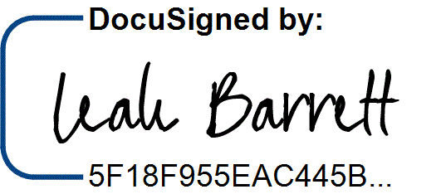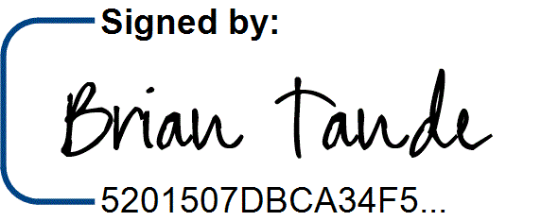7/29/2025 7/28/2025

Brian Tande, Ph.D. Date Leah Barrett, Ed.D. Date President President

South Dakota Mines Northeast Community College

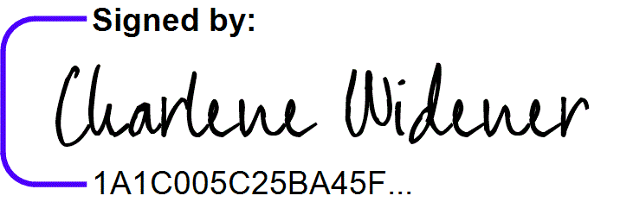[Brian.Tande@sdsmt.edu](mailto:Brian.Tande@sdsmt.edu) [lbarrett@northeast.edu](mailto:lbarrett@northeast.edu)

7/29/2025

7/25/2025

Lance Roberts, Ph.D. Date Charlene Widener, Ph.D. Date Provost and Vice President for Academic Affairs Vice President of Educational Services

South Dakota Mines Northeast Community College

[Lance.Roberts@sdsmt.edu](mailto:Lance.Roberts@sdsmt.edu) [cwidener@northeast.edu](mailto:cwidener@northeast.edu)

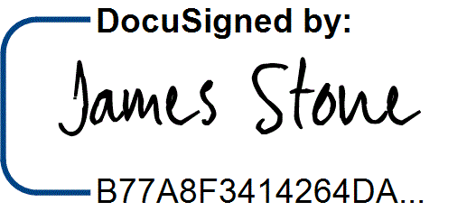7/28/2025 7/25/2025

James Stone, Ph.D. Date Connie Sixta Date Interim Department Head Dean of Science, Technology, Agriculture & Math

South Dakota Mines Northeast Community College

[James.Stone@sdsmt.edu](mailto:James.Stone@sdsmt.edu) [connie@northeast.edu](mailto:connie@northeast.edu)

## Appendix A: Course Sequence

**Course Sequence:** Northeast Community College

## Pre-Engineering - Industrial (A.S.)

|  |  |  |  |  |
| --- | --- | --- | --- | --- |
| **Semester** | **Course No.** | **Course Title** | **Credit Hours** | **Completed** |
| Freshman | ENGL 2070 | Technical Communications I | 3 |  |
| Year |
| MATH 1600 | Analytic Geometry and Calculus I | 5 |  |
| First |
| CHEM 1090 | General Chemistry I | 4 |  |
| Semester |
| ENGR 1010 | Introduction to Engineering Design | 3 |  |
|  |  |  |  |  |
|  |  | ***Total Credits*** | ***15*** |  |

|  |  |  |  |  |
| --- | --- | --- | --- | --- |
| **Semester** | **Course No.** | **Course Title** | **Credit Hours** | **Completed** |
| Freshman | Select 1 course from | General Education: English/Literature (Except ENGL 1020) | 3 |  |
| Year |
| MATH 2010 | Analytic Geometry and Calculus II | 5 |  |
| Second |
| PHYS 2110 | General Physics I with Calculus | 5 |  |
| Semester |
| ENGR 1020 | Programming and Problem Solving | 3 |  |
|  |  |  |  |  |
|  |  |  |  |  |
|  |  | ***Total Credits*** | ***16*** |  |

|  |  |  |  |  |
| --- | --- | --- | --- | --- |
| **Semester** | **Course No.** | **Course Title** | **Credit Hours** | **Completed** |
| Sophomore | PHYS 2120 | General Physics II with Calculus | 5 |  |
| Year |
| ENGR 2020 | Engineering Statics | 3 |  |
| First |
| MATH 2100 | Differential Equations | 3 |  |
| Semester |
| PSYC 1810 | Introduction to Psychology | 3 |  |
|  |  |  |  |  |
|  |  |  |  |  |
|  |  |  |  |  |
|  |  | ***Total Credits*** | ***14*** |  |

|  |  |  |  |  |
| --- | --- | --- | --- | --- |
| **Semester** | **Course No.** | **Course Title** | **Credit Hours** | **Completed** |
| Sophomore | Select 1 course from | General Education: Fine Arts and Language | 3 |  |
| Year |
| MATH 2020 | Analytic Geometry and Calculus III | 5 |  |
| Second |
| Select 1 course from | SPCH 1010 Fund of Comm or SPCH 1110 Public Speaking | 3 |  |
| Semester |
| ENGR 2010 | Introduction to Circuits and Electronics | 4 |  |
|  |  |  |  |  |
|  |  |  |  |  |
|  |  | ***Total Credits*** | ***15*** |  |

|  |  |
| --- | --- |
| **General Education Coursework Total:**  **Major and Elective Coursework Total:**  **Northeast Community College Coursework Total:** | **34 credit hours**  **26 credit hours**  **60 CREDIT HOURS** |

**Course Sequence:** South Dakota Mines – Fall Semester Start

## Industrial Engineering and Engineering Management (B.S.)

|  |  |  |  |  |
| --- | --- | --- | --- | --- |
| **Semester** | **Course No.** | **Course Title** | **Credit Hours** | **Completed** |
| Junior Year First Semester  - FALL | IENG 248/248L | Engineering Graphics & Computer Modeling w/Lab | 2 |  |
| IENG 381 | Introduction to Probability & Statistics | 3 |  |
| IENG 311/311L | Work Methods and Measurements w/Lab | 3 |  |
| IENG 352 | Creativity and Innovation | 1 |  |
| IENG 354 | Marketing Technology Innovations | 1 |  |
| ENGM 435 | Optimization Techniques | 3 |  |
| ENGL 289 | STEM Communication for Technical & Public Audiences | 3 |  |
|  | Professional Elective | 2 |  |
| ***Total Credits 18*** | | | |  |

|  |  |  |  |  |
| --- | --- | --- | --- | --- |
| **Semester** | **Course No.** | **Course Title** | **Credit Hours** | **Completed** |
| Junior Year | IENG 215 | Cost Estimating for Engineers | 3 |  |
| Second |
| IENG 321/321L | Ergonomics/Human Factors w/Lab | 3 |  |
| Semester - |
| IENG 441 | Simulation | 3 |  |
| SPRING |
| IENG 302 | Engineering Economics | 3 |  |
|  |  | Professional Elective | 3 |  |
|  | Select 1 course from | Social Science (Goal 3) - Civics CIV 100, HIST 151, HIS 152, | 3 |  |
|  | POLS 100, or POLS 210 |
|  |  | ***Total Credits*** | ***18*** |  |

|  |  |  |  |  |
| --- | --- | --- | --- | --- |
| **Semester** | **Course No.** | **Course Title** | **Credit Hours** | **Completed** |
| Senior Year First Semester  - FALL | IENG 362 | Stochastic Models | 3 |  |
| IENG 486 | Statistical Quality & Process Control | 3 |  |
| IENG 425 | Production & Operations Management | 3 |  |
| IENG 464 | Senior Design I | 3 |  |
| IENG 471 | Facilities Planning | 3 |  |
| IENG 382 | Theory of Probability & Statistics II | 3 |  |
| ***Total Credits 18*** | | | |  |

|  |  |  |  |  |
| --- | --- | --- | --- | --- |
| **Semester** | **Course No.** | **Course Title** | **Credit Hours** | **Completed** |
| Senior Year | IENG 355 | Financing Innovations | 1 |  |
| Second |
| IENG 366 | Engineering Management | 3 |  |
| Semester - |
| IENG 465 | Senior Design II | 3 |  |
| SPRING |
| IENG 475/475L | Computer-Controlled Manufacturing Sys & Robotics w/Lab | 3 |  |
|  | IENG 431 | Industrial Hygiene | 3 |  |
|  |  | Department Approved Elective | 3 |  |
|  |  |  |  |  |
|  |  | ***Total Credits*** | ***16*** |  |

|  |  |
| --- | --- |
| **General Education Coursework Total:**  **Major and Elective Coursework Total:**  **South Dakota Mines Coursework Total:** | **6 credit hours**  **64 credit hours**  **70 CREDIT HOURS** |