

Docusign Envelope ID: DDE1DB8B-7254-4BCF-8319-E89351B1627A

# Northeast Community College logoAssociate to Bachelors (A2B) Articulation Agreement

**Prescribed Curriculum:** Northeast Community College

## Associate of Science – Engineering (Metallurgical)

|  |  |  |  |  |
| --- | --- | --- | --- | --- |
| General Education Courses | | | | **34** CREDIT HOURS |
|  | **Credit Hours** | **Course No.** | **Course Title or Category** | |
| **Written Comm** | 3 | ENGL 2070, or  ENGL 1010 | Technical Communications I  English Composition I | |
| **Oral Communication** | 3 | SPCH 1010 or 1110 | Fundamentals of Communication or Public Speaking | |
| **Behavioral & Social Sciences** | 3 | Select 1 course from | AS General Education list, *except AGRI 1530* | |
| **English/Literature** | 3 | Select 1 course from | AS General Education list, *except ENGL 1020* | |
| **Fine Arts and**  **Language** | 3 | Select 1 course from | AS General Education list | |
| **Mathematics** | 10 | MATH 1600  MATH 2010 | Analytic Geometry and Calculus I Analytic Geometry and Calculus II | |
| **Natural Science** | 9 | CHEM 1090  PHYS 2110 | General Chemistry I  General Physics I w/Calculus | |

|  |  |  |  |
| --- | --- | --- | --- |
| Required Courses | |  | **19** CREDIT HOURS |
|  | **Credit Hours** | **Course No.** | **Course Title** |
| **Mathematics, Science, & Engineering** | 5 | MATH 2020 | Analytic Geometry and Calculus III |
| 3 | MATH 2100 | Differential Equations |
| 5 | PHYS 2120 | General Physics II with Calculus |
| 3 | ENGR 1010 | Introduction to Engineering Design |
| 3 | ENGR 2020 | Engineering Statics |

|  |  |  |  |
| --- | --- | --- | --- |
| Program Elective Courses | |  | **7** CREDIT HOURS |
|  | **Credit Hours** | **Course No.** | **Course Title** |
| **Program Course** | 4 | CHEM 1100 | General Chemistry II |
| **Electives** | 3 | ENGR 1020 | Programming and Problem Solving |

|  |  |
| --- | --- |
| **Associate of Science – Engineering (Metallurgical) Total:** | **60 CREDIT HOURS** |

**Post-Associate Degree Prescribed Curriculum:** South Dakota Mines

## Bachelor of Science – Metallurgical Engineering

|  |  |  |  |  |
| --- | --- | --- | --- | --- |
| General Education Courses | | | | **6** CREDIT HOURS |
|  | **Credit Hours** | **Course No.** | **Course Title or Category** | |
| **Written Communication** | 3 | ENGL 289 | Explorations in STEM Communications | |
| **Social Sciences** | 3 | Select 1 course from | Social Sciences (Goal 3) list | |

|  |  |  |  |
| --- | --- | --- | --- |
| Major Required Courses | |  | **43** CREDIT HOURS |
|  | **Credit Hours** | **Course No.** | **Course Title** |
| **Metallurgical Engineering** | 4 | MET 231/232 | Structures and Properties of Materials w/Lab |
| 4 | MET 220/220L | Mineral Processing and Resource Recovery w/Lab |
| 4 | MET 320 | Metallurgical Thermodynamics |
| 1 | MET 333 | Process Measurements and Control |
| 4 | MET 422 | Transport Phenomena |
| 4 | MET 321/321L | High Temp Extraction, Concentration, and Recycling w/Lab |
| 2 | MET 352 | Principles of Metallurgical Design |
| 4 | MET 330/330L | Physics of Metals w/Lab |
| 3 | MET 332 | Thermomechanical Processing |
| 2 | MET 464 | Senior Design I |
| 4 | MET 310/310L | Aqueous Extraction, Concentration, and Recycling w/Lab |
| 2 | MET 433 | Process Control |
| 4 | MET 440/440L | Mechanical Metallurgy w/Lab |
| 1 | MET 465 | Senior Design II |

|  |  |  |  |
| --- | --- | --- | --- |
| Other Required Courses | |  | **12** CREDIT HOURS |
|  | **Credit Hours** | **Course No.** | **Course Title** |
| **Mathematics** | 3 | MATH 373 | Introduction to Numerical Analysis |
| **Other Engineering** | 3 | Select 1 course from | EM 321 (Mechanics of Materials) or ME 216 (Solid Mechanics) |
| 4 | EE 301/301L | Introduction to Circuits, Machines, and Systems w/Lab |
| **Economics** | 2 | IENG 301 | Basic Engineering Economics |

|  |  |  |  |
| --- | --- | --- | --- |
| Elective Courses | |  | **9** CREDIT HOURS |
|  | **Credit Hours** | **Course No.** | **Course Title** |
| **Major Electives** | 6 | Select with Advisor | Major electives |
| **UD Humanities /**  **Social Science** | 3 | Select with Advisor | Upper Division Humanities or Social Science elective |

|  |  |
| --- | --- |
| **Post-Associate Degree Total:** | **70 CREDIT HOURS** |

|  |  |
| --- | --- |
| **Bachelor of Science – Metallurgical Engineering Total:** | **130 CREDIT HOURS** |

**A2B Articulation Agreement Guarantees & Limitations**

### GUARANTEES

Students who:

1. complete the Associate of Science – Pre-Engineering degree prescribed curriculum at Northeast Community College exactly as it is identified in this articulation agreement, **and**
2. have the degree conferred on their education record at Northeast Community College (post high school graduation)**, and**
3. earn a minimum cumulative grade point average (GPA) of 2.75 at the Northeast Community College, **and**
4. pass all 60 credits for the associate degree, earning a grade C- or higher in each course

are **guaranteed** the following at the South Dakota School of Mines and Technology (South Dakota Mines):

1. junior standing at South Dakota Mines with no more than 70 remaining credits to meet the graduation requirements for the Bachelor of Science degree in Metallurgical Engineering.
2. admission to South Dakota Mines
3. admission to the Bachelor of Science degree in Metallurgical Engineering.

### LIMITATIONS

1. This agreement is between the Associate of Science – Pre-Engineering degree at Northeast Community College and the Bachelor of Science degree in Metallurgical Engineering at South Dakota Mines only.
2. Students must meet all admission and application requirements at South Dakota Mines, including the submission of all required documentation by stated deadlines. Students are advised to contact the Office of Admissions at the South Dakota Mines early in their transfer planning.
3. Student must have a cumulative grade point average (GPA) at the Northeast Community College of 2.75 or higher

**and** only courses with grades of C- or higher are guaranteed to be accepted in transfer by South Dakota Mines.

1. The credit and course transfer guarantees described in this agreement apply to the Associate of Science – Pre- Engineering degree at Northeast Community College and the Bachelor of Science degree in Metallurgical Engineering at South Dakota Mines. If the student changes majors at Northeast Community College or at South Dakota Mines, the student is no longer covered by this Articulation Agreement and none of the Guarantees of the Agreement apply.
2. Students utilizing any form of transfer credit, including but not limited to credit awarded from other higher education institutions, standardized exam (CLEP, AP, DSST, etc.), prior learning assessment (military, certifications, ACE recommended credit, portfolio, challenge exam, work experience equivalent credit, etc.) to satisfy any Associate degree requirements will have those credits evaluated by South Dakota Mines. Should South Dakota Mines not accept the transfer credits accepted by Northeast Community College, the student will be required to make up the credit deficiency at South Dakota Mines.
3. No course substitutions are allowed for the courses listed in the Prescribed Curriculum for the associate degree at Northeast Community College.

### A2B CONTACT INFORMATION

South Dakota Mines Northeast Community College

Office of the Provost Registration Office

605.394.2256 402.844.7265

[Provost@sdsmt.edu](mailto:Provost@sdsmt.edu)

### RENEWAL, REVISION, and TERMINATION

1. This Associate to Bachelor Articulation Agreement (A2B) shall be in effect July 1 – June 30 each year and will automatically renew annually unless action is taken by South Dakota Mines or Northeast Community College to terminate or modify it.
2. The South Dakota Mines Office of the Provost and the Northeast Community College Academic Affairs division will collaborate to coordinate a review of the content of the associate and bachelor degrees on a three-year cycle to ensure this A2B is still appropriate.
3. South Dakota Mines and the Northeast Community College each reserve the right to seek revision of this agreement at any time.
4. Revision of any content of the agreement (except Appendices content) will be approved by each institution and result in a new agreement being signed, with copies retained by each institution.
   1. Revision to any Appendices will be communicated to each institution, but do not need to be approved by each institution and will not result in a new agreement being signed by each institution.
5. South Dakota Mines and the Northeast Community College each reserve the right to seek termination of this agreement at any time.
6. Should the agreement be terminated, each institution agrees to collaborate and engage in appropriate plans to notify and work with impacted students, providing a minimum one-year advance notice of termination.

### APPROVALS

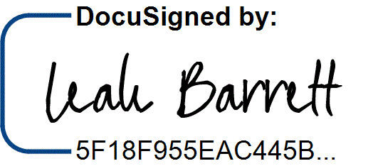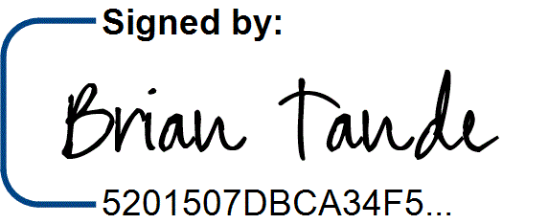7/29/2025 7/28/2025

Brian Tande, Ph.D. Date Leah Barrett, Ed.D. Date President President

South Dakota Mines Northeast Community College

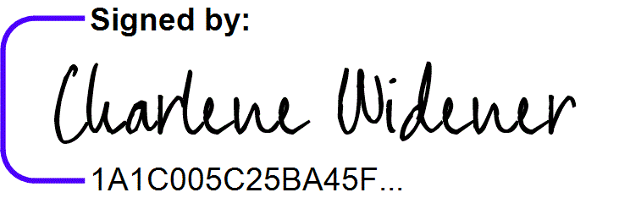[Brian.Tande@sdsmt.edu](mailto:Brian.Tande@sdsmt.edu) [lbarrett@northeast.edu](mailto:lbarrett@northeast.edu)

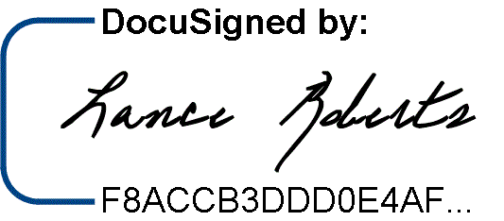7/29/2025

7/25/2025

Lance Roberts, Ph.D. Date Charlene Widener, Ph.D. Date Provost and Vice President for Academic Affairs Vice President of Educational Services

South Dakota Mines Northeast Community College

[Lance.Roberts@sdsmt.edu](mailto:Lance.Roberts@sdsmt.edu) [cwidener@northeast.edu](mailto:cwidener@northeast.edu)

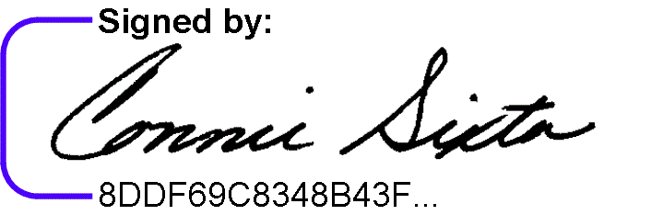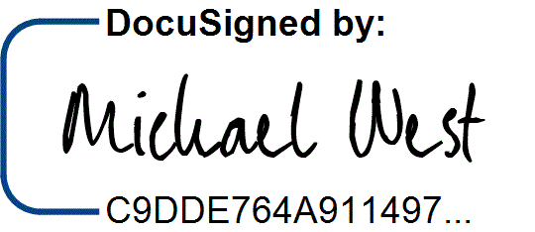7/28/2025 7/25/2025

Michael West, Ph.D. Date Connie Sixta Date Department Head Dean of Science, Technology, Agriculture & Math

South Dakota Mines Northeast Community College

[Michael.West@sdsmt.edu](mailto:Michael.West@sdsmt.edu) [connie@northeast.edu](mailto:connie@northeast.edu)

## Appendix A: Course Sequence

**Course Sequence:** Northeast Community College

## Pre-Engineering - Metallurgical (A.S.)

|  |  |  |  |  |
| --- | --- | --- | --- | --- |
| **Semester** | **Course No.** | **Course Title** | **Credit Hours** | **Completed** |
| Freshman | ENGL 2070 | Technical Communications I (or ENGL 1010 English Comp I) | 3 |  |
| Year |
| MATH 1600 | Analytic Geometry and Calculus I | 5 |  |
| First |
| CHEM 1090 | General Chemistry I | 4 |  |
| Semester |
| ENGR 1010 | Introduction to Engineering Design | 3 |  |
|  |  |  |  |  |
|  |  | ***Total Credits*** | ***15*** |  |

|  |  |  |  |  |
| --- | --- | --- | --- | --- |
| **Semester** | **Course No.** | **Course Title** | **Credit Hours** | **Completed** |
| Freshman | Select 1 course from | General Education: English/Literature (Except ENGL 1020) | 3 |  |
| Year |
| MATH 2010 | Analytic Geometry and Calculus II | 5 |  |
| Second |
| PHYS 2110 | General Physics I with Calculus | 5 |  |
| Semester |
| CHEM 1100 | General Chemistry II | 4 |  |
|  |  |  |  |  |
|  |  |  |  |  |
|  |  | ***Total Credits*** | ***17*** |  |

|  |  |  |  |  |
| --- | --- | --- | --- | --- |
| **Semester** | **Course No.** | **Course Title** | **Credit Hours** | **Completed** |
| Sophomore | PHYS 2120 | General Physics II with Calculus | 5 |  |
| Year |
| ENGR 2020 | Engineering Statics | 3 |  |
| First |
| MATH 2100 | Differential Equations | 3 |  |
| Semester |
| Select 1 course from | General Education: Behavioral/Social Sci (Except AGRI 1530) | 3 |  |
|  |  |  |  |  |
|  |  |  |  |  |
|  |  |  |  |  |
|  |  | ***Total Credits*** | ***14*** |  |

|  |  |  |  |  |
| --- | --- | --- | --- | --- |
| **Semester** | **Course No.** | **Course Title** | **Credit Hours** | **Completed** |
| Sophomore | Select 1 course from | General Education: Fine Arts and Language | 3 |  |
| Year |
| MATH 2020 | Analytic Geometry and Calculus III | 5 |  |
| Second |
| Select 1 course from | SPCH 1010 Fund of Comm or SPCH 1110 Public Speaking | 3 |  |
| Semester |
| ENGR 1020 | Programming and Problem Solving | 3 |  |
|  |  |  |  |  |
|  |  |  |  |  |
|  |  | ***Total Credits*** | ***14*** |  |

|  |  |
| --- | --- |
| **General Education Coursework Total:**  **Major and Elective Coursework Total:**  **Northeast Community College Coursework Total:** | **34 credit hours**  **26 credit hours**  **60 CREDIT HOURS** |

**Course Sequence:** South Dakota Mines – Fall Semester Start

## Metallurgical Engineering (B.S.) – even year start

|  |  |  |  |  |
| --- | --- | --- | --- | --- |
| **Semester** | **Course No.** | **Course Title** | **Credit Hours** | **Completed** |
| Junior Year First Semester  - FALL | MET 231 | Properties of Materials Lab | 1 |  |
| MET 232 | Properties of Materials | 3 |  |
| MET 320 | Metallurgical Thermodynamics | 4 |  |
| MET 422 | Transport Phenomena | 4 |  |
| Select 1 course from | Social Science (Goal 3) - Civics CIV 100, HIST 151, HIS 152,  POLS 100, or POLS 210 | 3 |  |
| ENGL 289 | Explorations in STEM Communications* | 3 |  |
| ***Total Credits 18*** | | | |  |

|  |  |  |  |  |
| --- | --- | --- | --- | --- |
| **Semester** | **Course No.** | **Course Title** | **Credit Hours** | **Completed** |
| Junior Year | MET 220/220L | Mineral Processing and Resource Recovery w/lab | 4 |  |
| Second |
| MET 321/321L | High Temperature Extraction, Concentration, & Rec w/lab | 4 |  |
| Semester - |
| MET 352/352L | Principles of Metallurgical Design w/lab | 2 |  |
| SPRING |
| MATH 373 | Introduction to Numerical Analysis | 3 |  |
|  | Select 1 course from | ME 216 Solid Mechanics or EM 321 Mechanics of Materials | 3 |  |
|  | IENG 301 | Basic Engineering Economics | 2 |  |
|  |  | ***Total Credits*** | ***18*** |  |

|  |  |  |  |  |
| --- | --- | --- | --- | --- |
| **Semester** | **Course No.** | **Course Title** | **Credit Hours** | **Completed** |
| Senior Year First Semester  - FALL | MET 333 | Process Measurements and Control | 1 |  |
| MET 464 | Senior Design | 2 |  |
| MET 330/330L | Physics of Metals w/lab | 4 |  |
| MET 332 | Thermomechanical Processing | 3 |  |
| EE 301/301L | Introduction to Circuits, Machines and Systems w/Lab | 4 |  |
|  | Major Electives | 3 |  |
|  |  |  |  |
| ***Total Credits 17*** | | | |  |

|  |  |  |  |  |
| --- | --- | --- | --- | --- |
| **Semester** | **Course No.** | **Course Title** | **Credit Hours** | **Completed** |
| Senior Year | MET 310/310L | Aqueous Extraction, Concentration, and Recycling w/lab | 4 |  |
| Second |
| MET 440/440L | Mechanical Metallurgy w/lab | 4 |  |
| Semester - |
| MET 433 | Process Control | 2 |  |
| SPRING |
| MET 465 | Senior Design II | 1 |  |
|  |  | Major Electives | 3 |  |
|  |  | Upper Division Humanities or Social Science Elective | 3 |  |
|  |  | ***Total Credits*** | ***17*** |  |

|  |  |
| --- | --- |
| **General Education Coursework Total:**  **Major and Elective Coursework Total:**  **South Dakota Mines Coursework Total:** | **6 credit hours**  **64 credit hours**  **70 CREDIT HOURS** |

**Course Sequence:** South Dakota Mines – Fall Semester Start

## Metallurgical Engineering (B.S.) – odd year start

|  |  |  |  |  |
| --- | --- | --- | --- | --- |
| **Semester** | **Course No.** | **Course Title** | **Credit Hours** | **Completed** |
| Junior Year First Semester  - FALL | MET 231 | Properties of Materials Lab | 1 |  |
| MET 232 | Properties of Materials | 3 |  |
| MET 320 | Metallurgical Thermodynamics | 4 |  |
| ENGL 289 | Explorations in STEM Communications* | 3 |  |
| Select 1 from | ME 216 Solid Mechanics or EM 321 Mechanics of Materials | 3 |  |
| ***Total Credits 14*** | | | |  |

|  |  |  |  |  |
| --- | --- | --- | --- | --- |
| **Semester** | **Course No.** | **Course Title** | **Credit Hours** | **Completed** |
| Junior Year | MET 220/220L | Mineral Processing and Resource Recovery w/lab | 4 |  |
| Second |
| MET 310/310L | Aqueous Extraction, Concentration, and Recycling w/lab | 4 |  |
| Semester - |
| MET 440/440L | Mechanical Metallurgy w/lab | 4 |  |
| SPRING |
| MET 352/352L | Principles of Metallurgical Design w/lab | 2 |  |
|  |  |  |  |  |
|  |  | ***Total Credits*** | ***14*** |  |

|  |  |  |  |  |
| --- | --- | --- | --- | --- |
| **Semester** | **Course No.** | **Course Title** | **Credit Hours** | **Completed** |
| Senior Year First Semester  - FALL | MET 333 | Process Measurements and Control | 1 |  |
| MET 422 | Transport Phenomena | 4 |  |
| MET 464 | Senior Design | 2 |  |
| IENG 301 | Basic Engineering Economics | 2 |  |
| MATH 373 | Introduction to Numerical Analysis | 3 |  |
| Select 1 course from | Social Science (Goal 3) - Civics CIV 100, HIST 151, HIS 152,  POLS 100, or POLS 210 | 3 |  |
| ***Total Credits 15*** | | | |  |

|  |  |  |  |  |
| --- | --- | --- | --- | --- |
| **Semester** | **Course No.** | **Course Title** | **Credit Hours** | **Completed** |
| Senior Year | MET 321/321L | High Temperature Extraction, Concentration, & Rec w/lab | 4 |  |
| Second |
| MET 433 | Process Control | 2 |  |
| Semester - |
| MET 465 | Senior Design II | 1 |  |
| SPRING |
| EE 301/301L | Introduction to Circuits, Machines & Systems w/Lab | 4 |  |
|  |  | Major Elective | 3 |  |
|  |  | ***Total Credits*** | ***14*** |  |

|  |  |  |  |  |
| --- | --- | --- | --- | --- |
| **Semester** | **Course No.** | **Course Title** | **Credit Hours** | **Completed** |
| Senior Year | MET 330/330L | Physics of Metals w/lab | 4 |  |
| Third |
| MET 332 | Thermomechanical Processing | 3 |  |
| Semester - |
|  | Major Elective | 3 |  |
| FALL |
|  | Upper Division Humanities or Social Science Elective | 3 |  |
|  |  |  |  |  |
|  |  | ***Total Credits*** | ***13*** |  |

|  |  |
| --- | --- |
| **General Education Coursework Total:**  **Major and Elective Coursework Total:**  **South Dakota Mines Coursework Total:** | **6 credit hours**  **64 credit hours**  **70 CREDIT HOURS** |