

**Technical Program Transfer Articulation Agreement** **Prescribed Curriculum:** Western Dakota Technical College **Environmental Engineering Technician (A.A.S.)**

|  |  |  |  |  |
| --- | --- | --- | --- | --- |
| General Education Courses | | | | **9** CREDIT HOURS |
| **General Education Category** | **Credit Hours** | **Course ID** | **Course Title or Category** | |
| **Written Communication** | 3 | ENGL 101 | English Composition | |
| **Social Sciences** | 3 | PSYC 101 | Psychology, **OR** Other [Social Science (Goal 3) course](https://ecatalog.sdsmt.edu/mime/media/view/27/7795/BOR%2BGen%2BEd%2BRequirements%2B2022-USE%2BTHIS%2BONE.pdf) | |
| **Mathematics** | 3 | MATH 120 | Trigonometry *(MATH 114 pre-req)* | |
| **Science** |  | Refer to “SDSMT Courses Taken While Jointly Attending WDT” section below | | |

|  |  |  |  |  |
| --- | --- | --- | --- | --- |
| Required Courses | | | | **48** CREDIT HOURS |
| **Degree Requirement** | **Credit Hours** | **Course ID** | **Course Title** | |
| **Science** | 4 | BIOL 101/101L | Biology Survey I w/Lab | |
| 4 | MICR 231/231L | General Microbiology I w/Lab | |
|  | 2 | AG 110 | Fundamentals in Soil Science | |
|  | 2 | AE 250 | Mapping and GPS Technologies | |
|  | 3 | AE 251 | Introduction to GIS | |
|  | 3 | AE 252 | Surveying I | |
| **Agriculture, Architectural** | 4 | EET 102 | Introduction to Environmental Sciences | |
| **Engineering, and** |
| 3 | EET 140 | Laboratory Methods in Environmental Science | |
| **Environmental Engineering** |
| 2 | EET 210 | Environmental Regulations & Hazmat Awareness | |
| **Technician** |
|  | 4 | EET 215 | Hydrology & Stream Field Methods | |
|  | 3 | EET 220 | Water Treatment and Distribution | |
|  | 2 | EET 225 | Air Quality | |
|  | 3 | EET 251 | Environmental Geology | |
| **Technical Electives** | 3 | EET 202 | Water Quality | |
| 3 | EET 235 | Construction Materials Sampling & Testing | |
| 3 | EET 260 | Wastewater Collection and Treatment | |

|  |  |  |  |  |
| --- | --- | --- | --- | --- |
| **SDSMT Courses Taken While Jointly Attending Western Dakota Tech** | | | | **8** CREDIT HOURS |
| **Course ID** | **Course Title** | **Credit Hours** | **Note** | |
| CHEM 112/112L* | General College Chemistry I w/ Lab | 4 | Replaces CHEM 106/106L required at WDT | |
| MATH 123* | Calculus I | 4 |  | |

*\*May be taken at SDSMT or any South Dakota Board of Regents institution*

|  |  |
| --- | --- |
| AAS Environmental Engineering Technician Degree Total:  Additional Credits Completed Toward BS Degree Requirements:  **Total Credits Completed by End of AAS Degree:** | 61 credit hours  4 credit hours  **65 CREDIT HOURS**  **(42 Cr Apply to BS)** |

**Post-Associate Degree Prescribed Curriculum:** South Dakota Mines

# Civil Engineering, Environmental Engineering Specialization (B.S.)

|  |  |  |  |  |
| --- | --- | --- | --- | --- |
| **General Education Courses** | | | | **19** CREDIT HOURS |
| **Category** | **Credit Hours** | **Course ID** | **Course Title or Category** | |
| **Goal 1: Written Communication** | 3 | ENGL 289 | Explorations in STEM Communications | |
| **Goal 2: Oral Communication** | 3 | ENGL 279 | Communication in the STEM Workplace | |
| **Goal 3: Social Sciences-Civics** | 3 | Select 1 course from | CIV 100, HIST 151, HIST 152, POLS 100, or POLS 210 | |
| **Goal 4: Arts/Humanities** | 6 | Select 2 courses from | Arts/Humanities (Goal 4) general education approved list | |
| **Goal 6: Natural Sciences** | 4 | CHEM 114/114L | General College Chemistry II w/Lab | |

|  |  |  |  |
| --- | --- | --- | --- |
| **Major Required Courses** | |  | **41** CREDIT HOURS |
|  | **Credit Hours** | **Course No.** | **Course Title** |
| **Engineering** | 3 | EM 214 | Statics |
| 3 | EM 331 | Fluid Mechanics |
| 3 | CBE 217 | Chemical Engineering Material Balances |
| 3 | CEE 284 | Applied Numerical Methods |
| 3 | EM 321 | Mechanics of Materials |
| 3 | CBE 222 | Thermodynamics |
| 3 | CEE 336/336L | Hydraulic Systems Design w/ Lab |
| 3 | CEE 316/316L | Construction Materials w/ Lab |
| 3 | CEE 346/346L | Geotechnical Engineering I w/ Lab |
| 3 | CEE 325 | Introduction to Sustainable Design |
| 3 | CEE 426 | Environmental Engineering Unit Operations & Process |
| 2 | CEE 463 | Concepts of Professional Practice |
| 3 | CEE 427 | Environmental Engineering Biological Process |
| 3 | CEE 489 | Capstone Design |

|  |  |  |  |
| --- | --- | --- | --- |
| **Other Required and Elective Courses** | | | **28** CREDIT HOURS |
|  | **Credit Hours** | **Course No.** | **Course Title** |
| **Economics** | 2 | IENG 301 | Engineering Economics |
| **Mathematics** | 4 | MATH 125 | Calculus II |
| 4 | MATH 225 | Calculus III |
| 3 | MATH 321 | Differential Equations |
| 3 | MATH 381 | Introduction to Probability & Statistics |
| **Physics** | 3 | PHYS 207 | Fundamentals of Physics I |
| **Electives** | 9 | Select from list | Department Approved Electives |

|  |  |
| --- | --- |
| **Post-Associate Degree Total:** | **88 CREDIT HOURS** |

|  |  |
| --- | --- |
| **Bachelor of Science – Civil Engineering Total:** | **130 CREDIT HOURS** |

Technical Program Transfer Articulation Agreement (TPTAA) Guarantees & Limitations

## **GUARANTEES**

Students who:

1. complete the Associate of Applied Science – Environmental Engineering Technician degree prescribed curriculum at Western Dakota Technical College (WDT) exactly as it is identified in this articulation agreement, **and**
2. have the degree conferred on their education record at WDT (post high school graduation)**, and**
3. earn a minimum cumulative grade point average (GPA) of 2.75 at WDT, **and**
4. pass all 65 credits documented on page one (57 credits at WDT and 8 credits at South Dakota Mines (or other South Dakota Board of Regents institution), earning a grade C- or higher in each course

are **guaranteed** the following at the South Dakota School of Mines and Technology (South Dakota Mines):

1. admission to South Dakota Mines
2. admission to the Bachelor of Science – Civil Engineering, Environmental Engineering Specialization degree
3. no more than 88 remaining credits at South Dakota Mines to meet the graduation requirements for the Bachelor of Science – Civil Engineering, Environmental Engineering Specialization degree.

## **LIMITATIONS**

1. This agreement is between the Associate of Applied Science – Environmental Engineering Technician degree at Western Dakota Technical College and the Bachelor of Science – Civil Engineering, Environmental Engineering Specialization degree at South Dakota Mines only.
2. Students must meet all admission and application requirements at South Dakota Mines, including the submission of all required documentation by stated deadlines. Students are advised to contact the Office of Admissions at the South Dakota Mines early in their transfer planning.
3. Student must have a cumulative grade point average (GPA) at Western Dakota Technical College of 2.75 or higher

**and** only courses with grades of C- or higher are guaranteed to be accepted in transfer by South Dakota Mines.

1. The credit and course transfer guarantees described in this agreement apply to the Associate of Applied Science
   * Environmental Engineering Technician degree at Western Dakota Technical College and the Bachelor of Science
   * Civil Engineering, Environmental Engineering Specialization degree at South Dakota Mines. If the student changes majors at Western Dakota Technical College or at South Dakota Mines, the student is no longer covered by this Articulation Agreement and none of the Guarantees of the Agreement apply.
2. Students utilizing any form of transfer credit, including but not limited to credit awarded from other higher education institutions, standardized exam (CLEP, AP, DSST, etc.), prior learning assessment (military, certifications, ACE recommended credit, portfolio, challenge exam, work experience equivalent credit) to satisfy any associate degree requirements will have those credits evaluated by South Dakota Mines. Should South Dakota Mines not accept the transfer credits accepted by Western Dakota Technical College, the student will be required to make up the credit deficiency at South Dakota Mines.
3. No course substitutions are allowed for the courses listed in the Prescribed Curriculum for the associate degree at Western Dakota Technical College.

## **TPTAA CONTACT INFORMATION**

South Dakota Mines Western Dakota Technical College

Office of the Provost Academics

605.394.2256 605.718.2905

[Provost@sdsmt.edu](mailto:Provost@sdsmt.edu) [Tiffany.Howe@wdt.edu](mailto:Tiffany.Howe@wdt.edu)

## **RENEWAL, REVISION, and TERMINATION**

1. This Technical Program Transfer Articulation Agreement (TPTAA) shall be in effect July 1 – June 30 each year and will automatically renew annually unless action is taken by South Dakota Mines or Western Dakota Technical College to terminate or modify it.
2. The South Dakota Mines Civil Engineering Department Head and the Western Dakota Technical College Environmental Engineering Technician Program Director will collaborate to review the content of the associate and bachelor degrees on a three-year cycle to ensure this TPTAA is still appropriate.
3. South Dakota Mines and Western Dakota Technical College each reserve the right to seek revision of this agreement at any time.

### Revision of any content of the agreement (except Appendices content) will be approved by each institution and result in a new agreement being signed, with copies retained by each institution.

* 1. Revision to any Appendices will be communicated to each institution, but do not need to be approved by each institution and will not result in a new agreement being signed by each institution.

1. South Dakota Mines and Western Dakota Technical College each reserve the right to seek termination of this agreement at any time.
2. Should the agreement be terminated, each institution agrees to collaborate and engage in appropriate plans to notify and work with impacted students, providing a minimum one-year advance notice of termination.

## **APPROVALS**

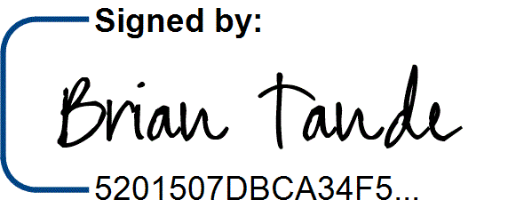8/1/2025

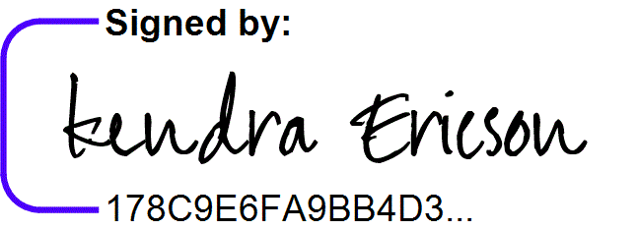7/31/2025

Brian Tande, Ph.D. Date Kendra Ericson, Ph.D. Date President President

South Dakota Mines Western Dakota Technical College

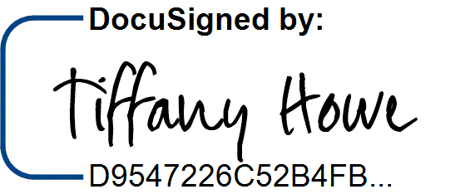[Brian.Tande@sdsmt.edu](mailto:Brian.Tande@sdsmt.edu) [Kendra.Ericson@wdt.edu](mailto:Kendra.Ericson@wdt.edu)

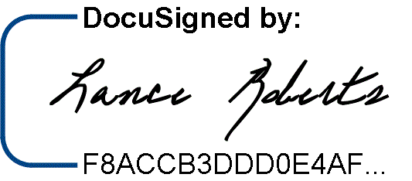8/1/2025

7/29/2025

Lance Roberts, Ph.D. Date Tiffany Howe Date Provost and Vice President for Academic Affairs Vice President for Teaching and Learning South Dakota Mines Western Dakota Technical College

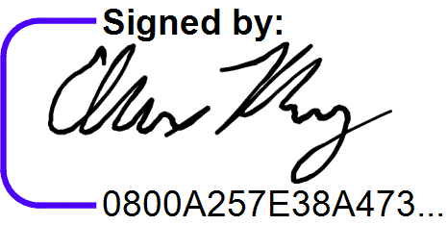[Provost@sdsmt.edu](mailto:Provost@sdsmt.edu) [Tiffany.Howe@wdt.edu](mailto:Tiffany.Howe@wdt.edu)

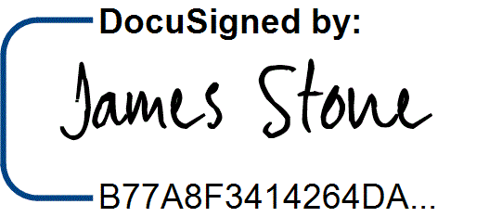7/31/2025

7/29/2025

James Stone, Ph.D. Date Alex Rosburg Date Department Head Environmental Engineering Program Director

South Dakota Mines Western Dakota Technical College

[James.Stone@sdsmt.edu](mailto:James.Stone@sdsmt.edu) [Alex.Rosburg@wdt.edu](mailto:Alex.Rosburg@wdt.edu)

# Appendix A: Course Sequence



Docusign Envelope ID: FB906225-D02E-4109-BD65-DF4A48EC3648

**Course Sequence:** Western Dakota Technical College

**Environmental Engineering Technician (A.A.S.)**

* **Option 1: College Algebra Ready**

|  |  |  |  |  |
| --- | --- | --- | --- | --- |
| **Semester** | **Course No.** | **Course Title** | **Credit Hours** | **Completed** |
| Freshman Year  First Semester | AE 250 | Introduction to Mapping/GIS | 2 |  |
| BIOL 101/101L | Biology Survey I w/Lab | 4 |  |
| PSYC 101* | General Psychology | 3 |  |
| EET 102 | Introduction to Environmental Sciences | 4 |  |
| MATH 114 | College Algebra | 3 |  |
| ***Total Credits 16*** | | | |  |

|  |  |  |  |  |
| --- | --- | --- | --- | --- |
| **Semester** | **Course No.** | **Course Title** | **Credit Hours** | **Completed** |
| Freshman | EET 140 | Laboratory Methods in Environmental Science | 3 |  |
| Year |
| EET 225 | Air Quality | 2 |  |
| Second |
| EET 251 | Environmental Geology | 3 |  |
| Semester |
| ENGL 101* | Composition I | 3 |  |
|  | MAT 120 | Trigonometry | 3 |  |
|  | CHEM 112/112L* | General College Chemistry I w/Lab ***(enrolled at SDSMT)*** | 4 |  |
| ***Total Credits 18 (14 WDT)*** | | | |  |

|  |  |  |  |  |
| --- | --- | --- | --- | --- |
| **Semester** | **Course No.** | **Course Title** | **Credit Hours** | **Completed** |
| Summer Between  Yr 1 and Yr 2 | MATH 123* | Calculus I ***(enrolled at SDSMT)*** | 4 |  |
| ***Total Credits 4 (0 WDT)*** | | | |  |

|  |  |  |  |  |
| --- | --- | --- | --- | --- |
| **Semester** | **Course No.** | **Course Title** | **Credit Hours** | **Completed** |
| Sophomore Year  First Semester | AE 252 | Introduction to Surveying | 3 |  |
| AG 110 | Fundamentals in Soil Science Hydrology | 2 |  |
| EET 215 | Hydrology & Stream Field Methods | 4 |  |
| EET 220 | Water Treatment and Distribution | 3 |  |
| MICR 231/231L | General Microbiology w/Lab | 4 |  |
| ***Total Credits 16*** | | | |  |

|  |  |  |  |  |
| --- | --- | --- | --- | --- |
| **Semester** | **Course No.** | **Course Title** | **Credit Hours** | **Completed** |
| Sophomore | AE 251 | Introduction to GIS | 3 |  |
| Year |
| EET 210 | Environmental Regulations & Hazmat Awareness | 2 |  |
| Second |
| EET 202 | Water Quality (Technical Elective) | 3 |  |
| Semester |
| EET 235 | Construction Materials (Technical Elective) | 3 |  |
|  | EET 260 | Wastewater Collection and Treatment (Technical Elective) | 3 |  |
| ***Total Credits*** | | | ***14*** |  |

|  |  |
| --- | --- |
| BS Degree-Applicable General Education Coursework Total (6 WDT + 8 SDSMT):  AAS Major and Elective Coursework Total:  **Total Credits Completed by End of Associate Degree:** | 14* credit hours  54 credit hours  **68 CREDIT HOURS** |



Docusign Envelope ID: FB906225-D02E-4109-BD65-DF4A48EC3648

**Course Sequence:** Western Dakota Technical College

**Environmental Engineering Technician (A.A.S.)**

* **Option 2: Trigonometry Ready**

|  |  |  |  |  |
| --- | --- | --- | --- | --- |
| **Semester** | **Course No.** | **Course Title** | **Credit Hours** | **Completed** |
| Freshman Year  First Semester | AE 250 | Introduction to Mapping/GIS | 2 |  |
| BIOL 101/101L | Biology Survey I w/Lab | 4 |  |
| ENGL 101* | Composition I | 3 |  |
| EET 102 | Introduction to Environmental Sciences | 4 |  |
| MATH 120 | Trigonometry | 3 |  |
| ***Total Credits*** | | | ***16*** |  |

|  |  |  |  |  |
| --- | --- | --- | --- | --- |
| **Semester** | **Course No.** | **Course Title** | **Credit Hours** | **Completed** |
| Freshman | EET 140 | Laboratory Methods in Environmental Science | 3 |  |
| Year |
| EET 225 | Air Quality | 2 |  |
| Second |
| EET 251 | Environmental Geology | 3 |  |
| Semester |
| CHEM 112/112L* | General College Chemistry I w/Lab ***(enrolled at SDSMT)*** | 4 |  |
|  | MATH 123* | Calculus I ***(enrolled at SDSMT)*** | 4 |  |
|  |  |  |  |  |
| ***Total Credits 16 (8 WDT)*** | | | |  |

|  |  |  |  |  |
| --- | --- | --- | --- | --- |
| **Semester** | **Course No.** | **Course Title** | **Credit Hours** | **Completed** |
| Sophomore Year  First Semester | AE 252 | Introduction to Surveying | 3 |  |
| AG 110 | Fundamentals in Soil Science Hydrology | 2 |  |
| EET 215 | Hydrology & Stream Field Methods | 4 |  |
| EET 220 | Water Treatment and Distribution | 3 |  |
| MICR 231/231L | General Microbiology w/Lab | 4 |  |
| ***Total Credits 16*** | | | |  |

|  |  |  |  |  |
| --- | --- | --- | --- | --- |
| **Semester** | **Course No.** | **Course Title** | **Credit Hours** | **Completed** |
| Sophomore | AE 251 | Introduction to GIS | 3 |  |
| Year |
| EET 210 | Environmental Regulations & Hazmat Awareness | 2 |  |
| Second |
| PSYC 101* | General Psychology | 3 |  |
| Semester |
| EET 202 | Water Quality (Technical Elective) | 3 |  |
|  | EET 235 | Construction Materials (Technical Elective) | 3 |  |
|  | EET 260 | Wastewater Collection and Treatment (Technical Elective) | 3 |  |
| ***Total Credits*** | | | ***17*** |  |

|  |  |
| --- | --- |
| BS Degree-Applicable General Education Coursework Total (6 WDT + 8 SDSMT):  AAS Major and Elective Coursework Total:  **Total Credits Completed by End of Associate Degree:** | 14* credit hours  51 credit hours  **65 CREDIT HOURS** |

**Course Sequence:** South Dakota Mines – Fall Semester Start

# Civil Engineering – Environmental Engineering Specialization (B.S.)

|  |  |  |  |  |
| --- | --- | --- | --- | --- |
| **Semester** | **Course No.** | **Course Title** | **Credit Hours** | **Completed** |
| SDSMT  First Semester  - FALL | CHEM 114/114L | General College Chemistry II w/Lab | 4* |  |
| EM 214 | Statics | 3 |  |
| MATH 125 | Calculus II | 4 |  |
| PHYS 207 | Fundamentals of Physics I | 3 |  |
| ***Total Credits 14*** | | | |  |

|  |  |  |  |  |
| --- | --- | --- | --- | --- |
| **Semester** | **Course No.** | **Course Title** | **Credit Hours** | **Completed** |
| SDSMT | CBE 217 | Chemical Engineering Materials Balance | 3 |  |
| Second |
| MATH 225 | Calculus III | 4 |  |
| Semester - |
| EM 331 | Fluid Mechanics | 3 |  |
| SPRING |
| EM 321 | Mechanics of Materials | 3 |  |
|  |  | Arts/Humanities (Goal 4) General Education Elective | 3* |  |
|  |  | ***Total Credits*** | ***16*** |  |

|  |  |  |  |  |
| --- | --- | --- | --- | --- |
| **Semester** | **Course No.** | **Course Title** | **Credit Hours** | **Completed** |
| SDSMT | CBE 222 | Thermodynamics | 3 |  |
| Third |
| MATH 321 | Differential Equations | 3 |  |
| Semester - |
| CEE 284 | Applied Numerical Methods | 3 |  |
| FALL |
| CEE 336/336L | Hydraulic Systems Design w/Lab | 3 |  |
|  | CEE 316/316L | Construction Materials w/Lab | 3 |  |
|  |  | ***Total Credits*** | ***15*** |  |

|  |  |  |  |  |
| --- | --- | --- | --- | --- |
| **Semester** | **Course No.** | **Course Title** | **Credit Hours** | **Completed** |
| SDSMT | CEE 325 | Introduction to Sustainable Design | 3 |  |
| Fourth |
| CEE 426 | Environmental Engineering Physical Chemical Processes | 3 |  |
| Semester - |
| ENGL 279 | Communication in the STEM Workplace | 3* |  |
| SPRING |
| IENG 301 | Engineering Economics | 2 |  |
|  |  | Arts/Humanities (Goal 4) General Education Elective | 3* |  |
|  |  | ***Total Credits*** | ***14*** |  |

|  |  |  |  |  |
| --- | --- | --- | --- | --- |
| **Semester** | **Course No.** | **Course Title** | **Credit Hours** | **Completed** |
| SDSMT | CEE 346/346L | Geotechnical Engineering I w/Lab | 3 |  |
| Fifth |
| CEE 463 | Concepts of Professional Practice | 2 |  |
| Semester - |
| CEE 427 | Environmental Engineering Biological Processes | 3 |  |
| SPRING |
| ENGL 289 | Explorations in STEM Communication | 3* |  |
|  |  | Department Approved Electives | 3 |  |
|  |  | ***Total Credits*** | ***14*** |  |

|  |  |  |  |  |
| --- | --- | --- | --- | --- |
| **Semester** | **Course No.** | **Course Title** | **Credit Hours** | **Completed** |
| SDSMT | CEE 489 | Capstone Design | 3 |  |
| Sixth |
| MATH 381 | Introduction to Probability & Statistics | 3 |  |
| Semester - |
|  | Department Approved Electives | 6 |  |
| SPRING |
| Select 1 course from | Social Science (Goal 3) CIV 100, HIST 151, HIST 152, POLS | 3* |  |
|  | 100, or POLS 210 |
|  |  | ***Total Credits*** | ***15*** |  |

|  |  |
| --- | --- |
| *General Education Coursework Total:  Major and Elective Coursework Total:  **South Dakota Mines Coursework Total:** | 19 credit hours  69 credit hours  **88 CREDIT HOURS** |