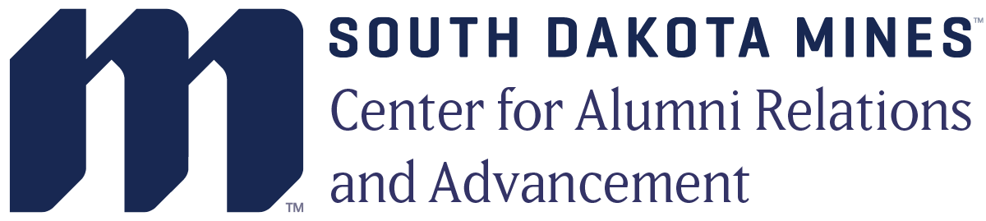
Director of Development
The South Dakota Mines Center for Alumni Relations & Advancement (CARA) is seeking a Director of Development to create and cultivate relationships with alumni, friends and industry partners to generate financial support for the university. CARA is currently in a $100 million comprehensive campaign for scholarship and program support as well as capital improvements. Reporting to the Vice President for Development, this key position is responsible for advancing philanthropy built on a firm understanding of the donor’s interests and passions.
Key Responsibilities:
- Responsible for building relationships with prospective donors in support of fundraising initiatives for South Dakota Mines, a public STEM university with more than 2,600 students.
- Manage a specific portfolio of 100-125 donors as well as donors in key geographic regions of the country.
- In collaboration with the CARA team, identify, cultivate and solicit major gift prospects—including corporate and planned estate gifts.
- Initiate and direct programs to enlist new donors, retain current donors, and upgrade their level of involvement and support.
- Update and maintain contact reports in a timely manner and implement next steps of the moves management process according to prospect/donor engagement.
- Participate in general CARA activities including staff task forces and committees, outreach activities, CARA Board and committee meetings and University fund development efforts as assigned.
- Collaborate with faculty, administration and other staff about donors and gift options.
- Maintain an awareness and understanding, through continuing education and interactions with colleagues at other institutions, of trends in development and new fund development techniques.
- Assist in the achievement of the overall South Dakota Mines CARA goals, plans and objectives.
- Work on other assignments as requested.

Requirements
- Competence in Microsoft Office suite and donor management systems, such as Blackbaud’s Raiser’s Edge/NXT.
- Ability to maintain confidentiality of sensitive and personal information.
- Good time management and organizational skills.
- Evening work and travel is required.

Qualifications
- Bachelor's degree required, master’s degree or equivalent experience desirable.
- Strong interpersonal and communication skills with a minimum of 5+ years of fund development, corporate, management, and/or sales and marketing experience.
- Previous development work in a college, university or non-profit preferred.
- Ideally the candidate will be in Rapid City, SD, but someone remote in a key market including Denver, Dallas, Houston, Minneapolis or Phoenix will be considered. If remote, the individual must be willing to come to campus on a regular basis.

Send cover letter, resume and three references to: Nancy Beets at Nancy.Grunden-Beets@sdsmt.edu

About the South Dakota Mines Center for Alumni Relations and Advancement
CARA is committed to recruiting and retaining a diverse workforce and offers an excellent comprehensive benefits package including paid medical, dental, vision, disability and life insurance for our employees; family medical, dental and vision coverage is available, but paid by employee; retirement plans; paid holidays; and a generous paid-time-off allowance.
Mission:
We promote the traditions, interests, influence and reputation of South Dakota Mines among alumni and friends through meaningful engagement and by inspiring and stewarding philanthropy.
Vision:
We will be a global network of alumni and friends who advance the prominence of South Dakota Mines.
Values:
- Collaboration: We work toward common goals with each other, the University, and stakeholders.
- Tradition: We celebrate the traditions and legacies that connect us as a South Dakota Mines family.
- Excellence: We are committed to the highest quality in all we do.
- Diversity and Inclusion: We value the diversity of unique backgrounds, experience, perspectives, and talents within our community and among our alumni and friends.
- Stewardship: We operate with integrity and transparency as excellent stewards of the resources entrusted to us.
CARA does not discriminate on the basis of sex, race, color, creed, national origin, ancestry, citizenship, gender identification, transgender, sexual orientation, religion, age, disability, genetic information or veteran status in employment or the provision of service.

